
Soma Cube Handout

Rendering & Shading

The seven Soma pieces are all polycubes of an order of three or four:
- The "L" tricube.
- T tetracube: a row of three blocks with one added below the center.
- L tetracube: a row of three blocks with one added below the left side.
- S tetracube: bent triomino with block placed on outside of clockwise side.
- Left screw tetracube: unit cube placed on top of anticlockwise side. Chiral in 3D.
- Right screw tetracube: unit cube placed on top of clockwise side. Chiral in 3D.
- Branch tetracube: unit cube placed on bend. Not chiral in 3D.
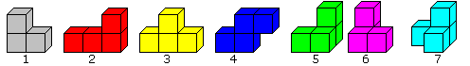

Draw each of these above cubes to a 3” side for each square. Be sure each one is made from a different material.

The term chiral in general is used to describe an object that is non-superposable on its mirror image. Achiral (not chiral) objects are objects that are identical to their mirror image (wikipedia).

HINT: Draw one cube. Copy and paste the 3” cube using snap in the various shapes. Be sure and have each shape be a different material.

Now, union all the pieces and rotate them and fit them together until you have a perfect square that shows all the different materials.

Render the image of your Soma cube. Print out three different 2D views of your Soma Cube (top, front, side). Print out one isometric view of your Soma Cube.

Now, shade the rendered model of the image. Print out three different 2D views of your Soma Cube (top, front, side). Print out one isometric view of your Soma Cube.

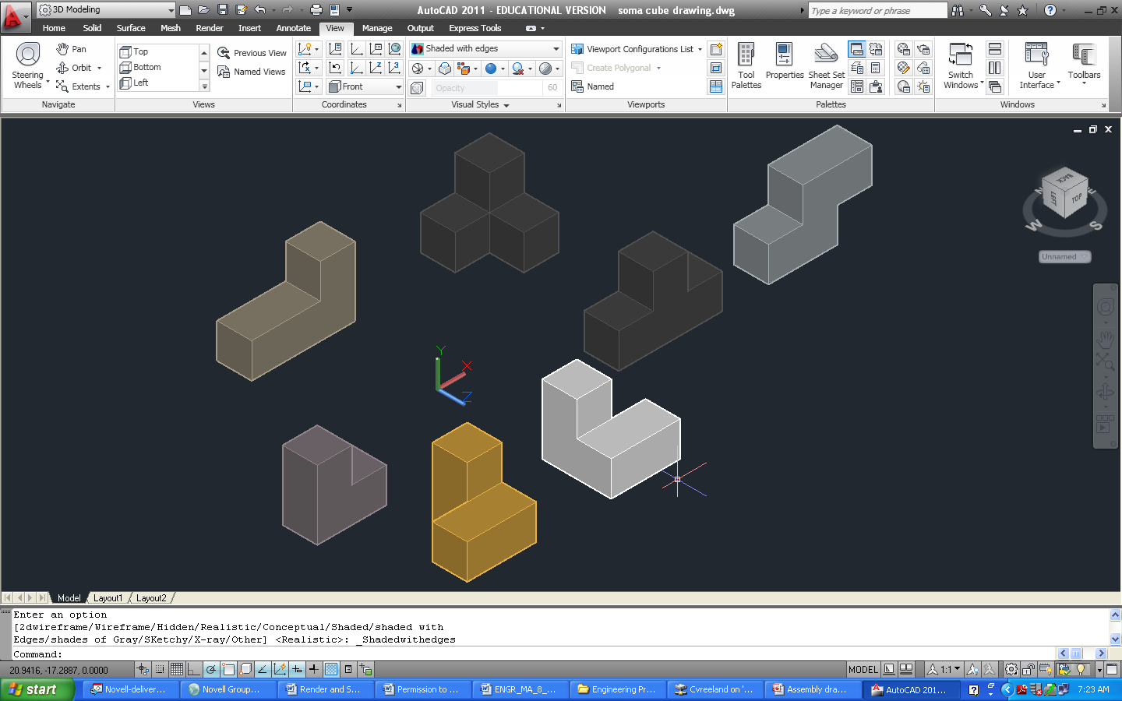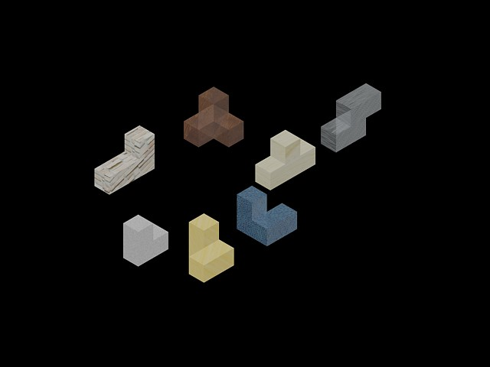

Shaded with lines in AutoCAD Presentation Rendered AutoCAD

