Worksheet to demonstrate an understanding of the terminology for the parts of a fastener

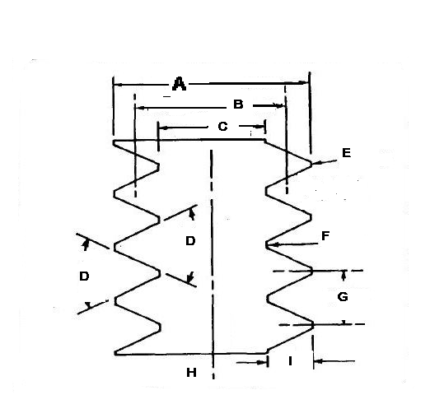
A – Major Diameter  B – Pitch Diameter  C – Minor Diameter  D – Thread Angle  E – Crest | F – Root  G – Pitch  H – Axis  I - Depth

