Dimensioning and Tolerancing Post Test KEY

Directions: Place the letter of the correct answer in the space provided:

D 1. ANSI

F 2. ASME

A 3. ISO

B 4. Dimensioning

C 5. Dual dimensions

E 6. Dimensioning systems

D 7. Dimension line

A 8. Extension line

F 9. Dimension text

E 10. Arrowheads

C 11. Scale

B 12. Leader

A. An international standard setting body.

B. Must comply with standards and convey communications to the drawing.

C. Dimensions provide both metric and imperial units on the drawing.

D. U.S. organization that recommends standards.

E. The text position is aligned or unidirectional.

F. A U.S. professional engineering society that focuses on mechanical engineering.

A. Locates the position of the dimension.

B. Points to the center of a circle with notes and descriptions.

C. The actual size the drawing is to the paper selected to draw the object.

D. Indicates direction and extent of a dimension.

E. Placed on the ends of leader and dimension lines.

F. Provides clarity to relationships of features

Multiple Choice

13. The first dimension line should be located this far from the object line:
a. 3/32
b. 3/16
c. 3/8
d. 3/4

14. All dimension lines after the first line should be positioned this distance away from each other:
a. 1/16
b. 1/8
c. 1/4
d. does not matter

15. The extension line should be this distance off the object line:
a. 1/64
b. 1/32
c. 1/16
d. 1/8

16. This dimension symbol represents 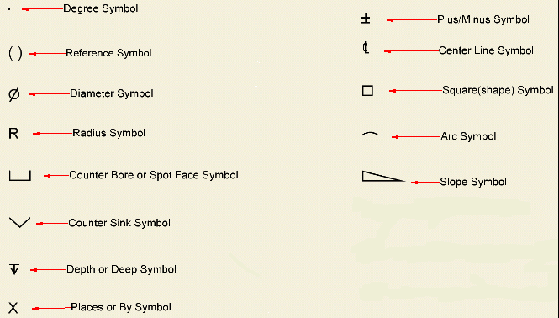
a. No circles
b. diameter
c. radius
d. circumference

17. This dimension symbol represents
a. remove
b. diameter
c. radius
d. circumference

18. This dimension symbol represents
a. undo
b. counter bore
c. counter sink
d. depth

19. This dimension symbol represents
a. undo
b. counter bore
c. counter sink
d. depth

20. This dimension symbol represents
a. undo
b. counter bore
c. counter sink
d. depth

21. This dimension symbol represents
a. redo
b. counter bore
c. counter sink
d. tolerance range

22. Dimension lines should be placed __________ whenever possible.
a. on the drawing figure
b. above the drawing figures
c. below the drawing figures
d. between the drawing figures

23. Drills and bores should be dimensioned with a
____________ annotation with the text for a leader.
a. radius symbol
b. circumference symbol
c. diameter symbol
d. tolerance symbol

24. Rounds and fillets should be dimensioned with ____________ annotation with the text for a leader.
a. radius symbol
b. circumference symbol.
c. diameter symbol
d. tolerance symbol

25. Full circular objects should be dimensioned using the
a. radius
b. diameter
c. circumference .
d. method you prefer.

Identify the lines illustrated below:

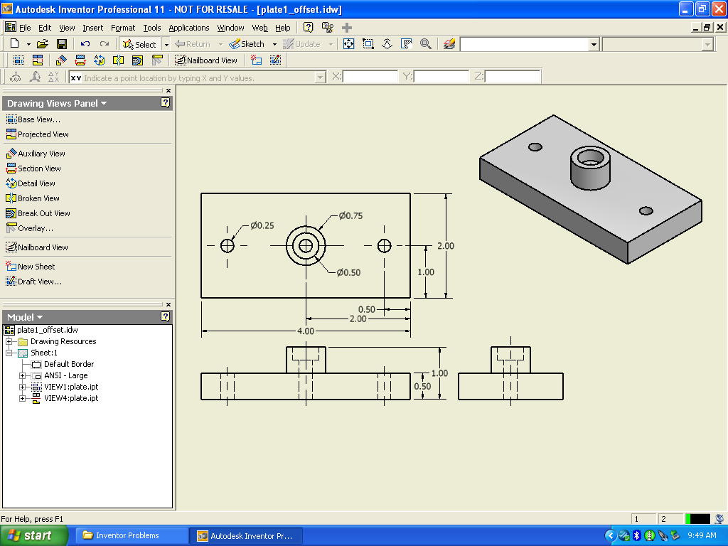
E.
H.
I.
D.
A.
F.
G.
B.
C.

26. Hidden Lines H

27. Center Mark C

28. Dimension Line F

29. Center Line I

30. Leader Text B

31. Visible Object Line G

32. Dimension Text D

33. Leader Line A

34. Extension Line E

35. The dimensions below are represented by using _____________ points.

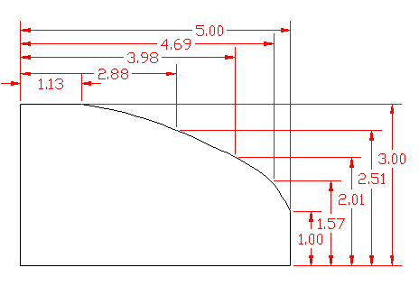

a. cumulative
b. coordinate
c. Cartesian
d. datum
36. The symbol below is used to represent:

a. no radius
b. radius
c. no diameter
d. diameter

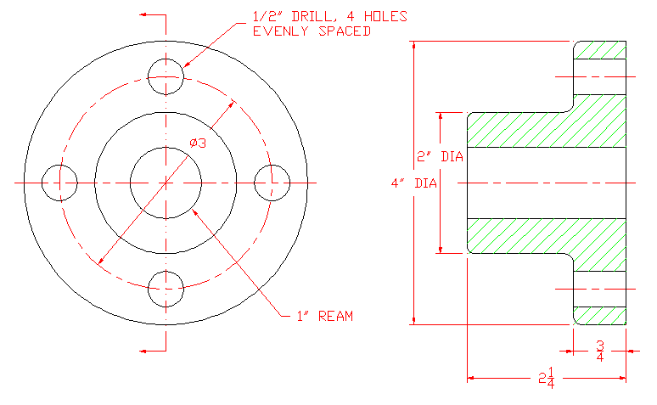
ALL FILLETS & ROUNDS 1/8”

37. Using the above drawing. What is the over-all diameter of the part?
a. 1”
b. 2”
c. 3”
d. 4”

38 What is the size of the fillets on the drawing above?
a. 1/16”
b. 1/8”
c. 1/4”
d. 1/2”

39. How deep is the ream in the above drawing?
a. 1/2”
b. 3/4”
c. 2”
d. 2 ¼”

40. How far are the 4 drilled holes from the center of the above drawing?
a. 1/2”
b. 1 ½ ”
c. 2”
d. 3”

