Tutorial 1: Introduction to 3D Parametric Modeling
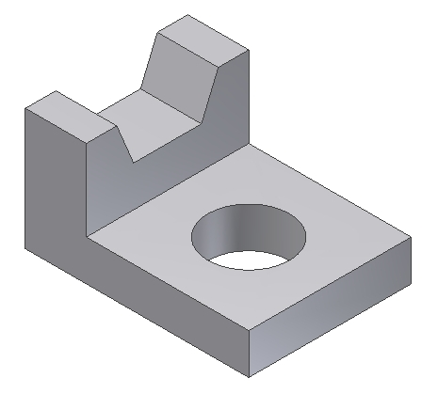
The following model will be created:

Follow the steps in this document to insure the geometry is created in logical order. Defining geometry this way allows the CAD user to change dimensions and see the results. This is one example of parametric modeling.

Study the following drawing before creating this model:
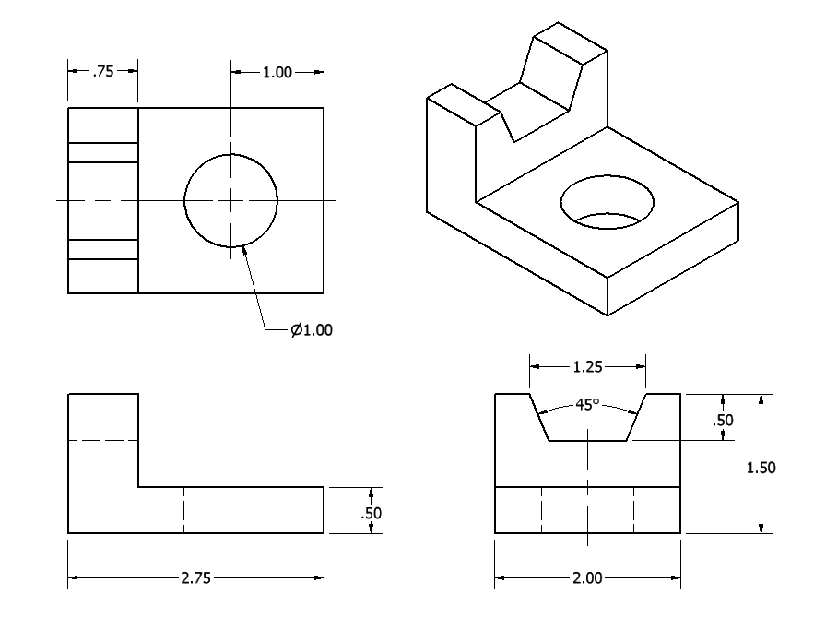

Step 1: Create an extruded feature
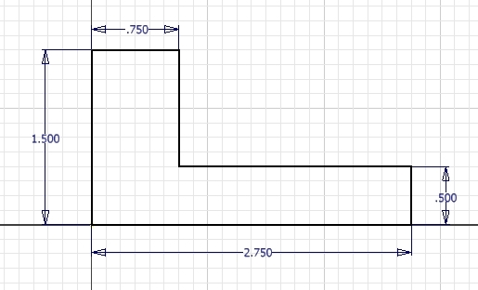

Create this sketch

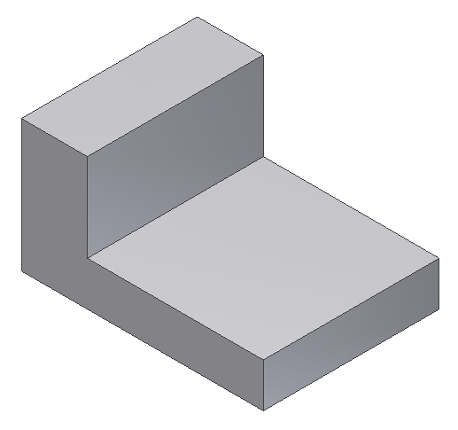

Extrude the sketch 2 inches

Step 2: Create a straight hole

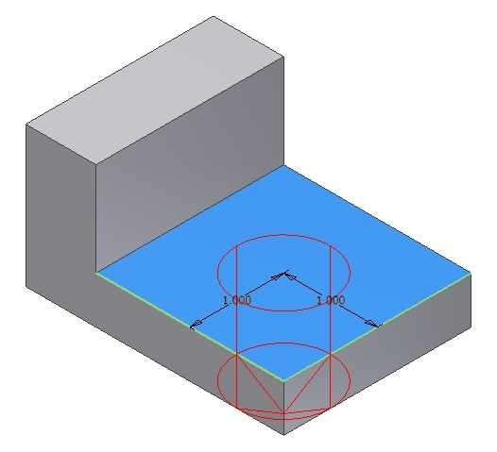
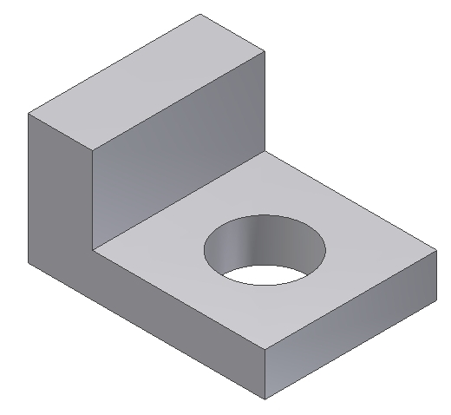
Locate the hole 1 inch from each edge as shown:

Step 3: Create a cut
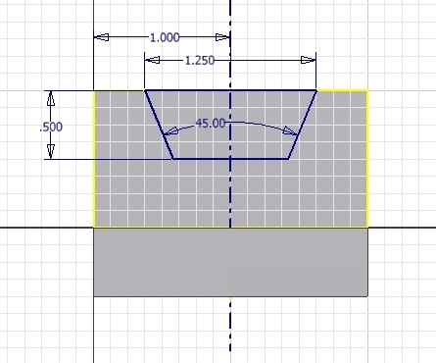
Develop the sketch in stages - use mirror to copy geometry
Select the highlighted surface for the sketch plane
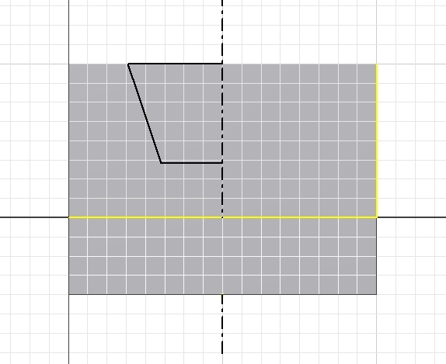
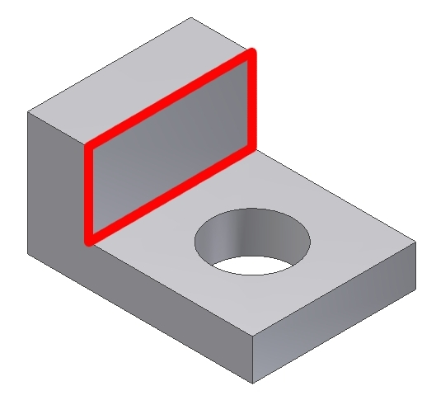
When your sketch is complete, use it to remove material as shown to finish the model.

Change dimensions of various features and notice the differences when the geometry updates.

