Tutorial 2: Introduction to 3D Parametric Modeling
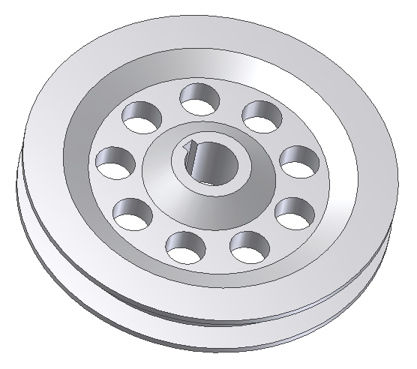
We will be creating the following model:

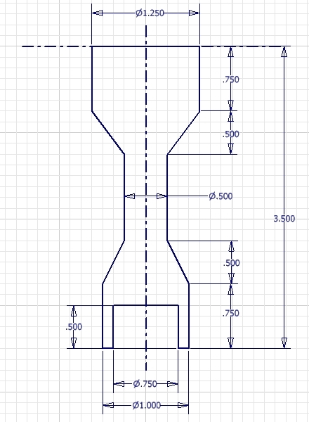
Step 1: Create a revolved feature

Create this sketch

Define the center lines first

When the sketch is finished, create a revolved feature
Step 2: Add a 1 inch through hole

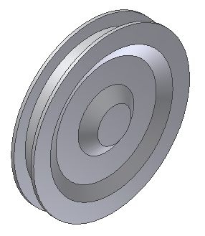
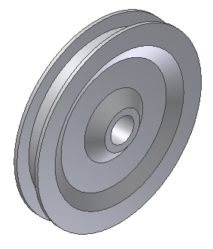

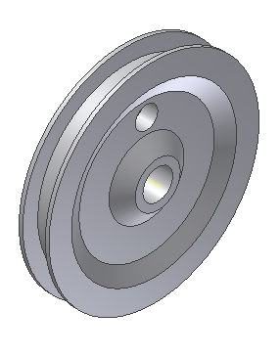
Step 3: Create another hole feature
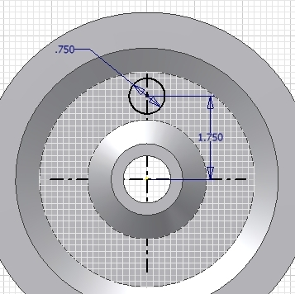

Step 4: Create a radial pattern with nine instances
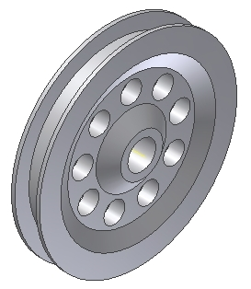

Step 5: Create an extruded cut
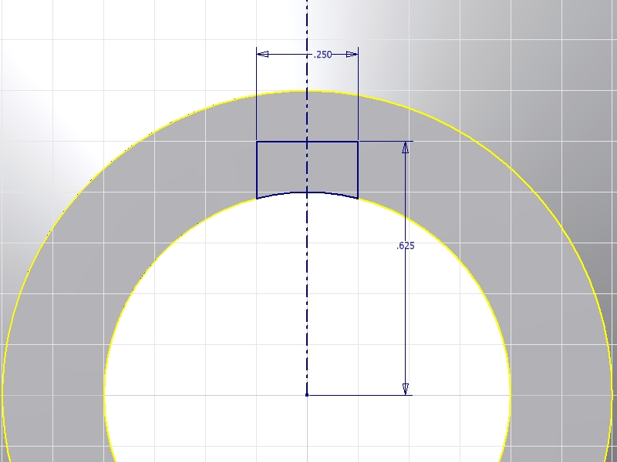
Create this sketch

Use the finished section to create an extruded cut

