Tutorial 3: Introduction to 3D Parametric Modeling

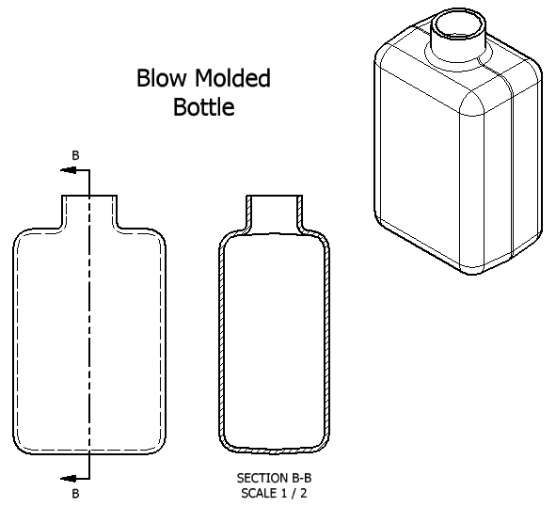
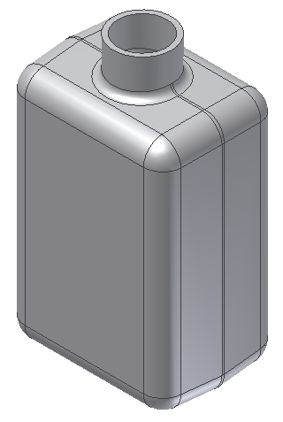
This part represents a blow molded bottle. These parts use angled sides so the parts will be removed easily from the mold that gives them their shape. The term draft is used to describe sides which are angled to allow parts to release from molds. The amount of draft varies depending on the mold process, material used, and the complexity of the part.

Step 1: Create an extruded feature
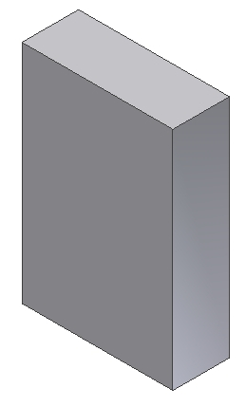
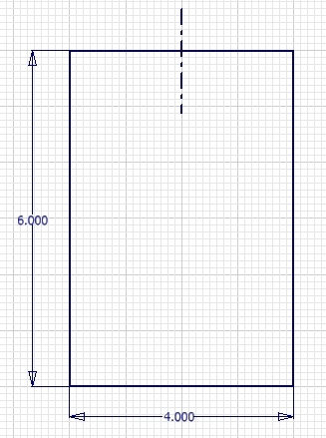

Create this sketch

Define the center lines first

Extrude the sketch
1.5 inches

Step 2: Create a draft feature
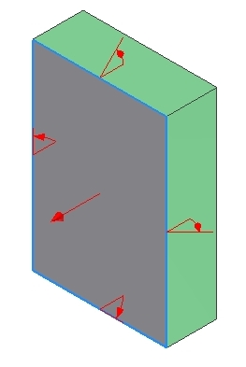

Select four sides (shown green)

Draft angle should be
3 degrees

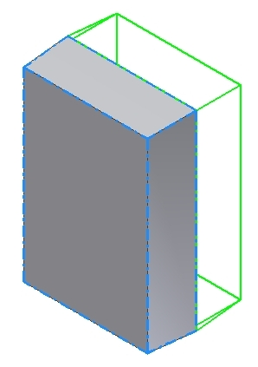
Step 3: Mirror the geometry Step 4: Round all edges using 0.5 inch radius
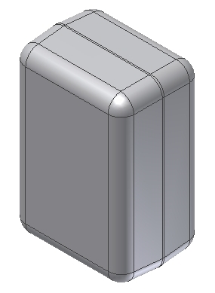

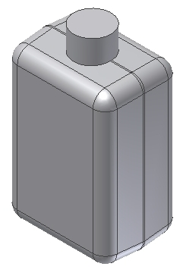

Step 5: Add a cylindrical extrusion at the top of the bottle
Three Steps:
(1) Create a workplane
(2) Draw a 1.5 inch diameter circle using the workplane
(3) Extrude the circle one inch as shown

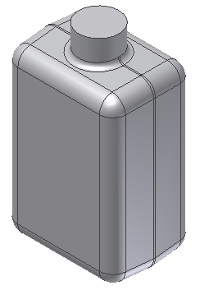
Step 6: Add a 0.18 inch round at the base of the cylinder

Step 7: Add a 0.125 inch shell
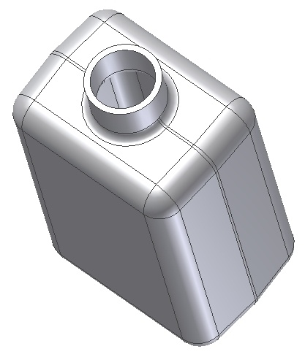
Select only the top surface to remain open

