Tutorial 4: Introduction to 3D Parametric Modeling

The following model will be created:
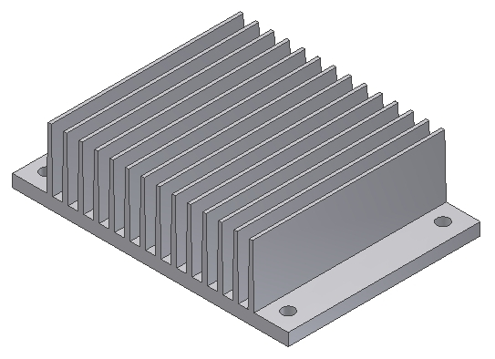

Step 1: Create an extruded feature measuring 44.5mm x 2mm
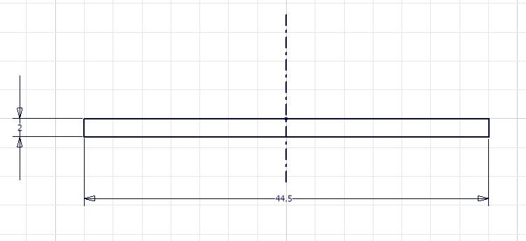
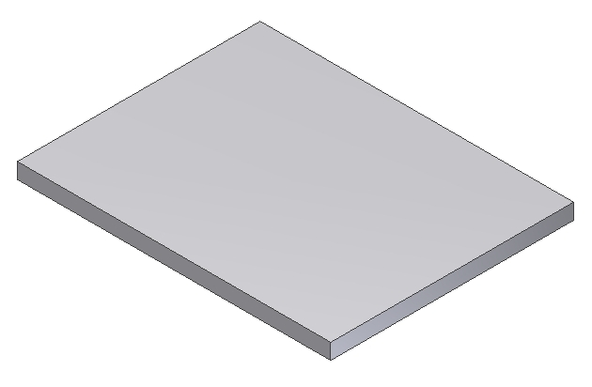
The sketched rectangle should be extruded 31 mm

31 mm

Step 2: Create another extruded feature to represent a cooling fin:
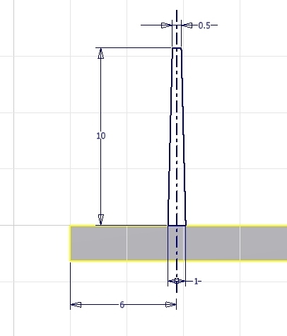
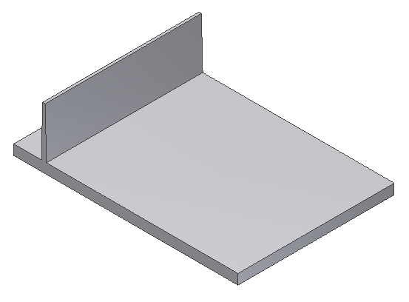

Step 3: Create a pattern of the last extruded feature
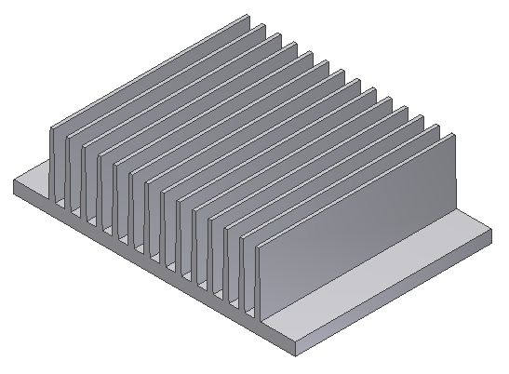
Create 14 instances 2.5mm apart

Step 4: Create a through hole located 3mm from each edge as shown:

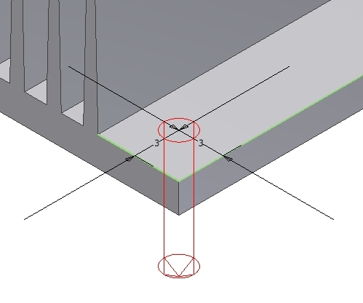
Create a 2mm diameter hole

Step 5: Pattern the hole
2 holes spaced
25mm apart

2 holes spaced
39 mm apart

