Tutorial 5: Introduction to 3D Parametric Modeling
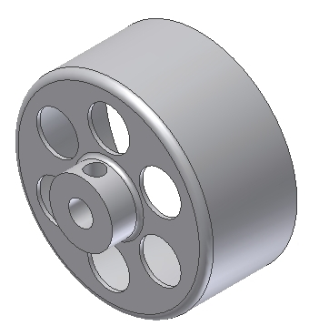
Culminating Performance Task
Create the following model:

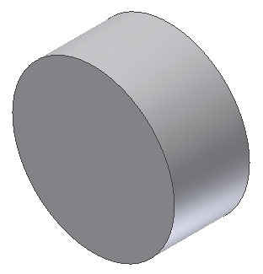
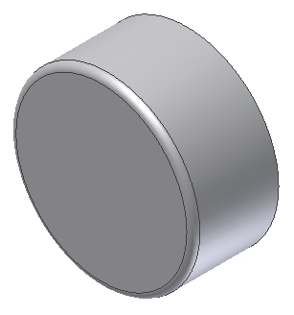
Step 1: Create an extruded feature
The cylinder has a diameter of 28mm and is extruded 13mm
Step 2: Create a 1mm round on the front edge only

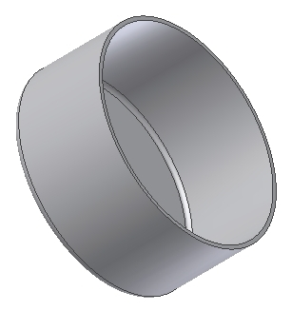
Step 3: Create a shell feature
The only open surface is the rear of the cylinder

The shell wall thickness is 0.5mm
Step 4: Create a hole
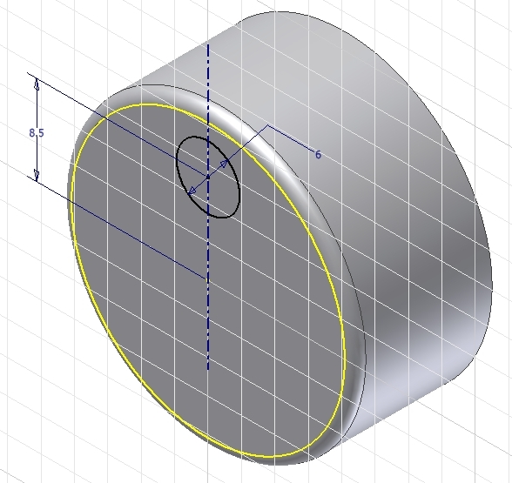
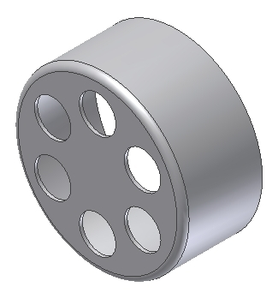
Step 5: Create a radial pattern of the hole
- Include six instances of the hole

Step 6: Create an extruded feature
The cylinder has a diameter of 9mm and is extruded 4mm
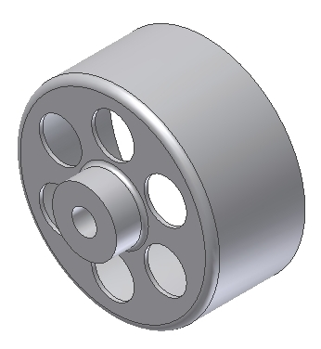
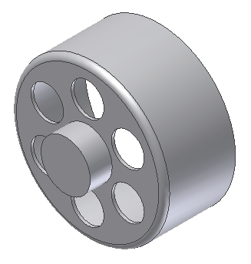
Step 7: Create a hole

Through hole
Diameter = 3.5mm

Step 8: Create a cut

