- Identify the following line types: leader lines, section lines, hidden lines, visible lines, and center lines.
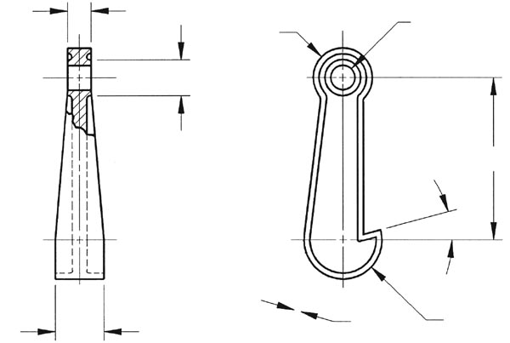

- Produce a non-scaled sketch of the following object on plain paper.

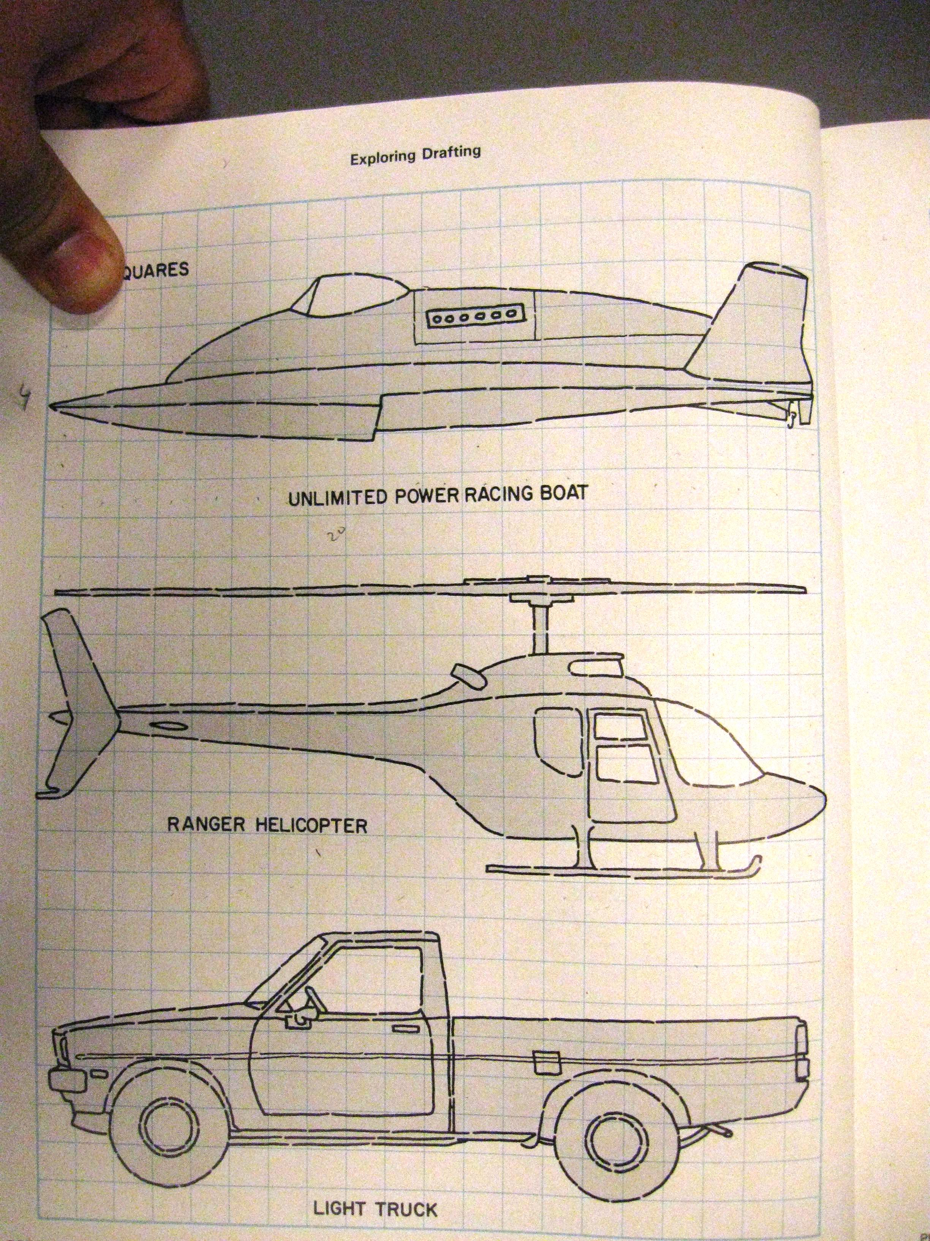

- Produce double scale sketch of the following object on grid paper. (each square equals ¼”)



