- Identify the following line types: leader line, section lines, hidden lines, visible lines, and center lines.
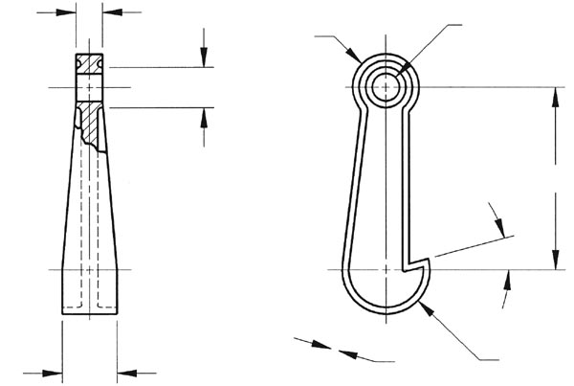

- Sketch the front, top and right side view of the following object and indicate your scale.
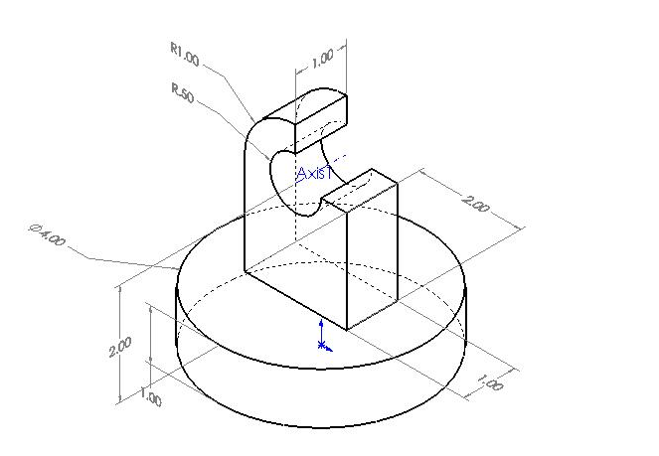

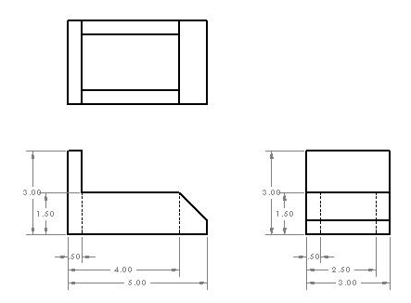
- Sketch an Isometric view of the object below.

