PLOTTING INITIALS WITH AUTOCAD: STEP-BY-STEP INSTRUCTIONS FOR INPUTTING ABSOLUTE, RELATIVE, AND POLAR COORDINATES
Points for plotting initials JK with Absolute Coordinates:

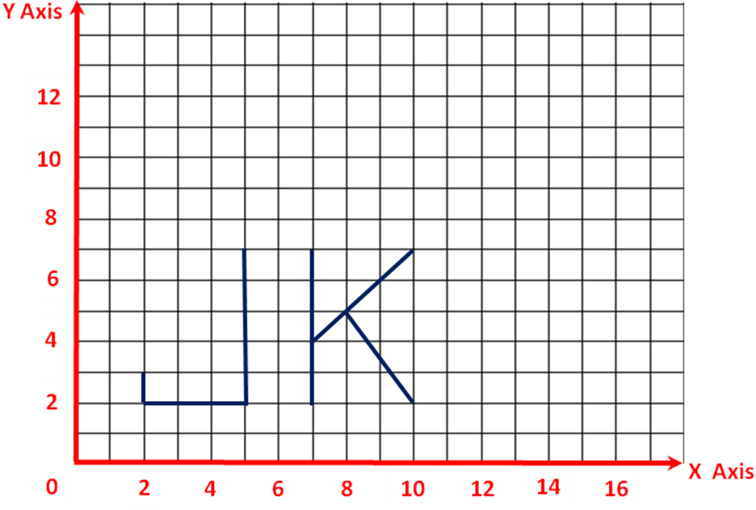
2,3
2,2
5,2
5,7
7,2
7,7
7,4
10,7,2
8,5
10,2

Absolute Coordinate System for Initials JK
Absolute Point or Command |  | Description / Referenced from 0,0
1 | Line Command | Begins line command to input point
2 | 2,3 | 2 in X & 3 in Y axis, first point of letter J
3 | 2,2 | 2 in X & 2 in Y axis, down one unit
4 | 5,2 | 5 in X & 2 in Y, to the right 3 units
5 | 5,7 | 5 in X & 7 in Y, up 5 units
6 | Press Enter | Terminates the line command, Letter J completed
7 | Line Command | Begins command to input point
8 | 7,2 | 7 in X & 2 in Y, begins the letter K
9 | 7,7 | 7 in X & 7 in Y, up 5 units
10 | Press Enter | Terminates the line command
11 | Line Command | Begins command to input point top slant line in K
12 | 7,4 | 7 in X & 4 in Y, beginning point for top slant line in K
13 | 10,7 | 10 in X & 7 in Y end point for top slant in line K
14 | Press Enter | Terminates the line command
15 | 8,5 | 8 in X & 5 in Y, begins lower slant in letter K
16 | 10,2 | 10 in X & 2 in Y, ends lower slant in letter K
17 | Press Enter | Terminates the line command

Points for plotting initials JK with Relative Coordinates:

2,3
@0,-1
@3,0

@0,5

7,2
@0,5

@0,-3

@3,3

@-2,-2

@2,-3

Relative Coordinate System for Initials JK
Relative Point or Command |  | Description / Referenced from 0,0
1 | Line Command | Begins line command to input point
2 | 2,3 | 2 in X & 3 in Y axis, first point of letter J
3 | @0,-1 | Down 1 unit in the Y axis
4 | @3,0 | To the right 3 units in X axis
5 | @0,5 | Up 5 units in the Y axis
6 | Press Enter | Terminates the line command, Letter J completed
7 | Line Command | Begins command to input point
8 | 7,2 | 7 in X & 2 in Y, begins the letter K
9 | @0,5 | Up 5 units in the Y axis
10 | @0,-3 | Down 3 units in Y axis, to begin top slant line in K
11 | @3,3 | Up 3 units in X & Y axes, end point of top slant line in K
12 | @-2,-2 | Down -2 in X & Y axes, start point of bottom slant line in K
13 | @2,-3 | 2 in X &-3 in Y axes, end point for bottom slant in line K
14 | Press Enter | Terminates the line command, Initials completed

Points for plotting initials JK with Polar Coordinates:

2,3
@1<270
@3<0

@%<90

7,2
@5<90

@5<270

@3<45

@3<225

@3.5<310

Polar Coordinate System for Initials JK
Relative Point or Command |  | Description / Referenced from 0,0
1 | Line Command | Begins line command to input point
2 | 2,3 | 2 in X & 3 in Y axis, first point of letter J
3 | @1<270 | Down 1 unit 270 degrees
4 | @3<0 | To the right 3 units in 0 degrees
5 | @5<90 | Up 5 units 90 degrees
6 | Press Enter | Terminates the line command, Letter J completed
7 | Line Command | Begins command to input point
8 | 7,2 | 7 in X & 2 in Y, begins the letter K
9 | @5<90 | Up 5 units 90 degrees
10 | @3<270 | Down 3 units 270 degrees, to begin top slant line in K
11 | @4<45 | Up 4 units degrees, end point of top slant line in K (estimated)
12 | @3<225 | Down 3 units 270 degrees, start point of bottom slant line in K  (estimated)
13 | @3.5<310 | Down 3.5 units 310 degrees, end point for bottom slant in line K  (estimated)
14 | Press Enter | Terminates the line command, Initials completed

