Architectural Drawings

The following 2D CAD model will be created:

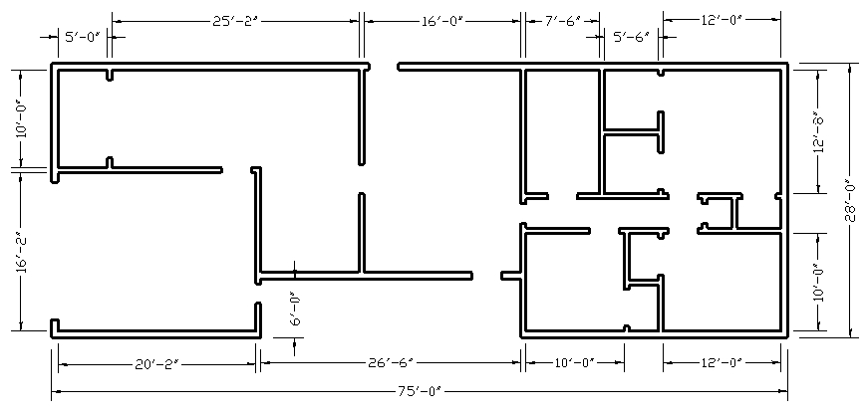

Create the Drawing

Step 1 → Select the units type
- Notice the drawing is defined using decimal inches so make sure your drawing units are set to inches showing two decimal places. Following is an example of a dialog box displayed when entering the UNITS command (or similar):
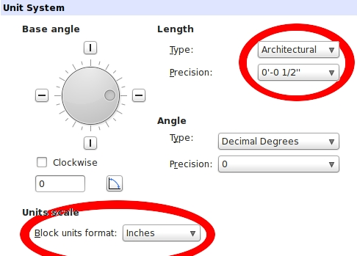

Step 2 → Define the drawing area
- Use the LIMITS command (or similar) to define the drawing area. The lower left corner should be 0,0 (zero, zero) and the upper right corner should be 90',50'
Step 3 → Display the drawing area
- Use the ZOOM command with the ALL option (or similar) to display the drawing area

Step 4 → Create a rectangle
- Use the RECTANGLE command (or similar)
- Enter the first corner of the rectangle to be 10',10'
- Enter the second corner to be 62',28'

Step 5 → Create the inside rectangle
- Use the OFFSET command (or similar)
- Enter the offset distance to be 8 (or 8”)
- Select anywhere on the rectangle as the object to offset
- Select anywhere on the inside of the rectangle as the side to offset

Step 6 → Explode the two rectangles
- Use the EXPLODE command (or similar)
- Select both rectangles

Step 7 → Create interior walls
- Study the drawing, then use the OFFSET command (or similar) to create the walls
  - Exterior walls are 8” thick
  - Interior walls are 6” thick
  - Hallway is 48” wide
- Use TRIM & EXTEND to complete the walls
  - This process will require zooming in and out so you can see the geometry and select items accurately

Step 8 → Create door openings
- When all interior walls are complete, create door openings where shown
  - All door openings are 36”
  - Usually, doors are located 6” from wall corners

Your model is completed.

