Creating Simple 2D CAD Geometry

Students should use skills developed in previous lessons to create these two models:
Drawing 1
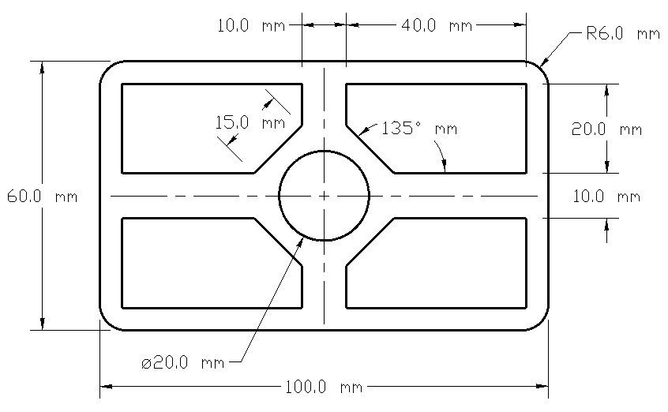

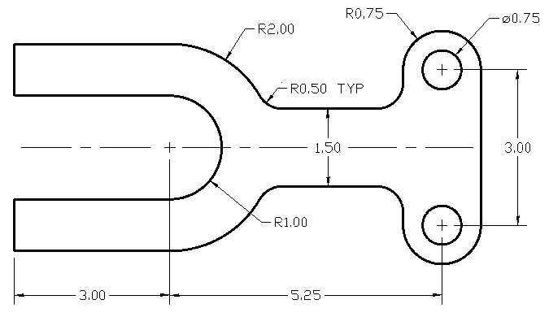
Drawing 2

