Engineering Drawings

The following 2D CAD models will be created:

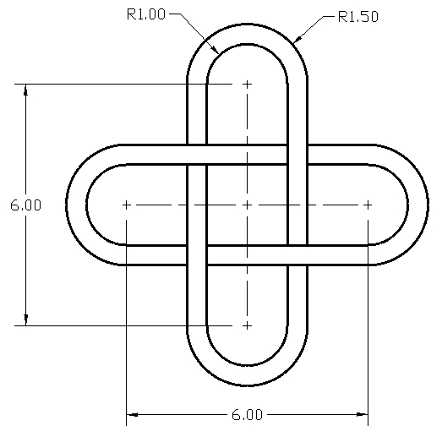
Drawing 1

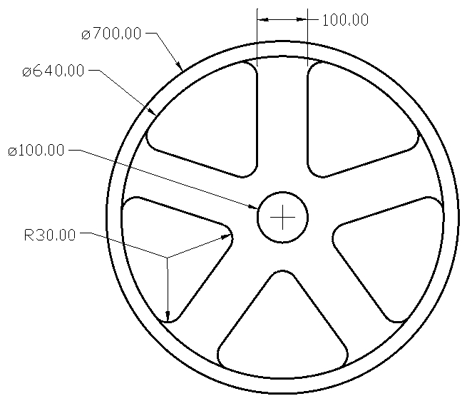

Drawing 2
Drawing 2

Create Drawing 1

Step 1 → Select the units type
- Notice the drawing is defined using decimal inches so make sure your drawing units are set to inches showing two decimal places. Following is an example of a dialog box displayed when entering the UNITS command (or similar):
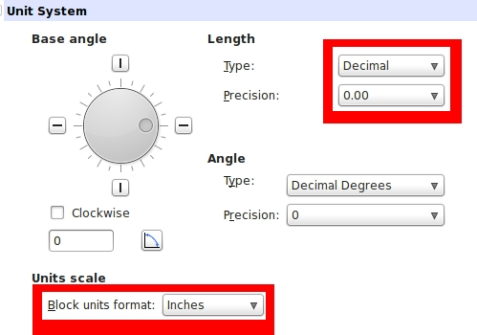

Step 2 → Define the drawing area
- Use the LIMITS command (or similar) to define the drawing area. The lower left corner should be 0,0 (zero, zero) and the upper right corner should be 12,12.
Step 3 → Display the drawing area
- Use the ZOOM command with the ALL option (or similar) to display the drawing area.

Step 4 → Create two circles
- Use the CIRCLE command (or similar) to create the first circle
  - Center point = 3,6
  - Diameter = 6
- Use the CIRCLE command (or similar) to create the second circle
  - Center point = 9,6
  - Diameter = 6
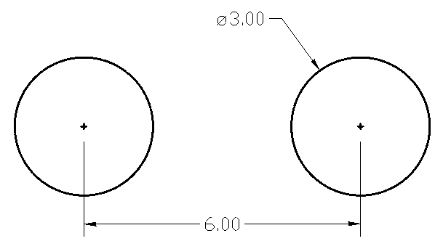

Step 5 → Create two lines
- Make sure the QUADRANT object snap is active
  - At the “Command” prompt, type in OSNAP
    - Activate the QUADRANT object snap if necessary
    - Press OK
- Use the LINE command (or similar) to create the first line
  - The first point of the line will be the top quadrant of the left circle
  - The second point of the line will be the top quadrant of the right circle
- Repeat the LINE command to create the bottom line as shown:
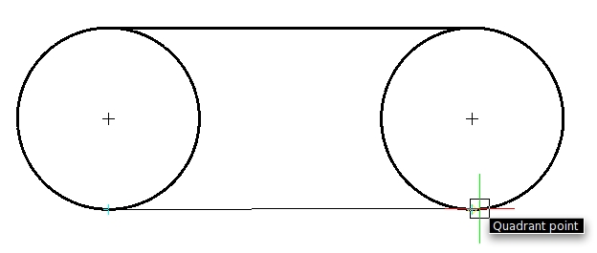

Step 6 → Trim the circles
- At the “Command” prompt, select both lines
  - The grips for each line will appear (blue squares, or similar)
- Type in or select the TRIM command (or similar)
- Select both circles where shown (red dots):
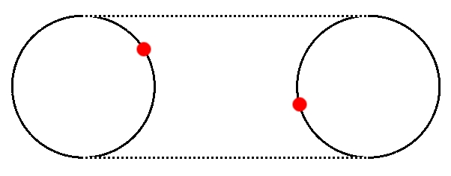

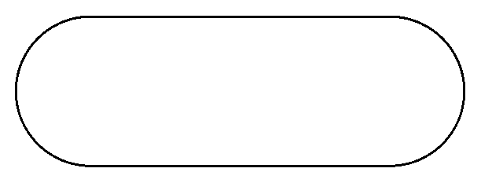
Your model should now look like this – a closed loop formed from two arcs and two lines:

Step 7 → Offsetting the arcs and lines
- Use the OFFSET command (or similar)
- Enter the offset distance to be 0.50
- Select any item to offset (either an arc or a line)
- Select anywhere inside the loop defined by the arcs and lines
- Continue offsetting all four objects

Your model should now look like this:
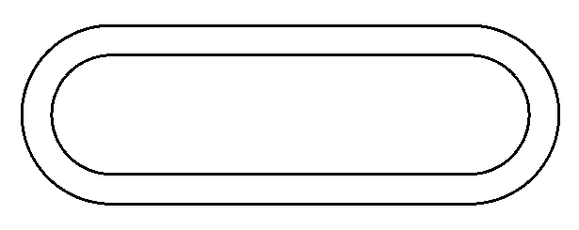

Step 8 → Create a radial pattern
- Use the ARRAY command (or similar)
- Select all objects to pattern
- Select a radial or circular pattern (not linear)
- The center point should be 6,6
- The angle of patterned objects will be 90
- Two objects will be patterned
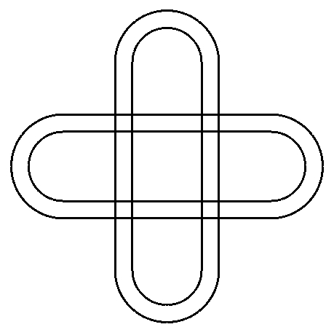
Your model should look like this:

Step 9 → Trim
- Use the TRIM command (or similar)
  - Select all objects as the cutting edges
  - Select the eight places to trim as shown:
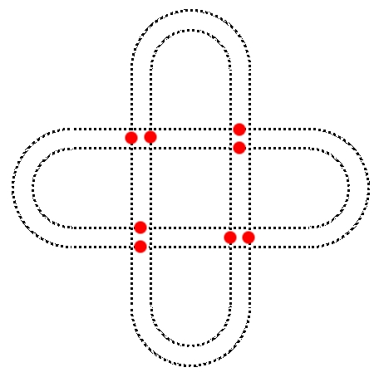

The finished model should look like this:

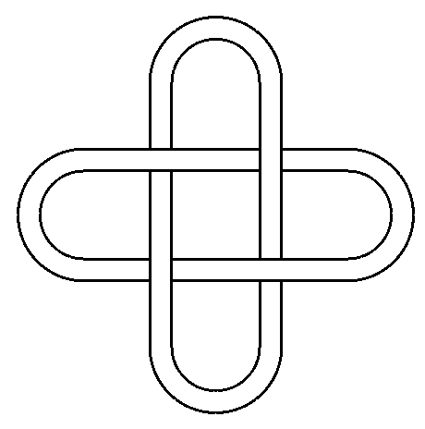

Create Drawing 2

Step 1 → Select the units type
- Notice the drawing is defined using decimal inches so make sure your drawing units are set to inches showing two decimal places. Following is an example of a dialog box displayed when entering the UNITS command (or similar):
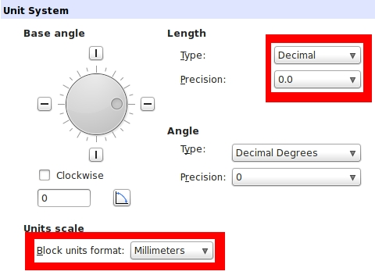

Step 2 → Define the drawing area
- Use the LIMITS command (or similar) to define the drawing area. The lower left corner should be 0,0 (zero, zero) and the upper right corner should be 900,900.
Step 3 → Display the drawing area
- Use the ZOOM command with the ALL option (or similar) to display the drawing area

Step 4 → Relocate the User Coordinate System (UCS)
- Use the UCS command (or similar)
- Enter the new origin to be 600,400
  - The UCS icon should now appear near the middle of the drawing window.

Step 5 → Create two lines
- Create the first line:
  - Use the LINE command
    - The start point is 50,100
    - The end point is 50,400 or @300<90 or @0,300
- Create the second line:
  - Use the LINE command
    - The start point is -50,100
    - The end point is -50,400 or @300<90 or @0,300

Step 6 → Pattern the two lines
- Use the ARRAY command (or similar)
  - Select all objects to pattern
  - Select a radial or circular pattern (not linear)
  - The center point should be 0,0
  - The angle of patterned objects will be 72
  - Two objects will be patterned
Your model should look like this:
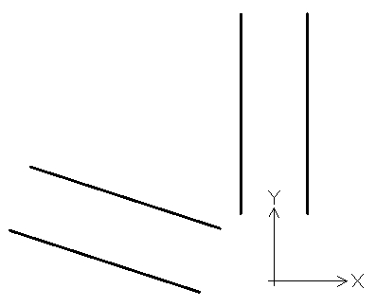

Step 7 → Create a circle
- Use the CIRCLE command
  - Center is 0,0
  - Radius is 320

Step 8 → Trim the objects
- Select the TRIM command (or similar)
  - Select all objects as cutting edges
  - Select objects to trim where shown:
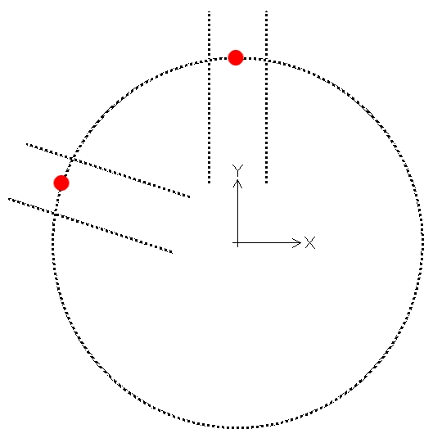

Step 9 → Erase some of the objects
- Use the ERASE command (or similar)
  - Only these three objects shown (two lines and one arc) should remain
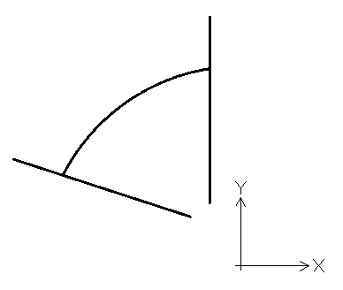

Step 10 → Add arcs
- Use the FILLET command (or similar)
  - Set the radius to 30
  - Select any two objects to place the arc
  - Repeat until your model looks like this:
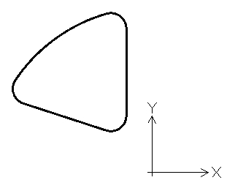

Step 11 → Delete the large arc
- Select the large arc, then delete it
- Your model should now look like this:

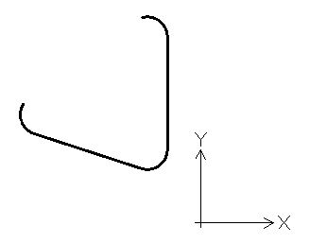

Step 12 → Pattern all objects
- Use the ARRAY command (or similar)
  - Select all objects to pattern
  - Select a radial or circular pattern (not linear)
  - The center point should be 0,0
  - The angle of patterned objects will be 72
  - Five objects will be patterned

Your model should look like this:

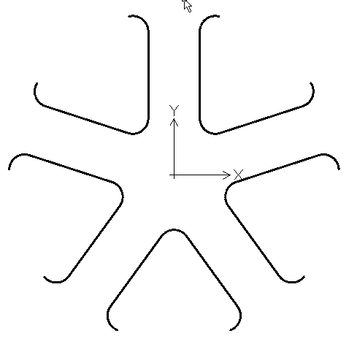

Step 13 → Create three circles
- Use the CIRCLE command
  - Center is 0,0
  - Radius is 320
- Use the CIRCLE command
  - Center is 0,0
  - Radius is 350
- Use the CIRCLE command
  - Center is 0,0
  - Radius is 50

Your model is now finished and should look like this:

