Intermediate 2D CAD Modeling

The following 2D CAD models will be created:
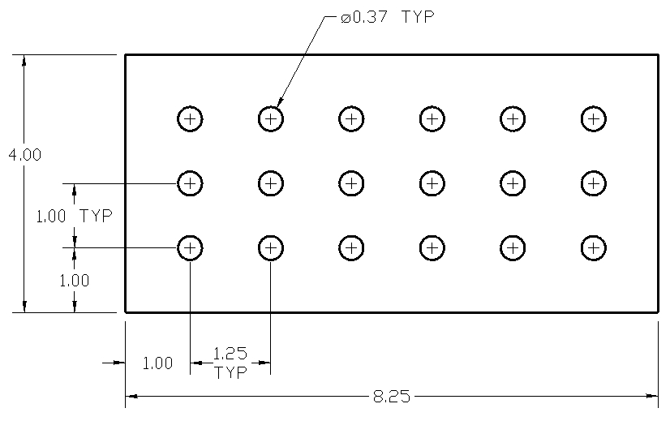

Drawing 1

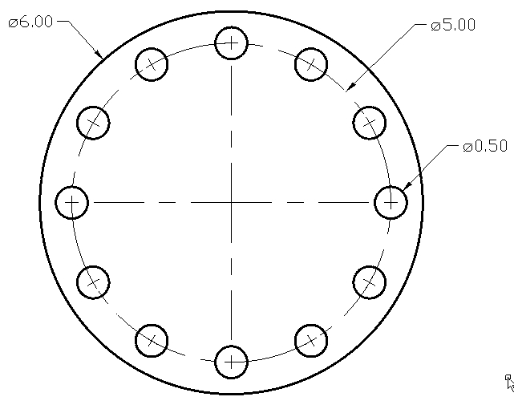

Drawing 2

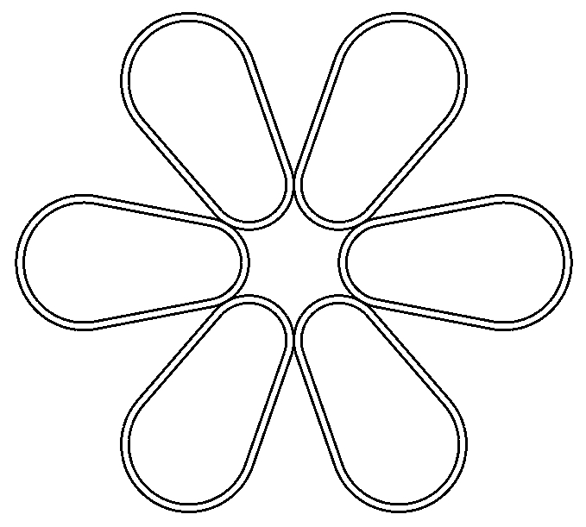

Drawing 3

Create Drawing 1

Step 1 → Select the units type
- Notice the drawing is defined using decimal inches so make sure your drawing units are set to inches showing two decimal places. Following is an example of a dialog box displayed when entering the UNITS command (or similar):
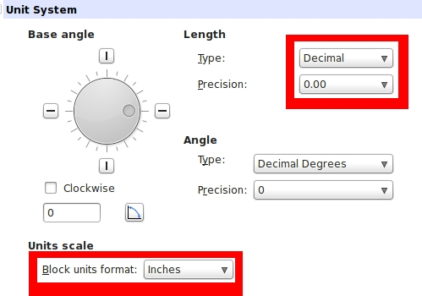

Step 2 → Define the drawing area
- Use the LIMITS command (or similar) to define the drawing area. The lower left corner should be 0,0 (zero, zero) and the upper right corner should be 12,9
Step 3 → Display the drawing area
- Use the ZOOM command with the ALL option (or similar) to display the drawing area
Step 4 → Create four lines
The RECTANGLE command could be used to create the four lines instead. One corner could be located at 2,2 while the other corner could be entered as @8.25,4.

The RECTANGLE command creates a polyline. In this case, the polyline would be a closed loop and all four lines would be connected. The EXPLODE command can be used to separate the joined polyline into four separate line segments.

Sometimes it's desirable to explode polylines into separate entities.
- Use the LINE command
  - Start point = 2,2
  - Endpoint = @8.25<0
  - Endpoint = @4<90
  - Endpoint = @8.25<0
  - Endpoint = CLOSE

Step 5 → Create the first circle
- Use the CIRCLE command
  - Center = 3,3
  - Diameter = 0.37

Step 6 → Create the linear pattern
- Use the ARRAY or PATTERN command (or similar)
  - Select the circle as the only object to pattern
  - Number of rows = 3
  - Number of columns = 6
  - Distance between rows = 1
  - Distance between columns = 1.25

Your model is now finished.

Create Drawing 2

Step 1 → Select the units type
- Notice the drawing is defined using decimal inches so make sure your drawing units are set to inches showing two decimal places. Following is an example of a dialog box displayed when entering the UNITS command (or similar):

Step 2 → Define the drawing area
- Use the LIMITS command (or similar) to define the drawing area. The lower left corner should be 0,0 (zero, zero) and the upper right corner should be 12,9
Step 3 → Display the drawing area
- Use the ZOOM command with the ALL option (or similar) to display the drawing area
Step 4 → Create two circles
- Use the CIRCLE command
  - Center = 6,4
  - Diameter = 6
- Use the CIRCLE command
  - Center = 8.5,4
  - Diameter = 0.50

Step 5 → Create the radial pattern
- Use the ARRAY or PATTERN command (or similar)
  - Select the small circle as the only object to pattern
  - Select Radial or Polar as the array type (not Linear)
  - The center of the pattern = 6,4
  - The number of items to pattern = 12
  - The angle to fill = 360
This completes the model.
Create Drawing 3

Step 1 → Select the units type
- Notice the drawing is defined using decimal inches so make sure your drawing units are set to inches showing two decimal places. Following is an example of a dialog box displayed when entering the UNITS command (or similar):

Step 2 → Define the drawing area
- Use the LIMITS command (or similar) to define the drawing area. The lower left corner should be 0,0 (zero, zero) and the upper right corner should be 12,9
Step 3 → Display the drawing area
- Use the ZOOM command with the ALL option (or similar) to display the drawing area

Step 4 → Create two circles
- Use the CIRCLE command to create the first circle
  - Center is 3,4
  - Radius is 2
- Use the CIRCLE command to create the second circle
  - Center is 7,4
  - Radius is 1.25
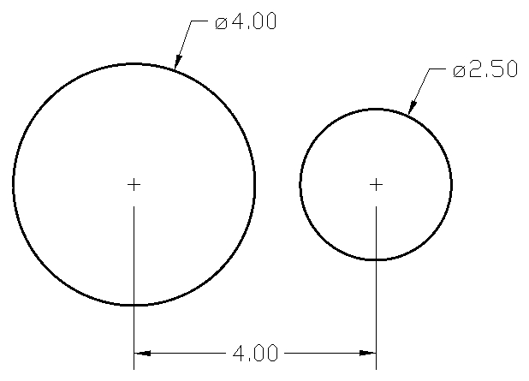

Step 5 → Insure the TANGENT object snap is active
- Use the OSNAP command (or similar) to display the Object Snap dialog box
  - Make sure the TANGENT object snap is active
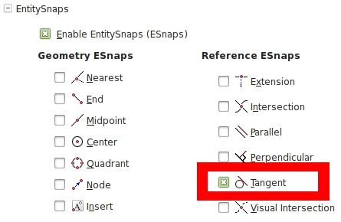

Step 6 → Draw two tangent lines
- Use the LINE command to draw two lines.
  - Each line will be tangent to the circles
  - Pick the endpoints of the line where shown:

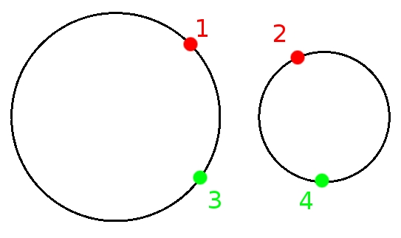

Your model should look like this:
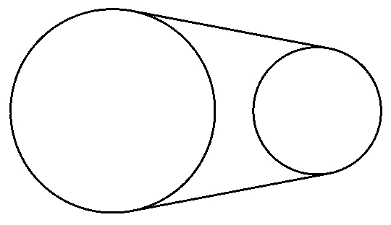

Step 7 → Trim the circles
- Use the TRIM command
  - Select the two lines as the cutting edges
  - Select the circles where shown as the objects to trim
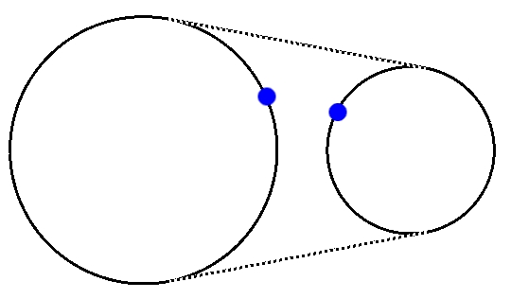
Your model should look like this:
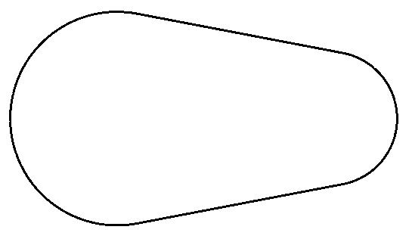

Step 8 → Convert the closed loop to a Polyline
- Use the POLYLINE command (or similar)
  - Select only one object (either one line or one arc)
  - When the CAD software indicates “This object is not a polyline. Do you want to turn it into one?,” answer “Yes”
  - Select the JOIN option
  - Select all objects
  - End the command

Note: visually, your model will look the same but when all the items are joined together into one polyline, the object behaves differently (the two lines and arcs will behave as if they are “one object”).

Step 9 → Offset the polyline
- Use the OFFSET command
- Enter an offset value of 0.25
- Identify the object to offset by picking anywhere on the polyline
- Identify the side to offset by picking anywhere outside the closed loop

Your model should look like this:
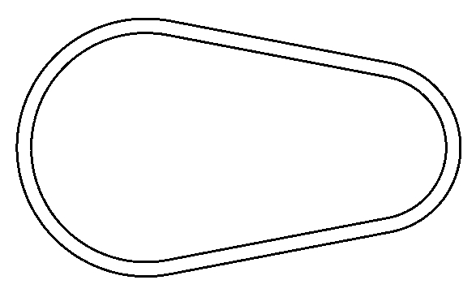

Step 10 → Create a block from the two polylines
- Use the BLOCK command (or similar)
- Select both polylines
- Use the following options:
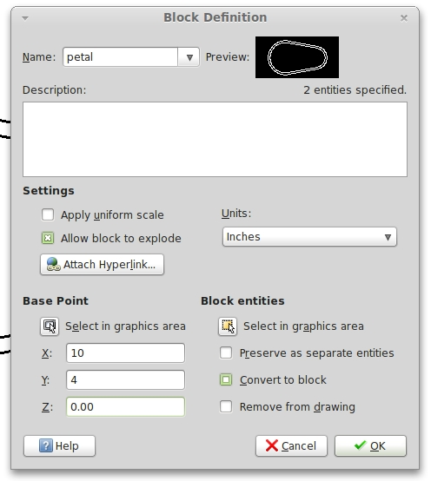

Step 11 → Create a radial pattern using the block
- Use the ARRAY or PATTERN command (or similar)
- Select the block
- Use the following options to complete your model:

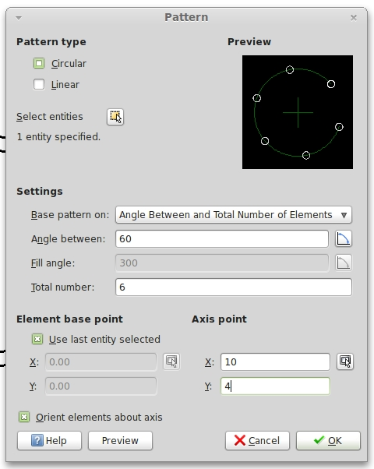

Step 12 → Display your model
- Use the ZOOM command (or similar)
  - Use the EXTENTS option

Your completed model should look like this:

