Skills Assessment
Geometric Construction Using CAD Sketching
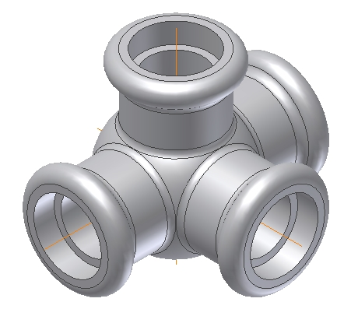
Culminating Performance Task

The following model will be created:

Study the following drawing before creating this model. Notice this part is symmetrical along a horizontal and vertical axis. This means only a fourth of the model will be created, then two mirror commands are used to duplicate geometry. The part is then completed by adding a cut in the middle.

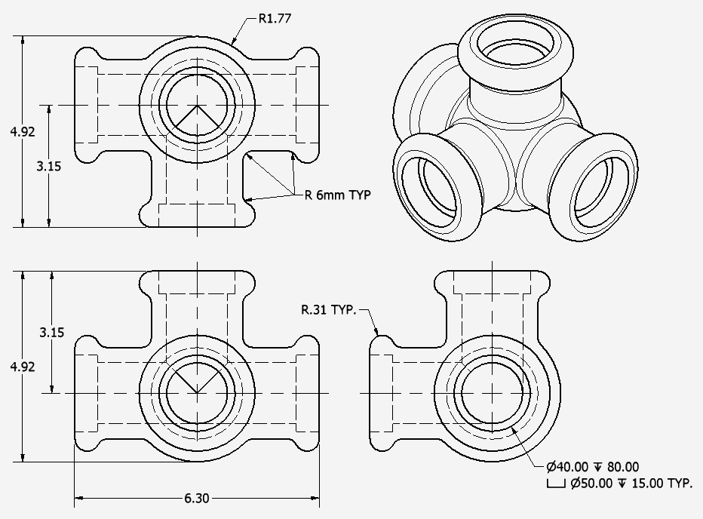

Create a Part file
- Select a format setup for inch units
- This takes you into the Sketch environment automatically

Create the following sketch then revolve it 360 degrees along the vertical axis.
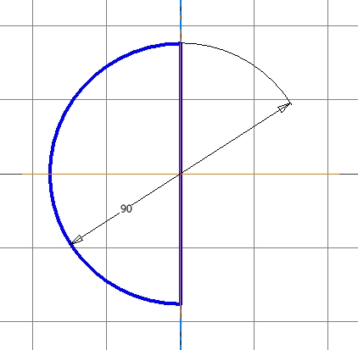
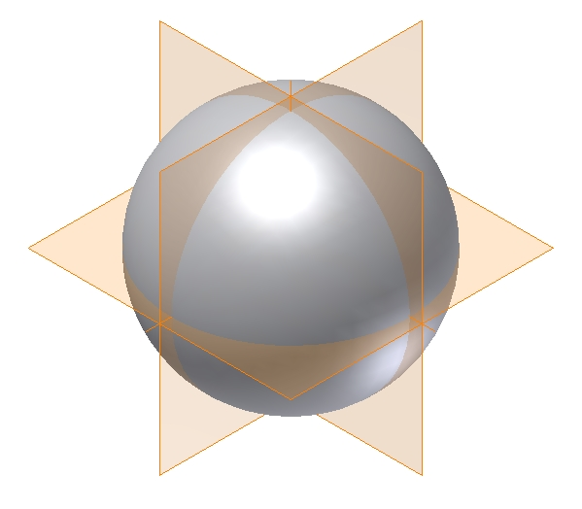
Your model should look like this

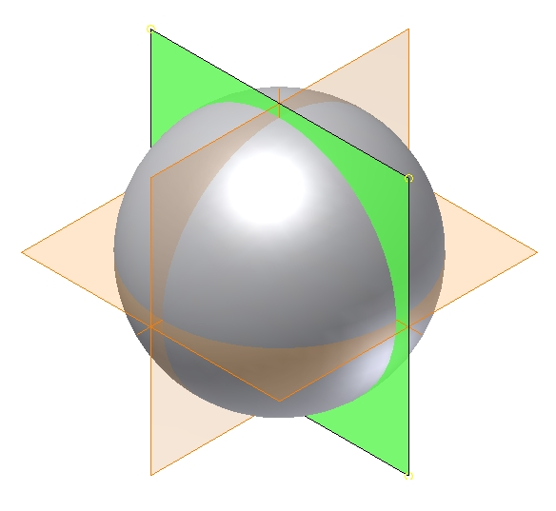

Create a new 2D Sketch – select the highlighted datum plane to locate the sketch:

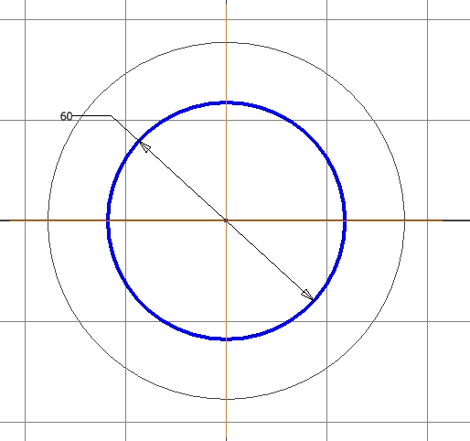
Create the 60mm diameter circle – make sure it is concentric with the sphere created earlier.

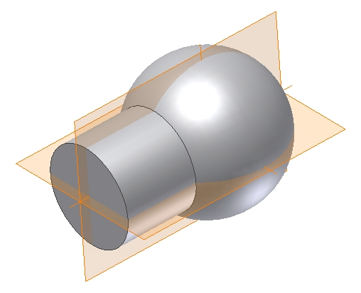

Extrude the 2D sketch a distance of 80mm
Your model should look like this:

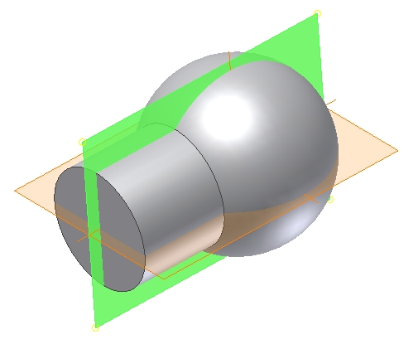

Create another 2D sketch located on the highlighted datum plane.

Create this sketch:
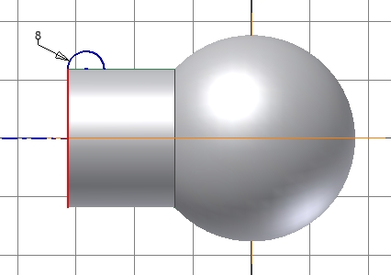

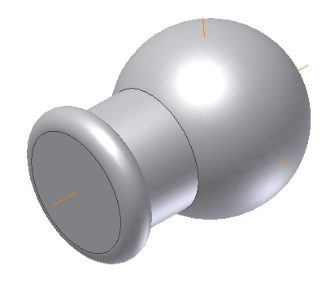
When the sketch is finished, create a revolved feature 360 degrees as shown.

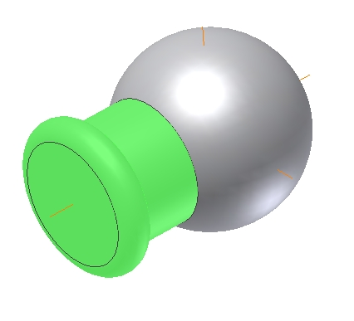
Create a radial pattern. Select the features highlighted.

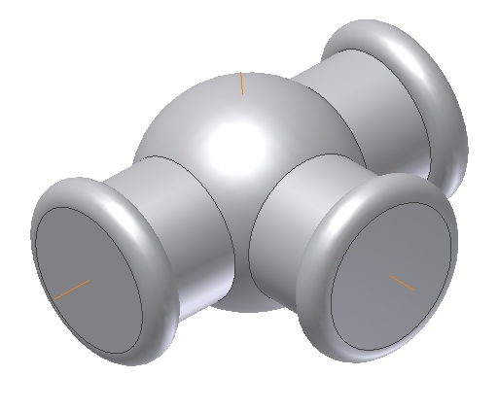

The radial pattern will fill 180 degrees with three instances as shown. Select the vertical datum axis as the axis of rotation for the radial pattern.

This radial pattern will fill 90 degrees with only two instances as shown. Select the horizontal datum axis as the axis of rotation for the radial pattern.
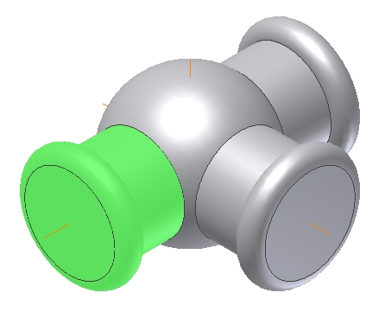
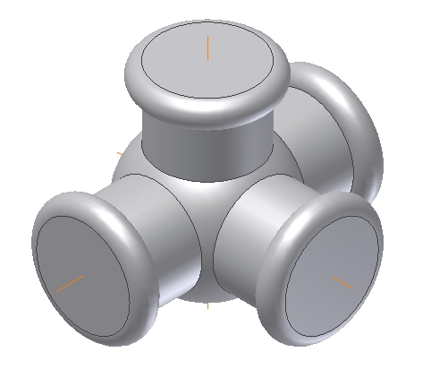

Axis of rotation for the radial pattern.

Create another radial pattern. Select the features highlighted.
Create a counter sink hole using the dimensions indicated (note hole depth is 80mm)
Pattern the hole like you patterned the other features.

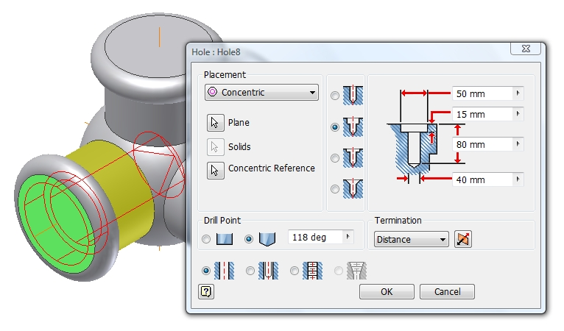
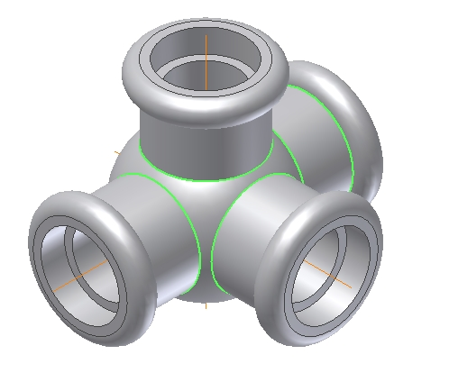
Create one round feature located on the eight edges highlighted. The radius will be 6mm.

The completed model

