Tutorial 1 Handout
Geometric Construction Using CAD Sketching

Show the following PowerPoint Presentations:
- 3D Parametric CAD Modeling PowerPoint
- Creating Geometry Using 3D PSM PowerPoint
Instructor Presentation
- Creating a simple part using recommended guidelines
  - The following exercise will illustrate how a simple 3D solid CAD model can be created using parametric solid modeling software.
  - The instructor will demonstrate and explain all steps and procedures
Students Create the Model
- Students will use 3D parametric solid modeling (PSM) CAD software to create the model

The following model will be created:
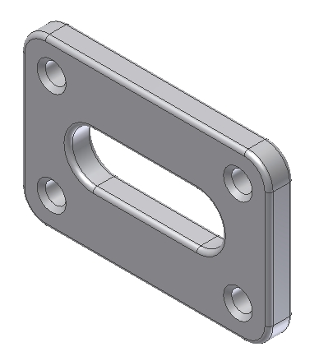

Follow the steps in this document to insure the geometry is created in logical order. Defining geometry this way allows the CAD user to change dimensions and see the results. This is one example of parametric modeling. Also, this model will illustrate how variations of a model can be created by supressing or unsuppressing features.

Study the following drawing before creating this model:

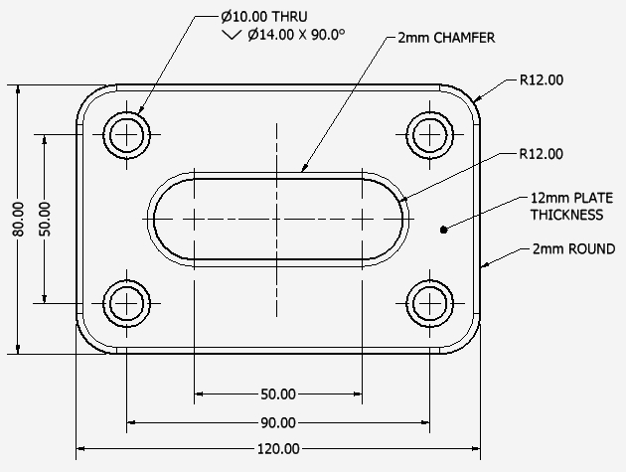

Create a Part file
- Select a metric format and insure units are millimeters
- This takes you into the Sketch environment automatically

Create the following sketch:
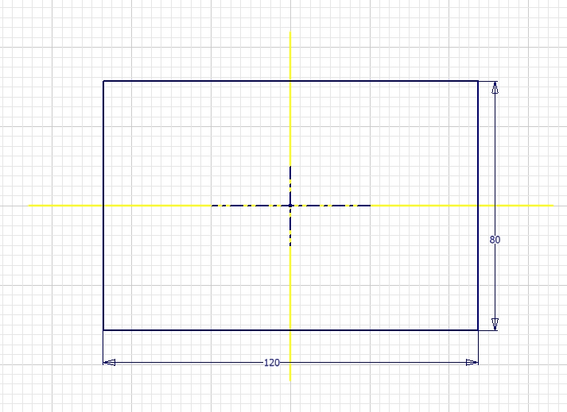
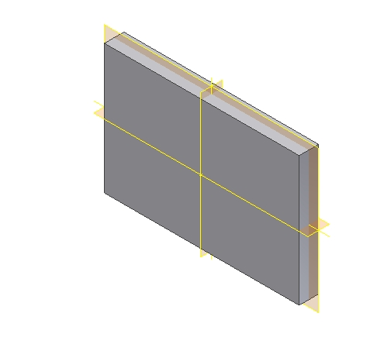
When you complete the sketch, exit the Sketch environment and extrude the 2D section a distance of 12mm from both sides of the sketch plane. Your model should look like this when finished:

Create another sketch
- Select the large front surface as the sketch plane
- Define the following sketch
  - 2 center lines
  - 2 lines
  - 2 arcs
  - 2 dimensions
- Align the center lines to the vertical and horizontal datum planes
- The edges of these planes are perpendicular to your sketch view
- Insure the arcs and lines are symmetrical to the sketched center lines
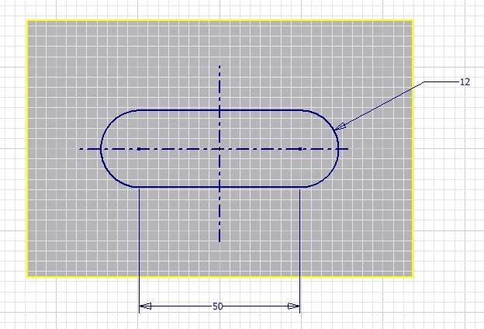
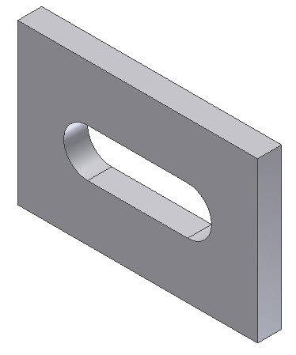
Use this sketch to create an extruded cut so your model looks like this:

Create a 12mm diameter straight hole which goes through the plate:
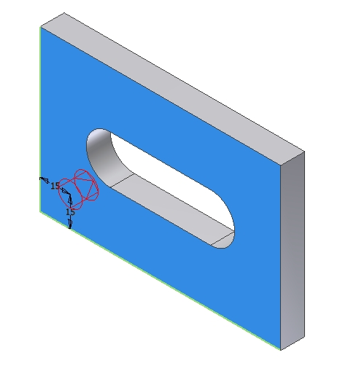
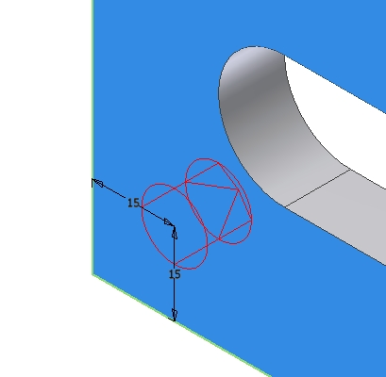

Create one linear pattern of the hole in two directions:
- Create 2 horizontal instances 90mm apart
- Create 2 vertical instances 50mm apart
- Your model will have a total of four holes and should look like this:

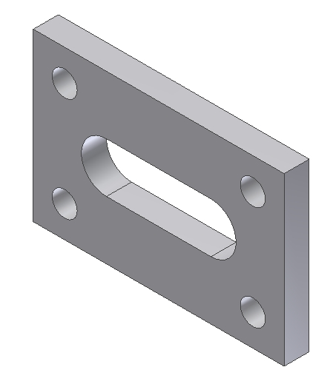
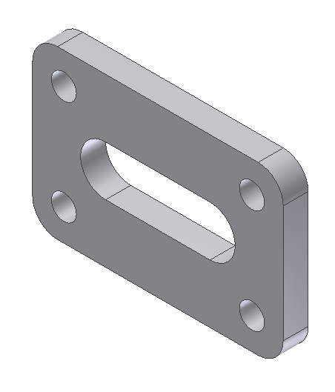
Use one round feature to place four 12mm rounds at each corner of the model as shown:
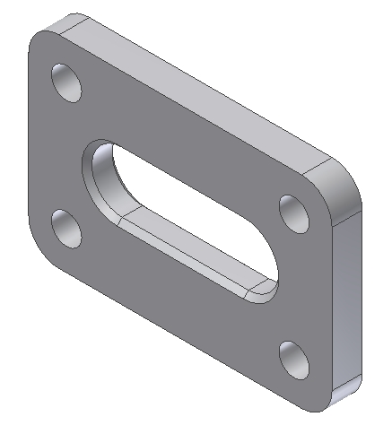
Use the chamfer feature to create a 2mm chamfer as shown.
- Place the chamfer onto all of the front and back edges of the cut
Create one round feature
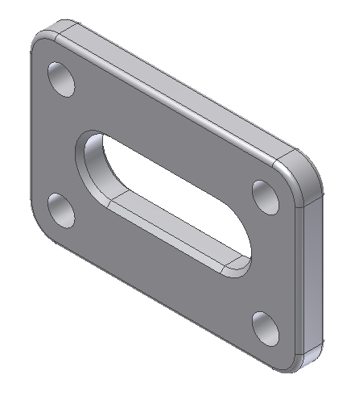
- Place a 2mm round along the front and rear outside edges as shown:

Change the first hole created
- Select a counter bore hole with the following information:
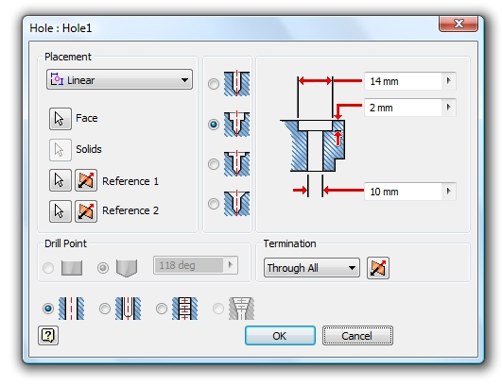

Your model should now look like this:

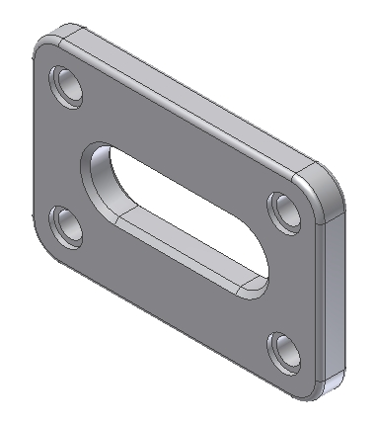

Create a variation of this model
- The chamfer located on the cut in the middle of the part will be suppressed
- Add a 2mm round to the edges where the chamfer is located.
- Your model should now look like this:

