Tutorial 2 Handout
Geometric Construction Using CAD Sketching

The following model will be created:

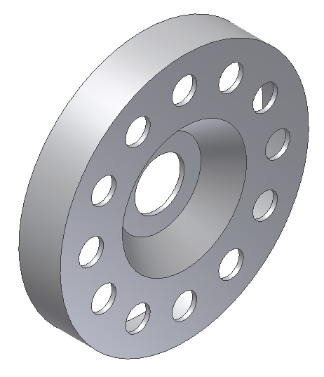

Create a Part file
Select a metric format and insure units are millimeters
This takes you into the Sketch environment automatically

Create the following sketch:

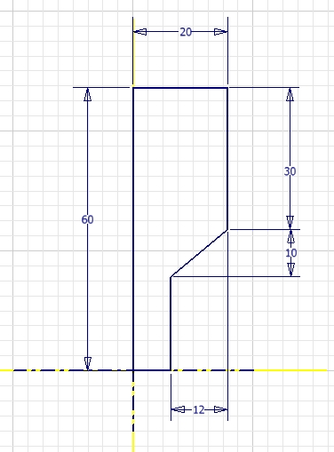

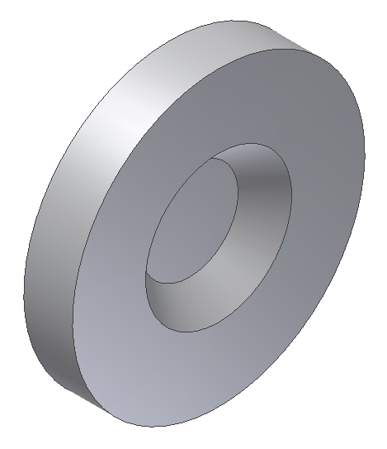
Revolve the 2D section 360 degrees.

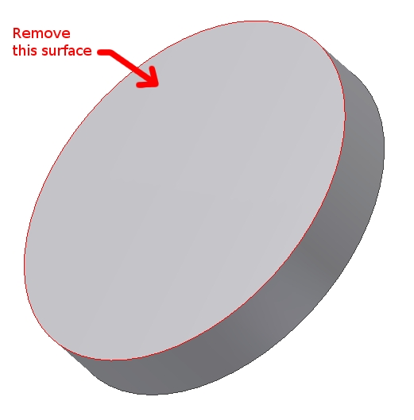

Spin the model around and select the shell feature. Remove only the surface shown, and then indicate a shell thickness of 2.0 mm.

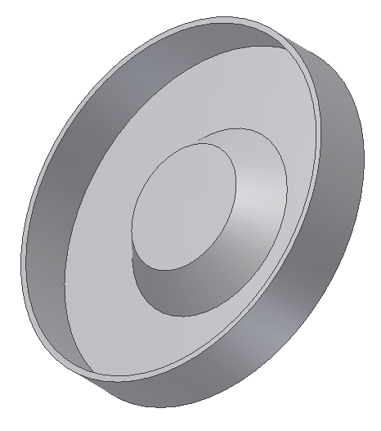
Your model should look like this.

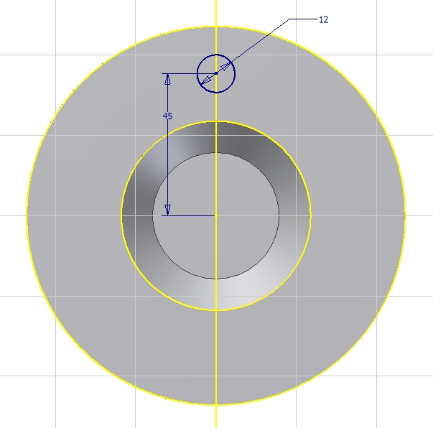

Spin the model back around to show the front, and sketch this section on the front surface.

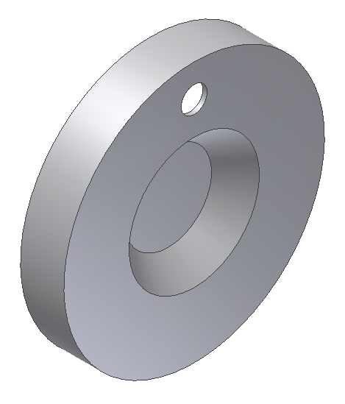
Extrude the section, removing material as shown.

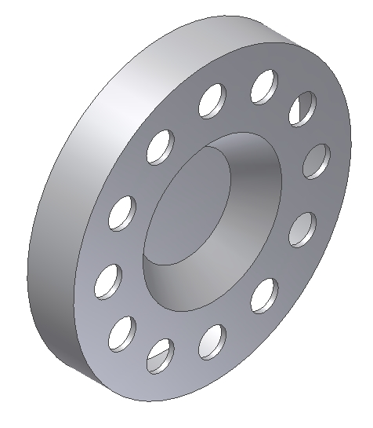

Use the pattern tool to create a radial pattern with twelve instances of the cut.

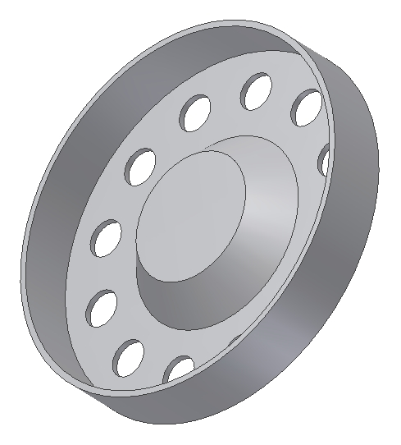

Spin the model again so the back of the model is visible.

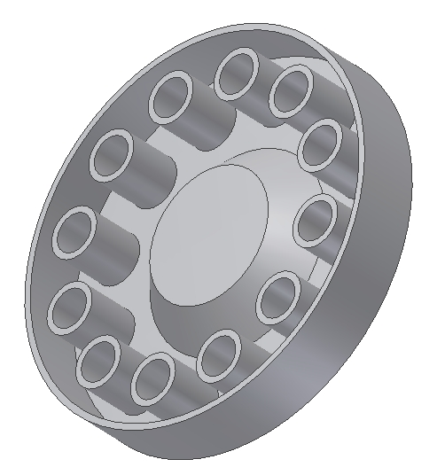

Reorder the shell so it's located before the hole cut that was patterned. Your model should look like this:

Relocate the shell feature again so it's the last feature, and then create a hole with a diameter of 24.00 mm.

