Tutorial 3 Handout
Geometric Construction Using CAD Sketching

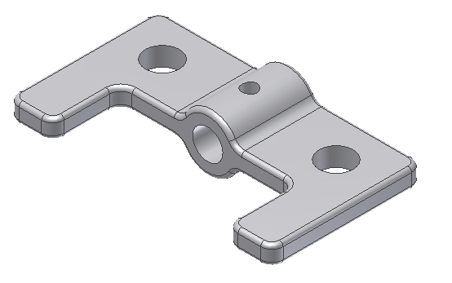
The following model will be created:

Study the following drawing before creating this model:
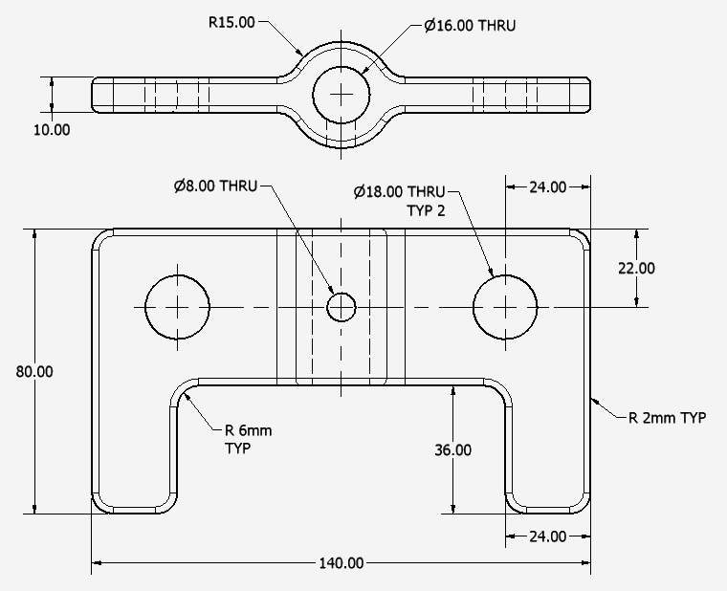

Create a Part file
- Select a metric format and insure units are millimeters
- This takes you into the Sketch environment automatically

Create the following sketch – make sure the left and right sides are symmetrical along the vertical center line.

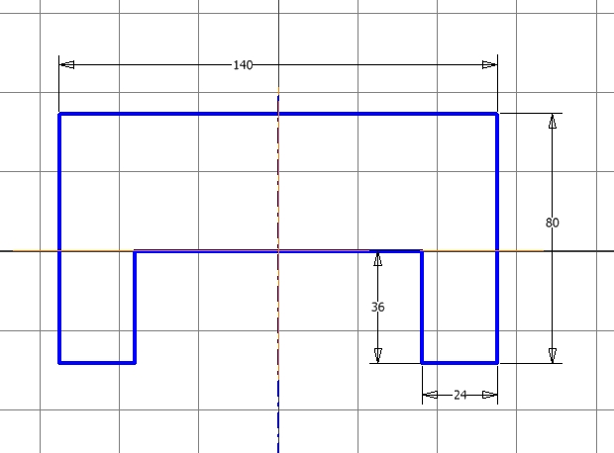

When you complete the sketch, exit the Sketch environment and extrude the 2D section a distance of 12mm from both sides of the sketch plane. Your model should look like this when finished:

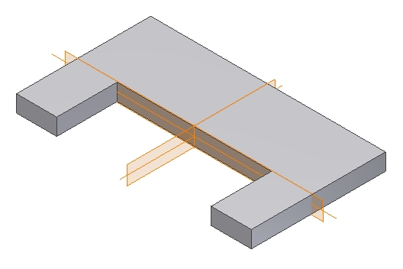

Create another 2D Sketch – select the highlighted surface to locate the sketch:

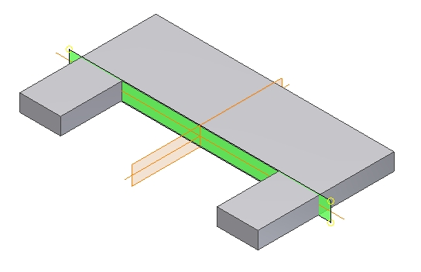

Sketch the following – make sure the circle is centered along the intersection of the datum planes as shown:

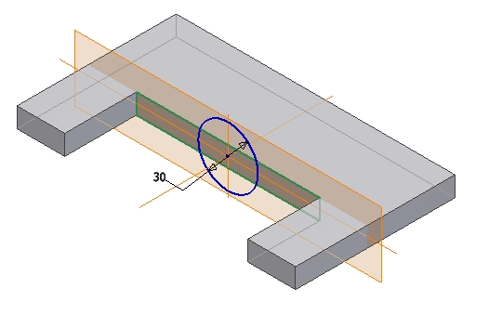

Extrude the sketch until it stops at the rear edge of the model. Your model should look like this:

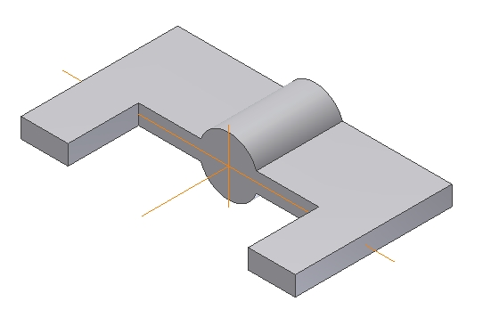

Create a 16.00 mm straight hole as shown. Indicate the hole depth as “through all” or equivalent.
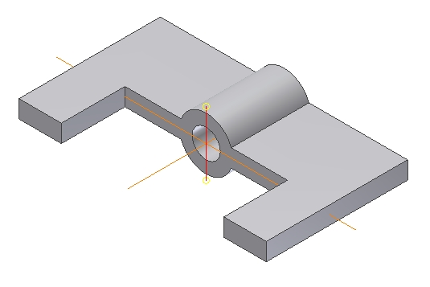

Add a 6mm round to the four edges as shown:
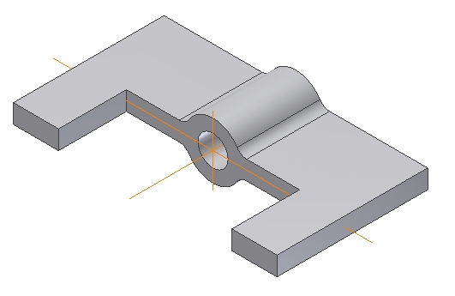

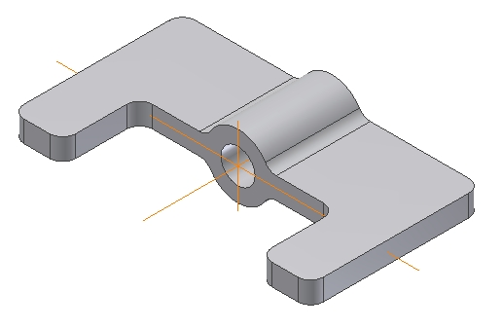
Add a 6mm round to the eight edges as shown:

Add a 2mm round to the edges along the top and bottom of the model – use the “Loop” option to quickly select all edges.

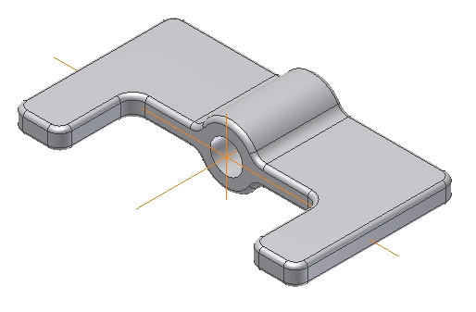

Study the drawing on page 2 of this document to locate the hole as shown:
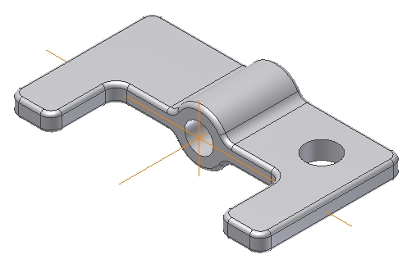

Mirror the last hole along using the vertical plane as the mirror reference.
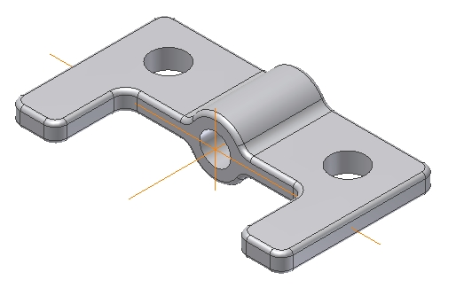

Create another 2D sketch. Select the highlighted datum plane to locate the sketch.

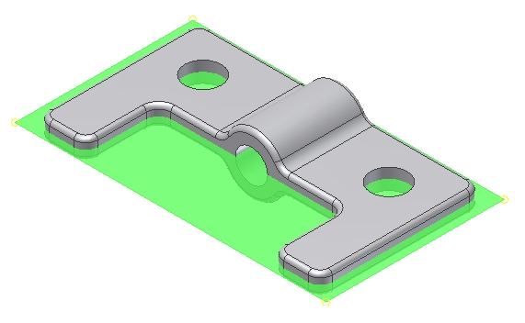

Define the sketch using an 8mm circle located as shown. Make sure the center of the circle is aligned with the center of the hole as shown:

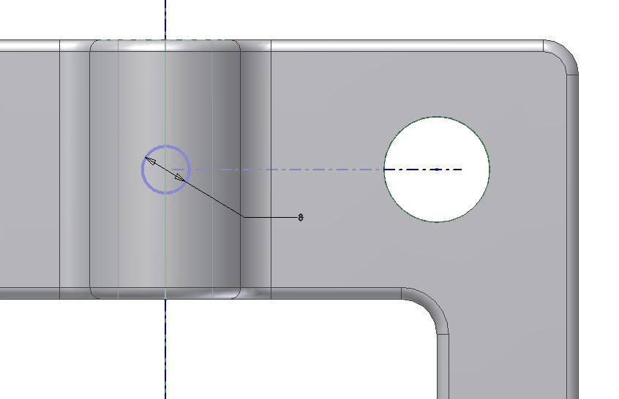

The Completed Model

Additional exercises:
(1) Change the first 18mm diameter straight hole to a counter bore hole
(2) Change the thickness of the first extruded feature
(3) Suppress the last set of rounds and add 2mm chamfers to the edges instead. This will create a design variation of the model allowing two versions. Note: Either the 2mm rounds or the 2mm chamfers or both will have to be suppressed in order to keep the geometry from experiencing regeneration errors.

