Tutorial 4 Handout
Geometric Construction Using CAD Sketching

The following model will be created:

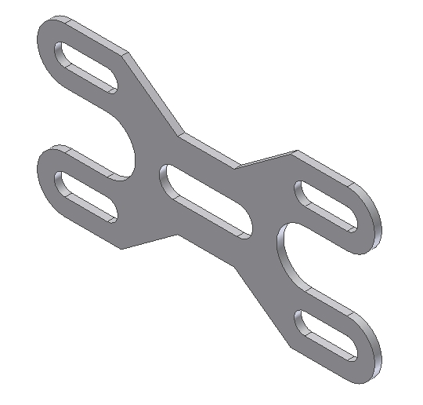

Study the following drawing before creating this model. Notice this part is symmetrical along a horizontal and vertical axis. This means only a fourth of the model will be created, then two mirror commands are used to duplicate geometry. The part is then completed by adding a cut in the middle.

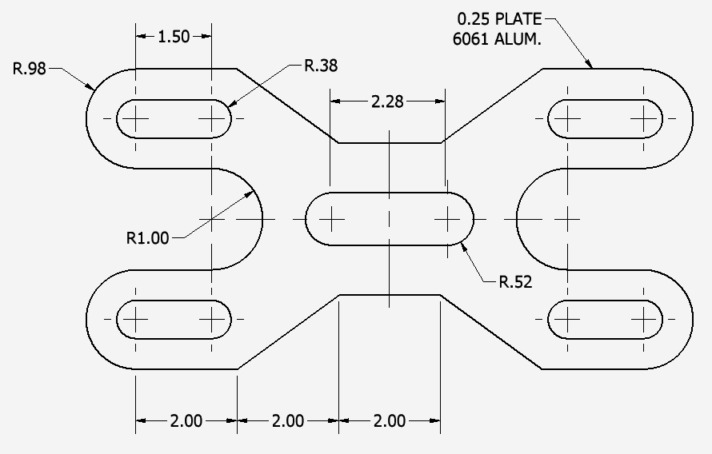

Create a Part file
- Select a format setup for inch units
- This takes you into the Sketch environment automatically

Create the following sketch:
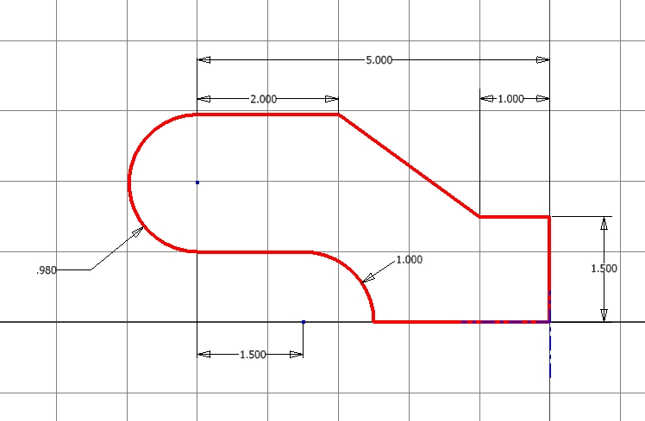
When you complete the sketch, exit the Sketch environment and extrude the 2D section a distance of 0.25 from both sides of the sketch plane. Your model should look like this when finished:
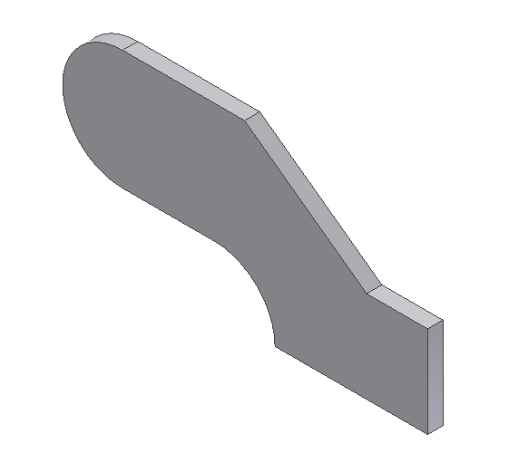
Create a new sketch located on the green surface:

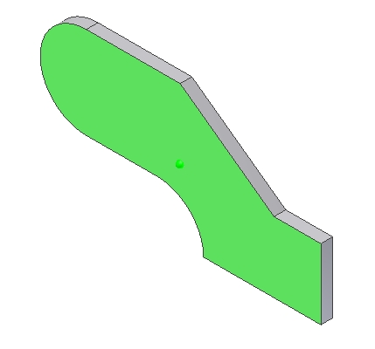

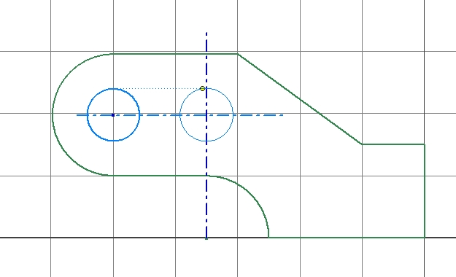
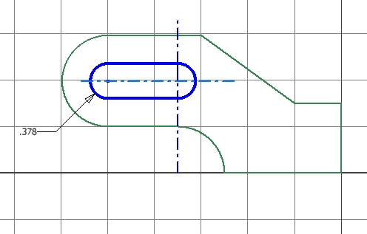
Create the centerlines and constrain them to the arcs from the first feature.

Create two circles, then add two horizontal lines.

When completed, your sketch should look like this:

After finishing the sketch, create a cut as shown.
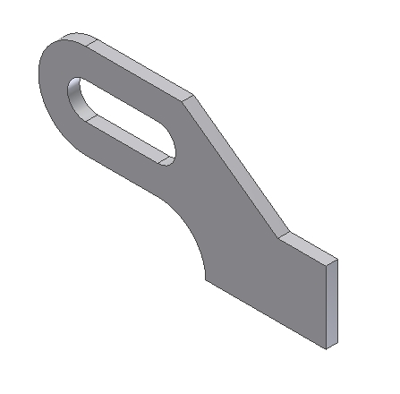

Mirror both features, selecting the plane shown as the mirror plane.

Mirror plane

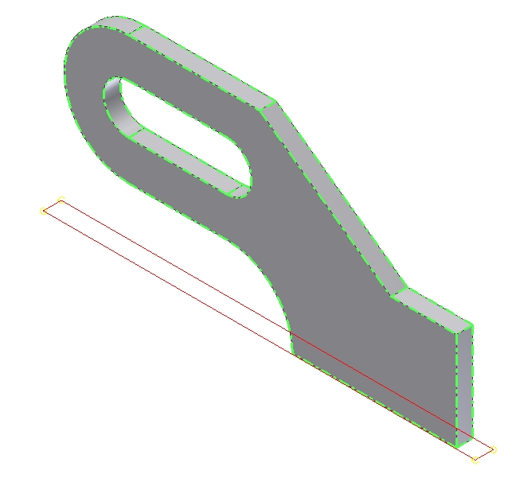

Mirror the first two features and the mirrored features. Select the plane shown as the mirror plane.
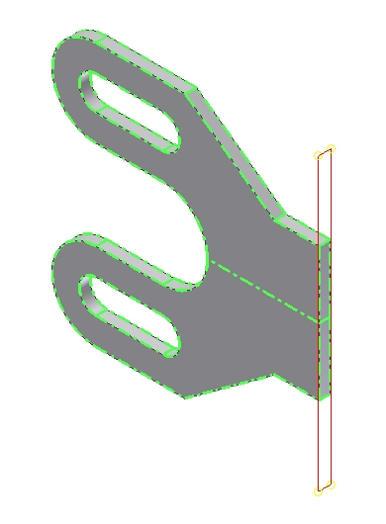

Mirror plane

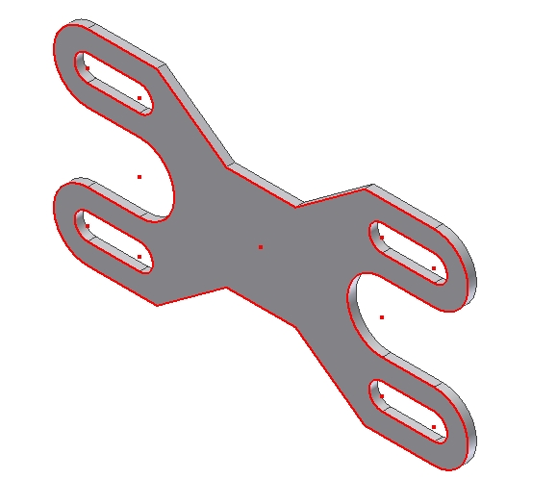

Create a sketch for the center cut. Locate the sketch on the highlighted surface:

Define the following sketch. Align the horizontal and vertical center lines to either the default datum planes or axes.

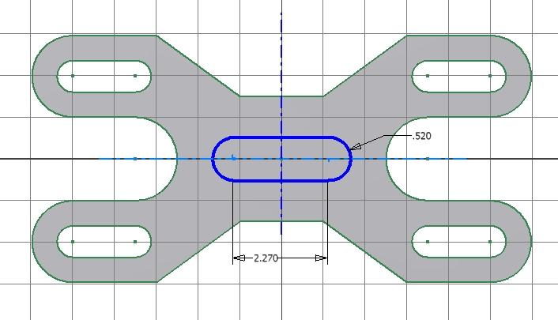

The completed model:

