Career Vocabulary
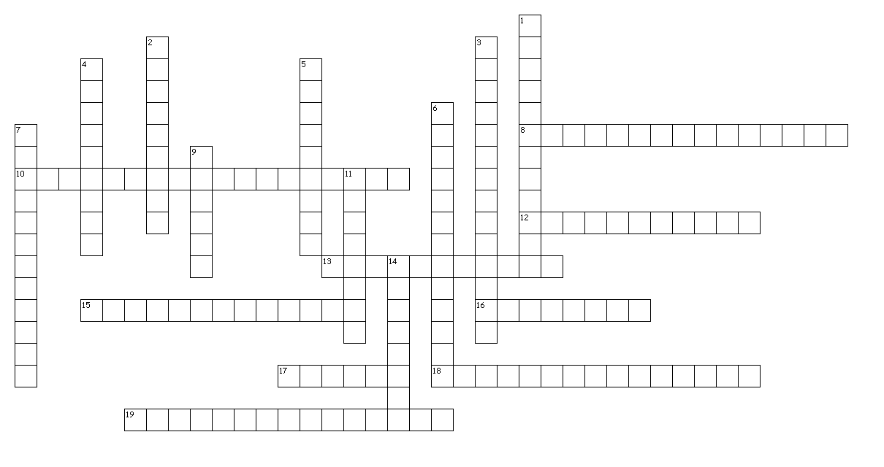

Across

8. Achievements during a career
10. A summary of your career aspirations, what you expect from a job, and what you have to offer the employer, usually found under your contact information on a resume
12. Concrete, descriptive verbs to express skills, assets, experiences, and accomplishments
13. A letter that accompanies a resume to explain or commend
15. To form or mark differently from other such things; to distinguish
16. To present yourself with excessive or unwarranted enthusiasm and to over-praise yourself for a job
17. Financial compensation an employee receives for performing a job
18. Tailoring one’s attire, grooming, and overall appearance toward making a great first impression in a job interview
19. Used by employers to verify the accuracy of the information provided on a resume or job application

Down

1. Nonverbal communication through the use of postures, gestures, and facial expressions
2. A broad-based verbal questioning of a job applicant by a potential employer to see how well the applicant communicates
3. Form completed by a potential employee to signify his interest in a job
4. Conventional requirements of social behavior and conduct in a professional practice
5. A person to whom one refers for testimony as to one’s character and abilities
6. Having more education, training, or experience than is required for a job or position
7. A person who belongs to and conforms to the standards of a profession
9. A brief written account of personal, educational and professional qualifications and experience
11. A person or business that hires one or more people, especially for wages or salary
14. A person working for another person or a business firm for pay

Created by Puzzlemaker at DiscoveryEducation.com


