Auxiliary Views Cryptogram

Each letter is replaced by a different letter.

You are given A, E, and I. See if you can figure out the phrase.

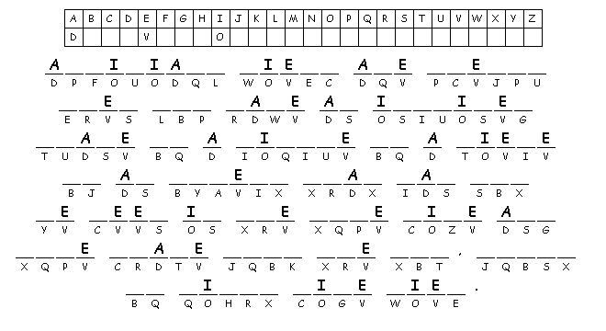

Created by Puzzlemaker at DiscoveryEducation.com

