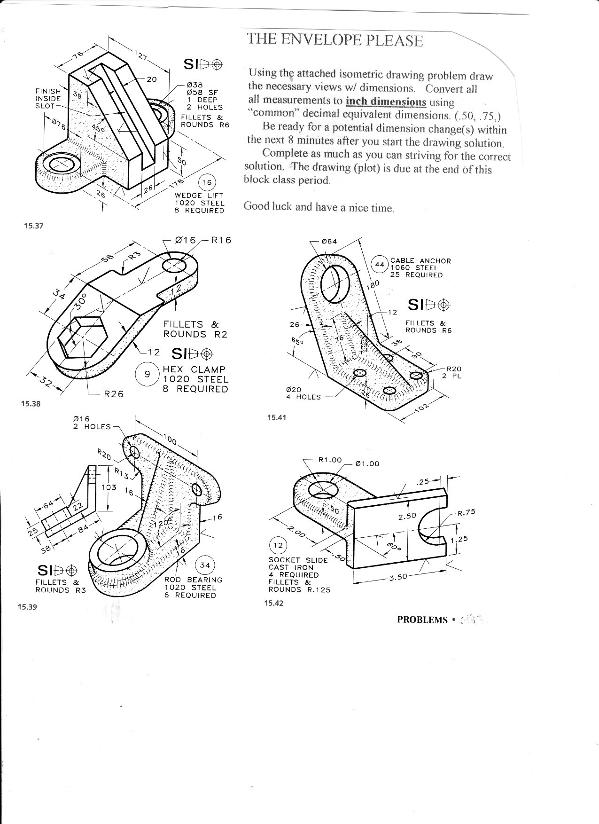
For the following isometric drawing problems, draw the necessary views with dimensions.
Convert all measurements to inch dimensions using common decimal equivalent dimensions.
Prepare for additional dimension changes after drawing the solutions.

