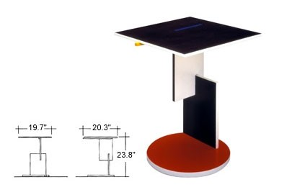
Construct an assembly drawing on your own interpretation of a Reitvelt Schroeder design style table. Suggested measurements are provided.

Be sure and make a companion Bill of Materials for all parts.



