Day 1 Assignment
Manufacturing Processes & Materials

Students Create The CAD Model
- The following shampoo container is an assembly comprised of two parts: a bottle and a cap. Both parts are formed from plastic – the top part is formed by injection molding, the bottle is blow molded. We will be creating geometry representing the cap and bottle. A few details from the CAD model have been omitted from this exercise. The blow molded bottle will be modeled first, then the injection molded cap will be created.

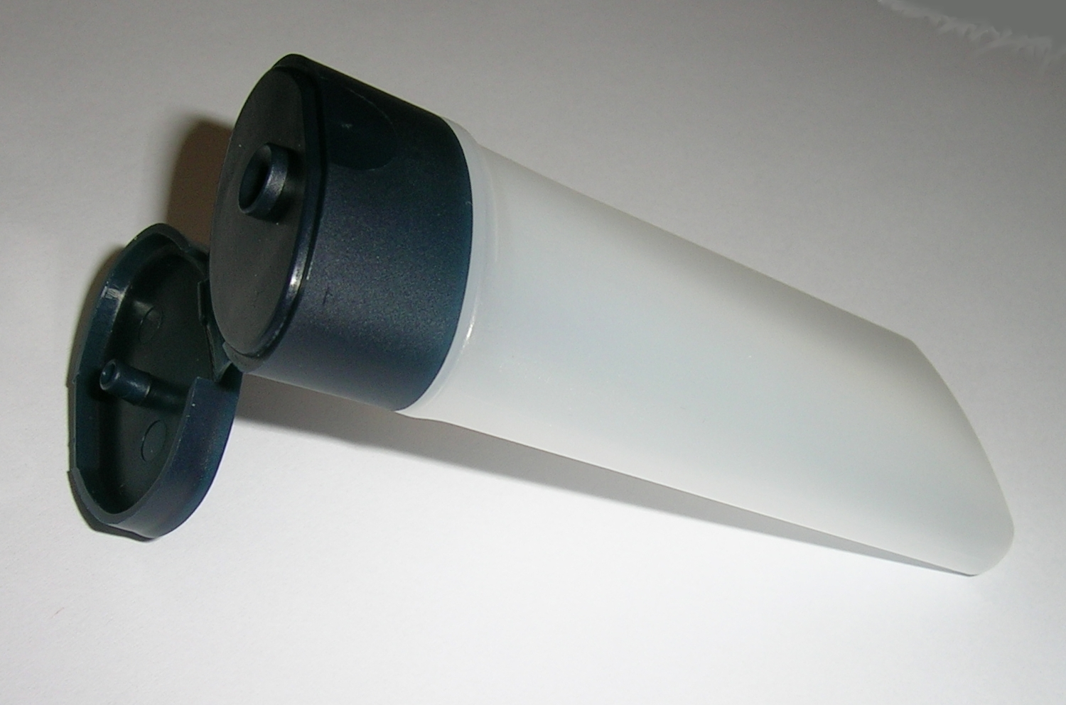
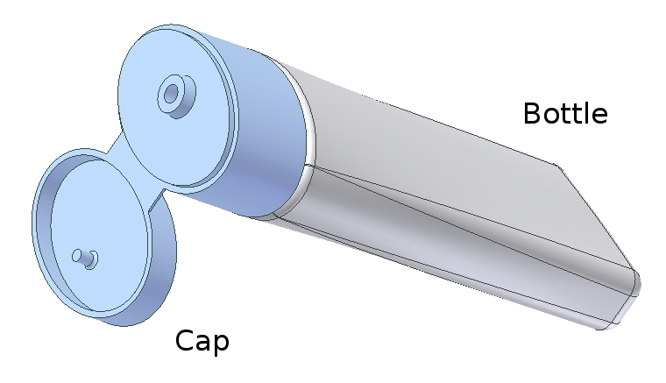
Study the following drawing before creating these part files:
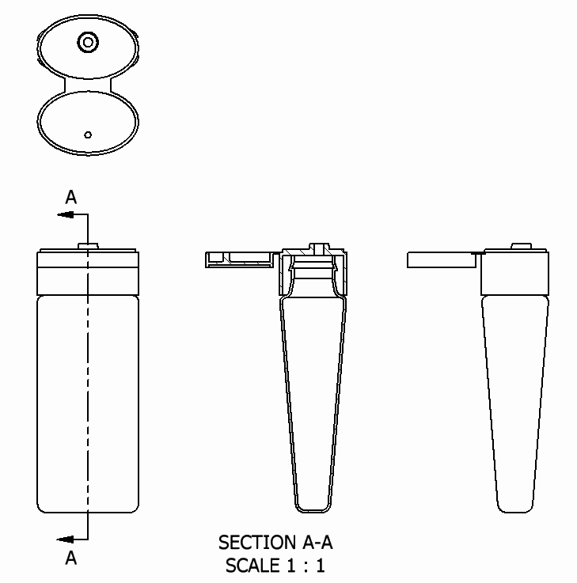
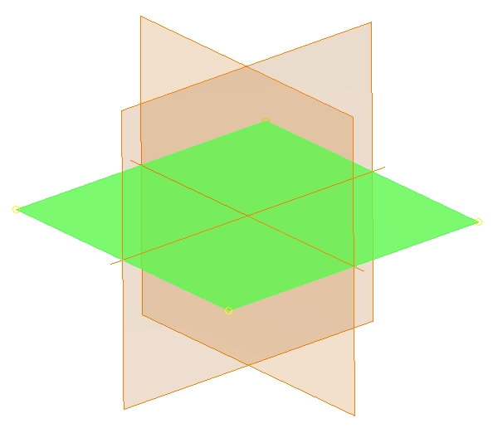
Creating the Blow Molded Bottle
Create a Part file
– Select a metric format and insure units are millimeters

– Create a work plane 71mm above the highlighted default datum plane

Create the following sketch located on the same plane used to create the offset datum plane.

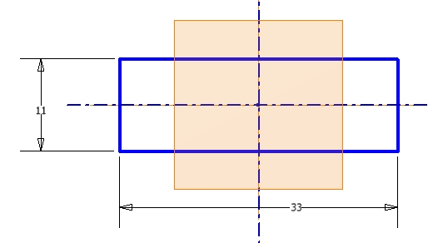

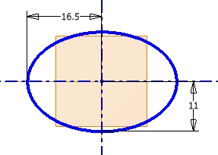
Create the following sketch located on the new offset datum plane.

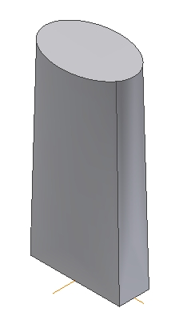

Use the Loft command to create the following feature. Select both of the last two sketches to define the loft feature.

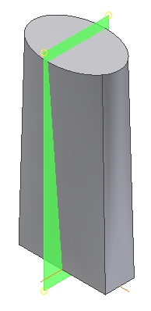

Select the highlighted datum plane to locate another 2D sketch.

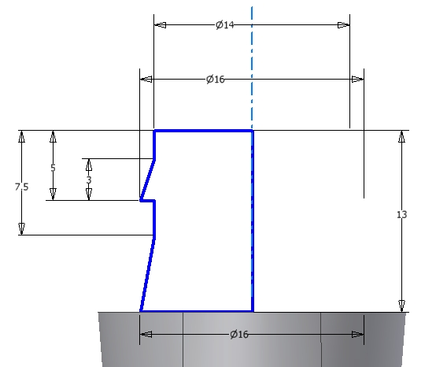
Sketch the following geometry. When finished, revolve this section 360 degrees.

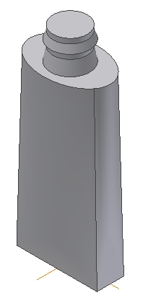

With the previous sketch revolved 360 degrees, your model should now look like this.

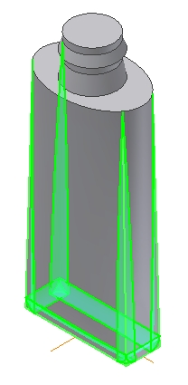

Place a 3mm round on the edges highlighted.

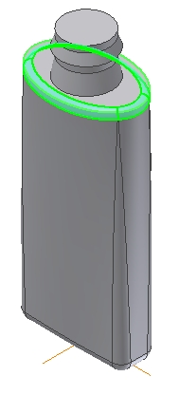

Place a 2mm round on the edge highlighted.

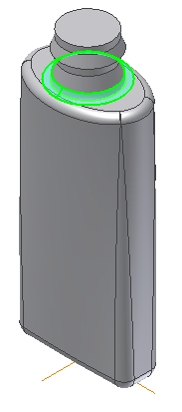

Place a 2mm round on the edge highlighted.

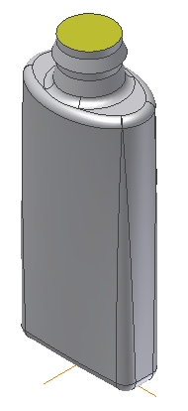

Make the model “hollow” by using the Shell feature. Select the highlighted surface to be removed from the shell. Define a shell thickness of 0.8mm.

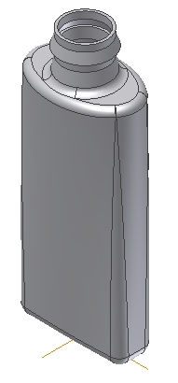

Your part model is finished and should look like this.

Create a Drawing file using an A-Size format then create these three views. Dimensions and other notations will be added later.

