Day 2 Assignment
Manufacturing Processes & Materials

The following model will be created
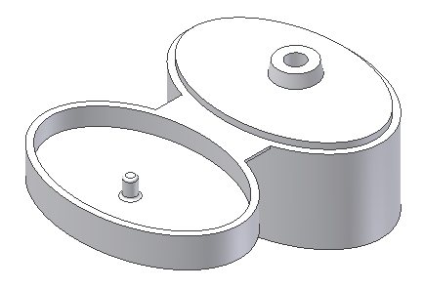

This part is the top of a very small shampoo bottle. It's made from injection molded plastic. Many of the actual details have been omitted from this exercise.

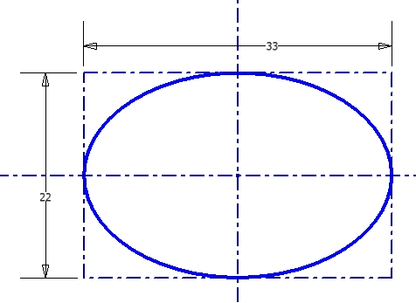

Create a part using millimeter units.

Define this sketch and extrude it 14mm.

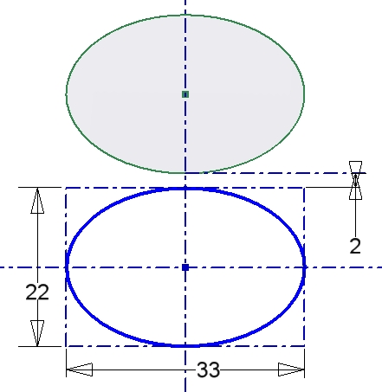

Create the top of the bottle cap by defining this sketch and extruding it 5mm. The tops of the two extrusions will be coplanar as shown.

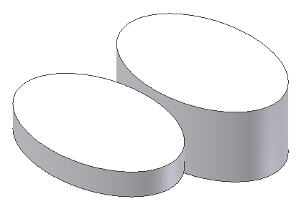

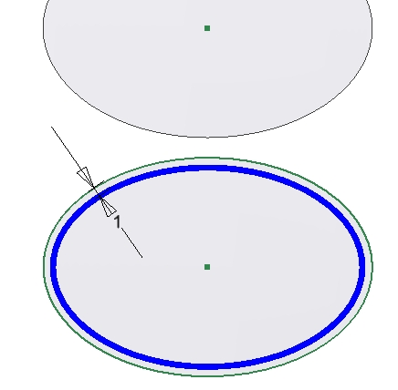

Create a cut by offsetting the outside edge of the top by 1mm.

Use this sketch to create an extruded cut 3mm

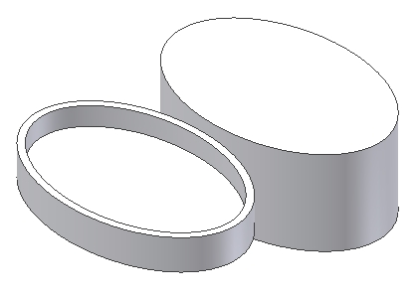

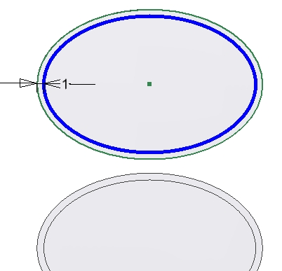

Create a ridge by offsetting another ellipse by 1mm, then creating an extruded cut 1mm as shown.

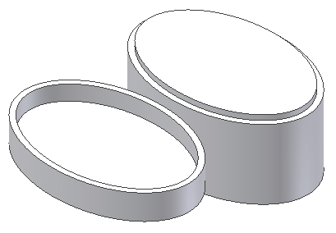

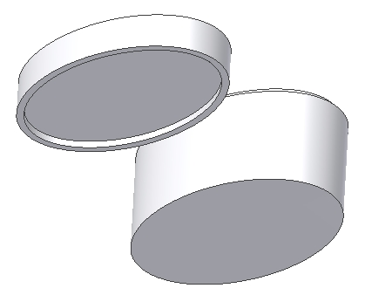
Spin the model so it's oriented like this. Create another 1mm offset ellipse and then create a cut that's also 1mm deep as shown.

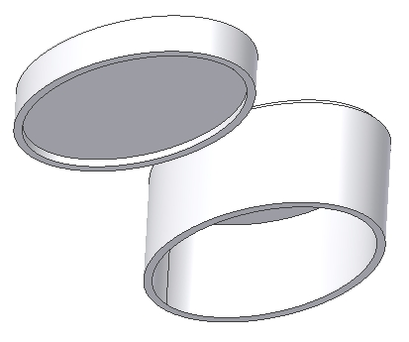

Create another 1mm offset ellipse and then create a cut that is 13mm deep as shown.

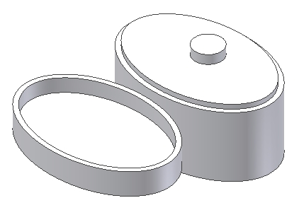

Create the protrusion. Define the following sketch, then extrude the circle 2mm.

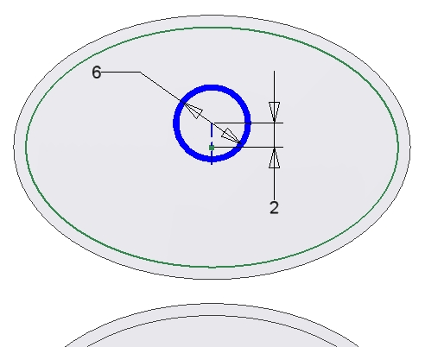

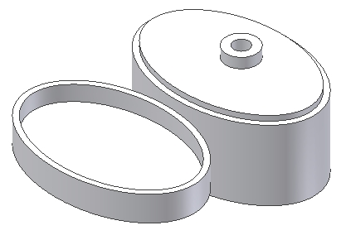
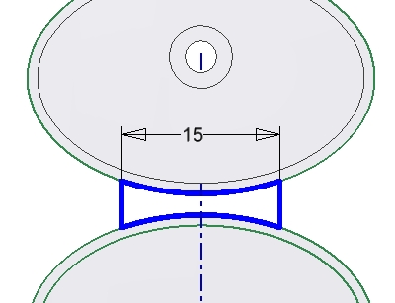

Define the sketch as shown to create the “living hinge” that joins the two disjoint features.

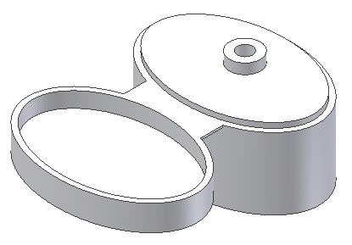

Extrude the sketch 0.4mm as shown

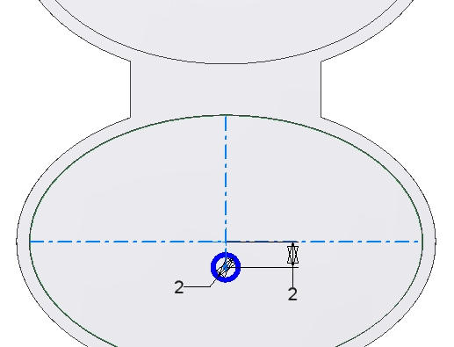

Create the sketch shown, then extrude it 3mm.

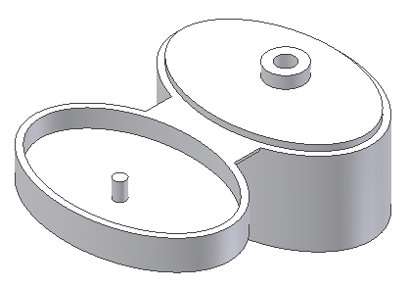

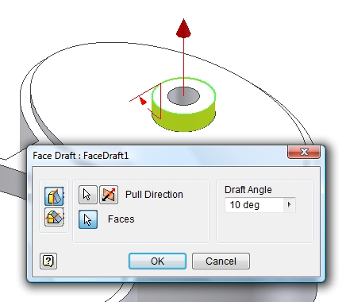
Create a draft feature as shown.

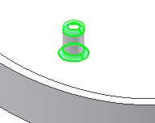

Add a fillet feature to the two edges shown highlighted. Enter a value of 0.4mm for the radius.

This completes the part model.

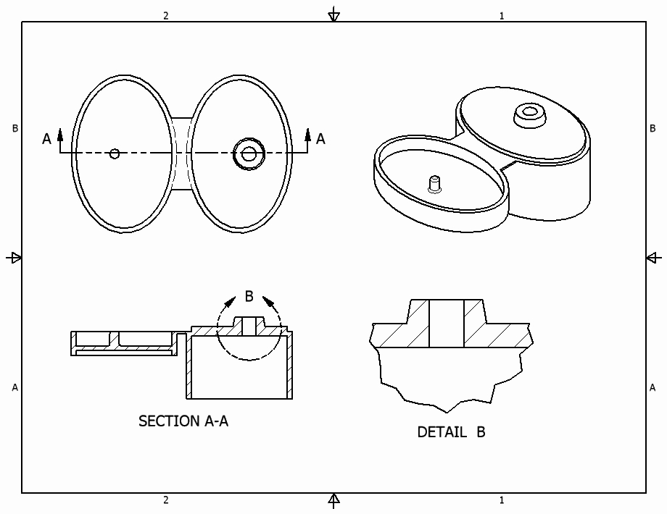

Create a drawing file, then create the orthographic, section, detail and other views to fully describe the part. Add all dimensions and notes necessary to create the working drawing.

