Day 3 Assignment
Manufacturing Processes & Materials

The following model will be created
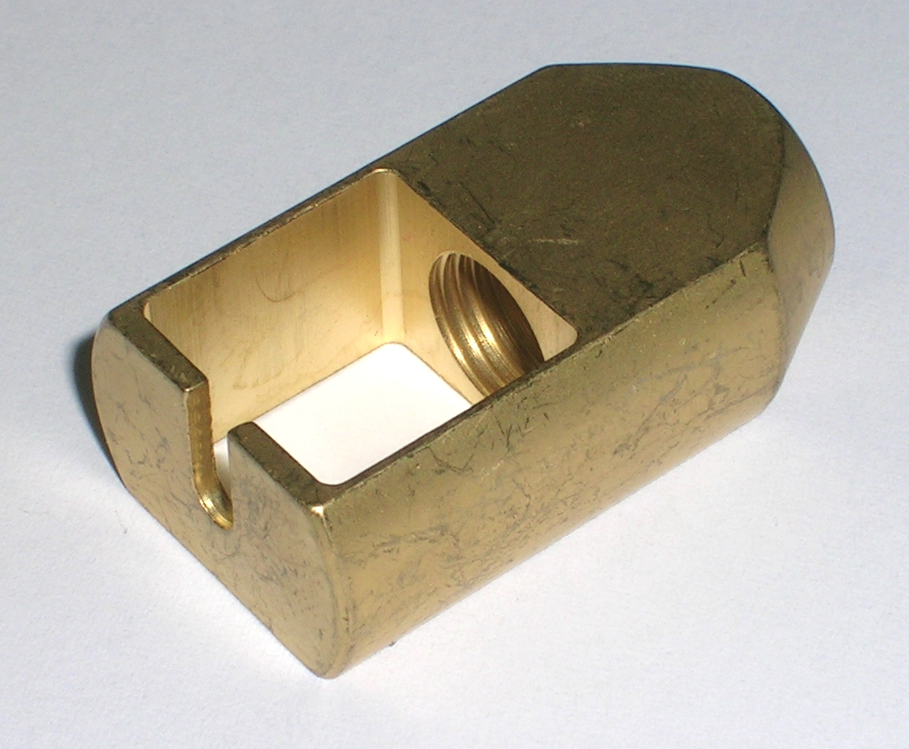
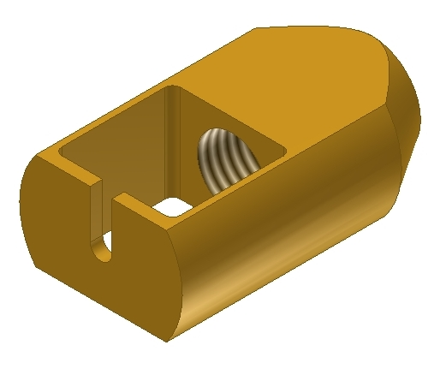

This is a machined brass part. Study the drawings, then create the part adding all features as shown. When the part is finished, create a working drawing. Create all necessary views, then add dimensions and notes to complete the drawing. When completed, your drawing model will look something like this:

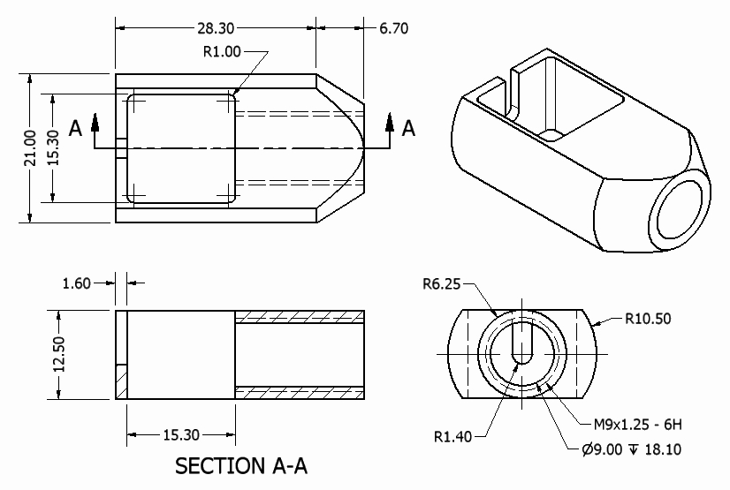

The following model will be created
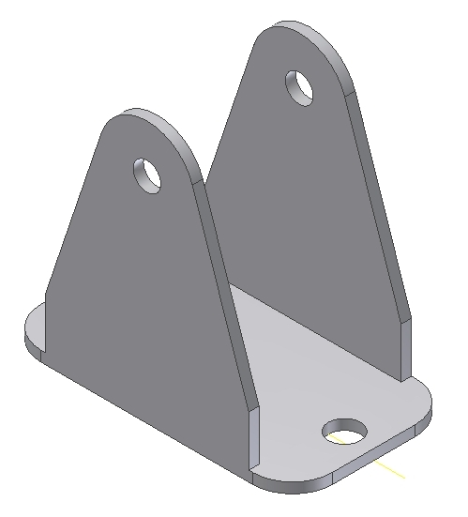
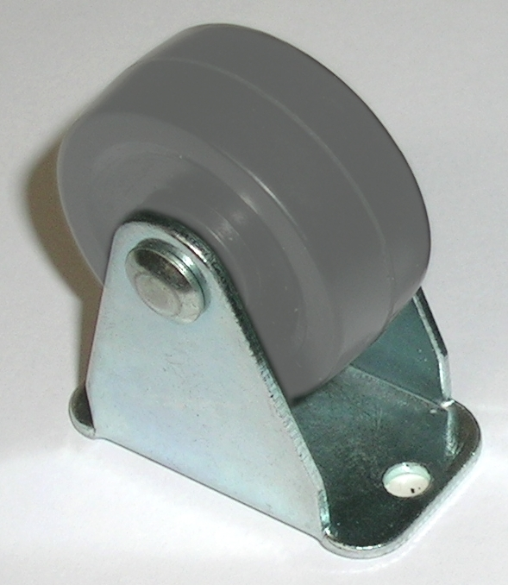

This is a sheet metal part. Study the drawings, then create the part adding all features as shown. When the part is finished, create a working drawing. Create all necessary views, then add dimensions and notes to complete the drawing. When completed, your drawing model will look something like this:

