Day 4 Assignment
Manufacturing Processes & Materials

The following parts will be created
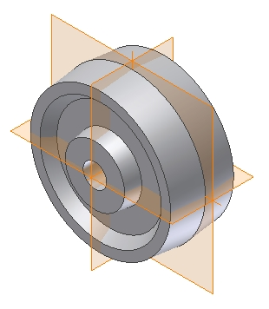

Caster Wheel

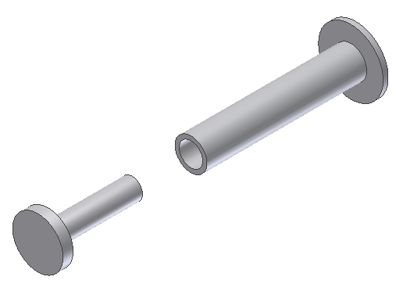

Fastener
Parts

This is an injection molded plastic part. Study the drawings, noting all dimensions are shown in millimeters. Create the part adding all features as shown. When the part is finished, create a working drawing. Create all necessary views, then add dimensions and notes to complete the drawing. When completed, views in your working drawing model may look something like this:

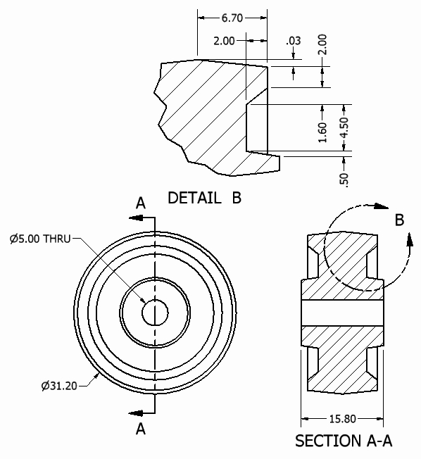

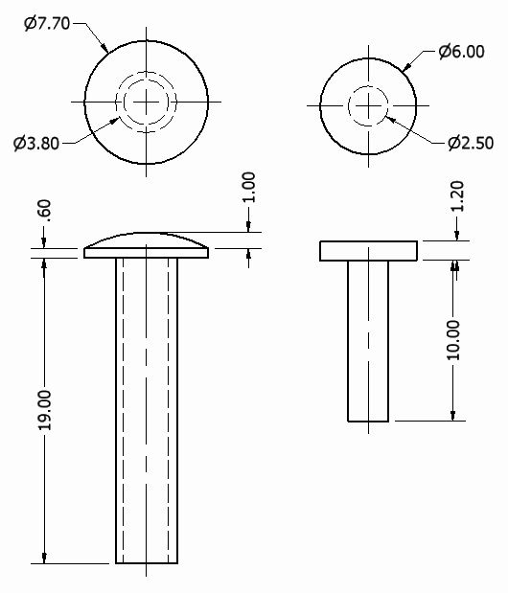

Create the following fasteners making each one a separate part file.

Use them in the caster wheel assembly.

Create the following caster wheel assembly.

When finished, place the caster wheel assembly into a drawing file then create a set of working drawings. Include necessary views, dimensions, and notes.

