Day 1 Assignment
Welding Design & Drawing

The following model will be created by first defining two separate part files. An assembly will be created with three parts added and located as shown. The assembly will be converted to a weldment, then fillet weld information will be added to the T-joints.

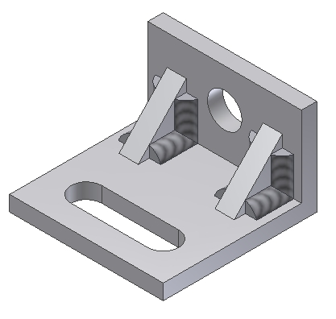

Study the following drawing before creating this model:

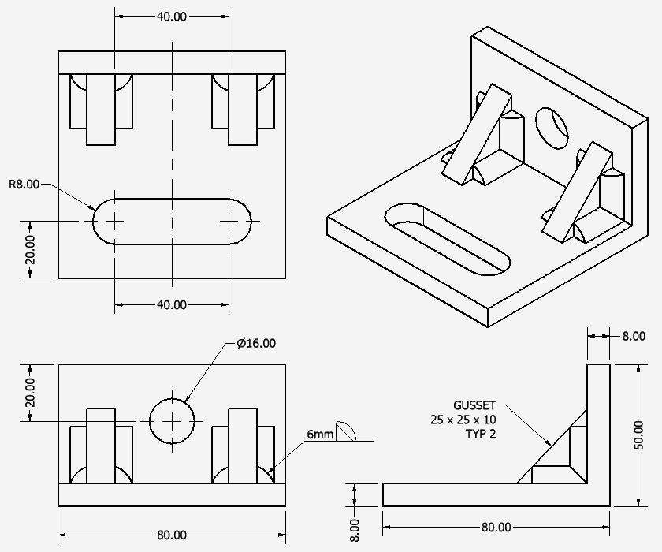

Create a Part file: “L Plate”
- Select a metric format and insure units are millimeters

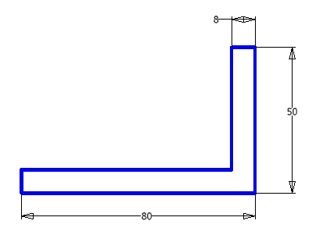

Create the following sketch

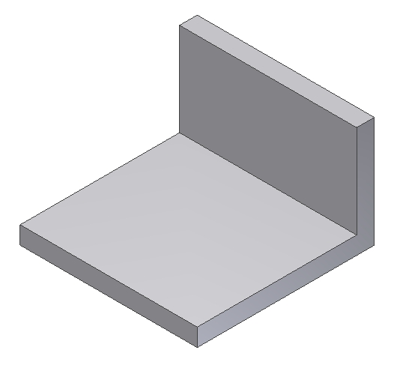

Extrude the sketch 80mm as shown

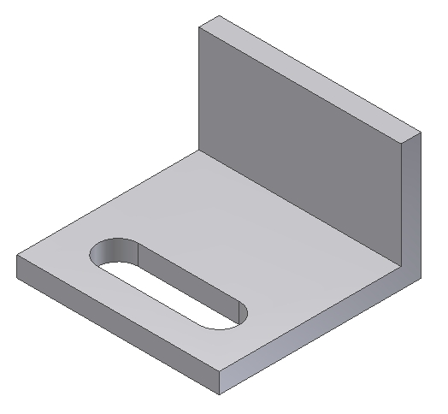

Create the cut as shown.

Refer to the drawing reviewed previously for feature details.

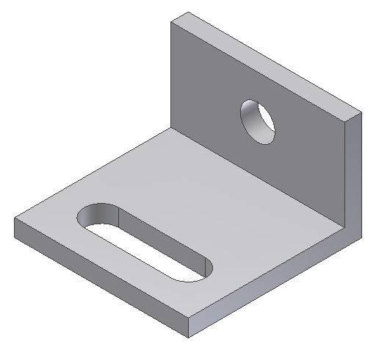

Create the hole as shown.

This completes the “L Plate” part file. Save the file.

Create a new part file: “Gusset 25x25x10.”

Define the gusset reviewed earlier.

Save the gusset part file.

Create an assembly: “L Plate Weldment.”

Place the “L Plate” into the assembly. Add two gussets, located as shown on the second page of this document.

Note: It is possible to create a weldment as a specific type of assembly, however, in this example, the assembly will be converted to a weldment after the parts are assembled.

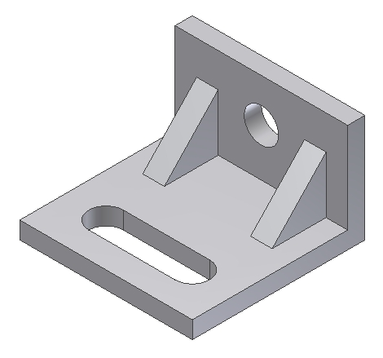

Convert the assembly into a weldment

Add 6mm fillet welds to all t-joints as shown (use similar weld information as shown)

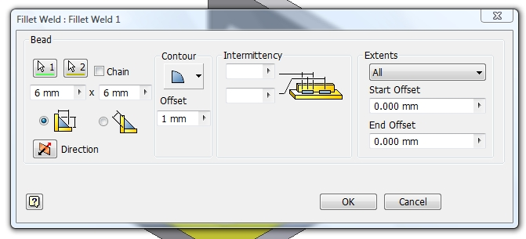

When finished, create a drawing file: “L Plate Weldment.”

Place your weldment assembly, creating four views similar to what is shown in the drawing mentioned earlier.

Dimensions and other notations will be added later.

