Day 2 Assignment
Welding Design & Drawing

Students Create The Model
- Students will use 3D parametric solid modeling (PSM) CAD software to create the following assembly model

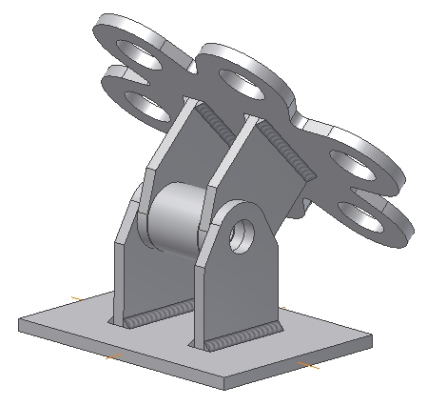

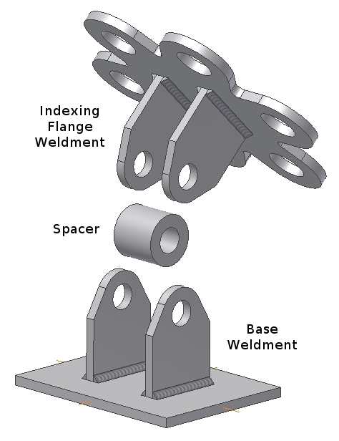

Study the following illustrations to create the model.

The final assembly will be constructed from two sub assemblies and one part file.

All plate material will be 0.375 thick mild steel.

The SPACER part file has an outside diameter of 2.00, includes a 1.00 through hole and is 1.93 inches long.

Create a separate part file: BASE PLATE

Create a separate part file: LUG

Create an assembly, name it BASE WELDMENT, then place the files as shown.

Convert the sub-assembly to a weldment, then add the 0.25 fillet welds as shown.

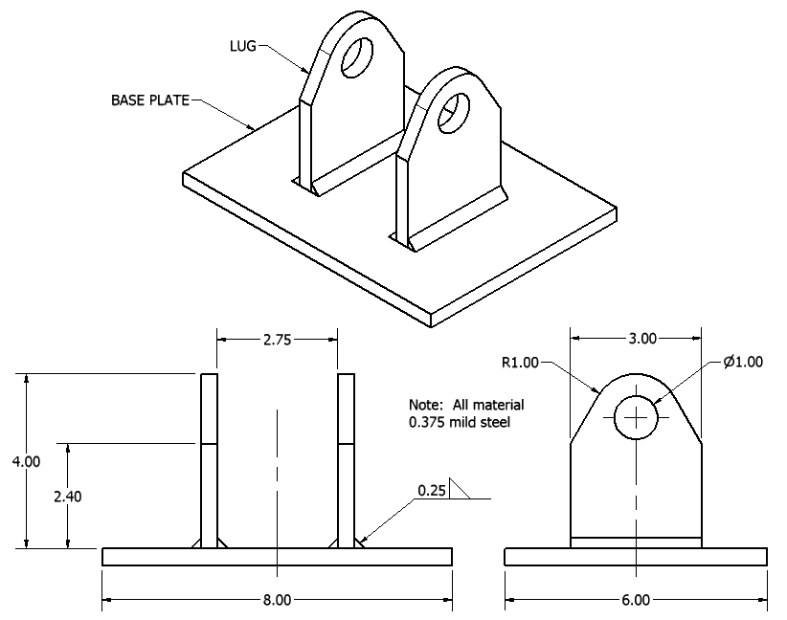

Create a separate part file: INDEXING FLANGE

Create an assembly file, name it INDEXING FLANGE WELDMENT.

Place the INDEXING FLANGE part file and two LUG part files as shown.

Convert the sub-assembly to a weldment then add the 0.25 fillet welds as shown.

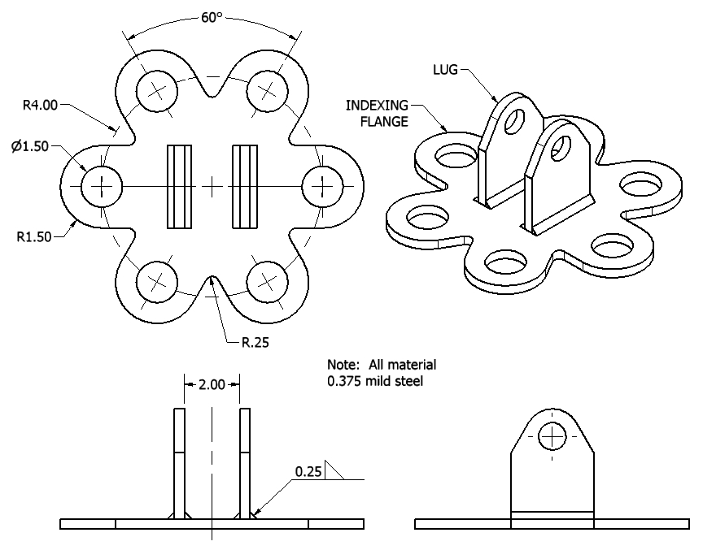

Create the final assembly: INDEXING FLANGE FINAL ASSEMBLY

Locate the INDEXING FLANGE WELDMENT so it's oriented 45 degrees from the BASE WELDMENT as shown.

The Spacer part file should be located inside the LUG part files located on the INDEXING FLANGE.

All holes in the four LUG's and the SPACER should be aligned as shown.

