Day 3 Assignment
Welding Design & Drawing

The following weldment will be created.

All material is 0.375 1010 Steel

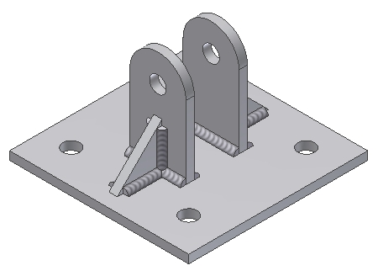
HINGE TAB

GUSSET

BASE PLATE

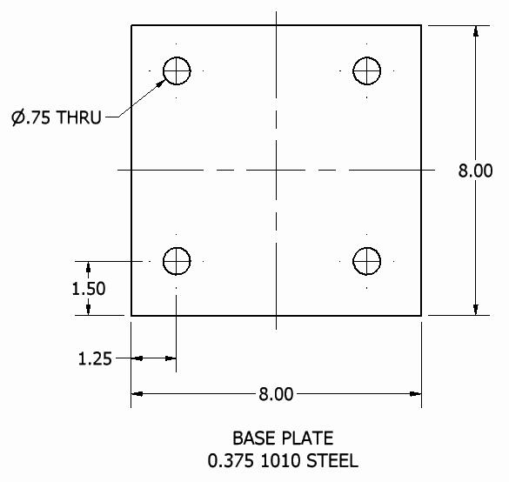

Study the following part files:
BASE PLATE HINGE TAB GUSSET

The GUSSET measures 2 x 2 x 0.375

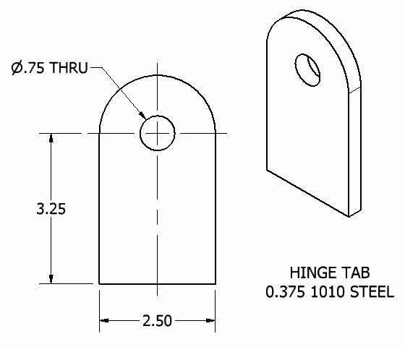

Create an assembly, name it ANCHOR WELDMENT, then place the files as shown.

Convert the sub-assembly to a weldment, then add the 0.25 fillet welds as shown.

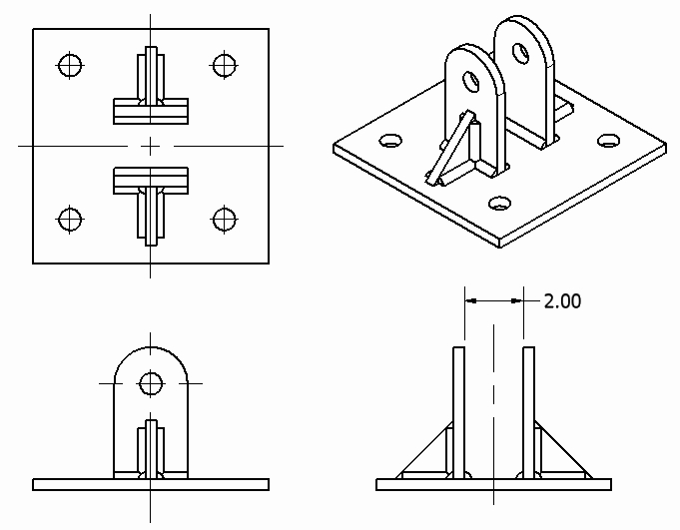

The following weldment will be created

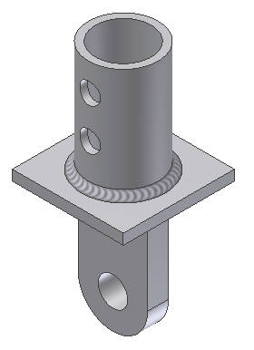
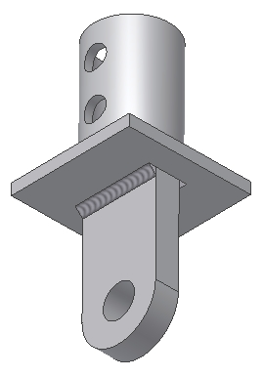

SOCKET

CONNECTOR
PLATE

SOCKET
HINGE TAB

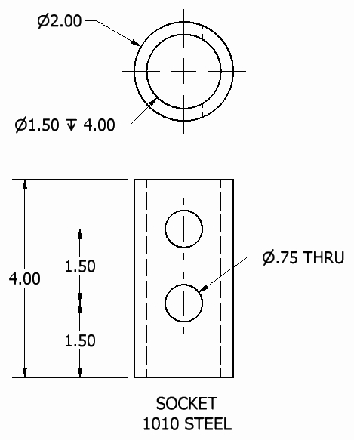
Study the following part files:
SOCKET CONNECTOR PLATE SOCKET HINGE TAB

Note: CONNECTOR PLATE measures 4 x 4 x 0.375

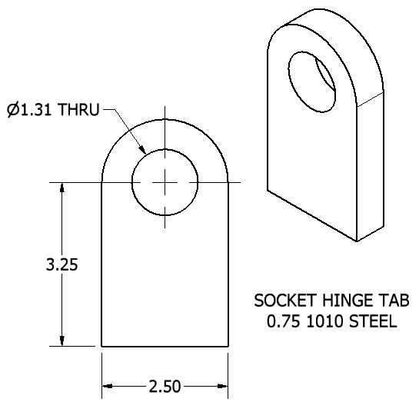

Create an assembly, name it SOCKET WELDMENT, then place the part files as shown above.

Convert the sub-assembly to a weldment, then add the 0.25 fillet welds shown above.

