Day 4 Assignment
Welding Design & Drawing

The following final assembly will be created:

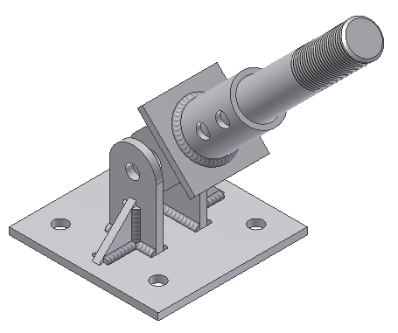

Create the following part files:
- ANCHOR SHAFT
- ANCHOR BUSHING

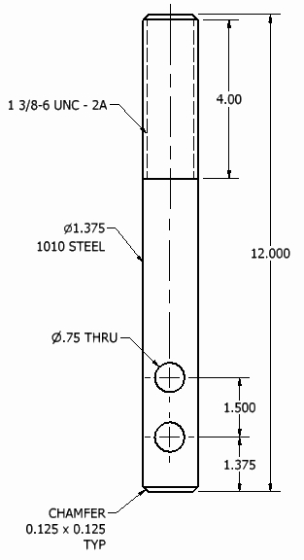
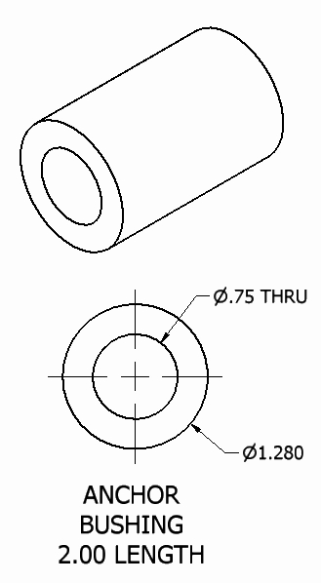

Create an assembly ANCHOR ASSEMBLY
- Add these components in this order to the assembly
- Use the following drawings to establish the proper location and orientation of the items in the assembly

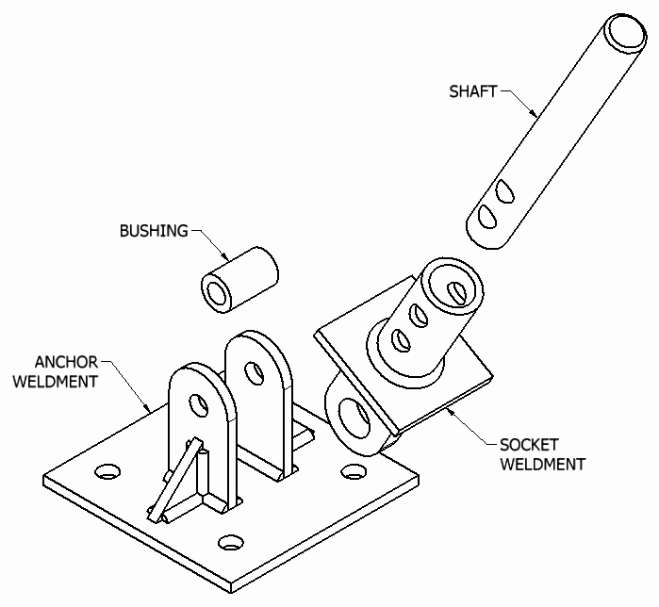

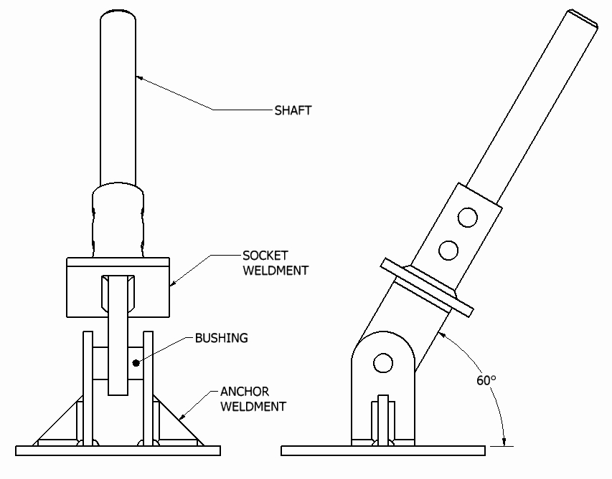

To complete this model perform the following using the ANCHOR ASSEMBLY model placed into a drawing file:

- Select fasteners from a library of parts which could be used in the following
  - Select bolts, washers and nuts
  - ANCHOR WELDMENT if attached to a 3/4” plate
  - SOCKET WELDMENT to attach the SOCKET part file

- Create the following views:
  - Pictorial views
    - Isometric view
    - Perspective view
  - Section view(s)
  - Auxiliary view(s)
  - Detail View(s)
  - Broken View(s)

