

Foundation Skills

PATHWAY: All Pathways
COURSE: All CTAE Courses
UNIT: Bernoulli’s Principle

Introduction
Annotation: This lesson covers the Bernoulli’s principle and related practical applications.
Note: Station Activities should be setup prior to class, see section 6. Also see materials and equipment section for all required materials.

Grade(s):
x | 9th
x | 10th
x | 11th
x | 12th

Time:
2 - 50 minute periods
Author:
Philip Ledford and Dr. Frank Flanders
Additional Author(s):

Students with Disabilities:
For students with disabilities, the instructor should refer to the student's IEP to be sure that the accommodations specified are being provided. Instructors should also familiarize themselves with the provisions of Behavior Intervention Plans that may be part of a student's IEP. Frequent consultation with a student's special education instructor will be beneficial in providing appropriate differentiation.

Focus Standards
GPS Focus Standards:
CTAE-FS-2 Academic Foundations: Learners achieve state academic standards at or above grade level.

AG-BAS-19: The student demonstrates the application of physics in agriscience.
a. Explains areas of physics used in agriscience.

ACCT-AM-2: Students will understand the relationship between air pressure, temperature, and density.
a. Identify vertical airflow and atmospheric stability.

GPS Academic Standards:
SP3: Students will evaluate the forms and transformations of energy.

SCSh3: Students will identify and investigate problems scientifically.
c. Collect, organize and record appropriate data.
e. Develop reasonable conclusions based on data collected.

SCSh6: Students will communicate scientific investigations and information clearly.
- Write clear, coherent laboratory reports related to scientific investigations.

National / Local Standards / Industry / ISTE:
Understandings & Goals
Enduring Understandings:
Students will understand that a basic knowledge of scientific principles can be used in many fields of study and practical applications in everyday life.

Essential Questions:
Why is Bernoulli’s principle important?
How does Bernoulli’s principle apply to life outside the class room?

Knowledge from this Unit:
Students will:
- examine the history of Bernoulli’s principle.
- define Bernoulli’s principle.
- examine practical applications of Bernoulli’s principle.

Skills from this Unit:
Students will analyze demonstrations of Bernoulli’s principle and explain how Bernoulli’s principle is used in aeronautics and other practical applications.

Assessment(s)
Assessment Method Type: Select one or more of the following. Please consider the type(s) of differentiated instruction you will be using in the classroom.

 | Pre-test
x | Objective assessment - multiple-choice, true- false, etc.
_x_ Quizzes/Tests
__ Unit test
x | Group project
 | Individual project
 | Self-assessment - May include practice quizzes, games, simulations, checklists, etc.
__ Self-check rubrics
__ Self-check during writing/planning process
__ Journal reflections on concepts, personal experiences and impact on one’s life
__ Reflect on evaluations of work from teachers, business partners, and competition judges
__ Academic prompts
__ Practice quizzes/tests
x | Subjective assessment/Informal observations
__ Essay tests
_x_ Observe students working with partners
__ Observe students role playing
 | Peer-assessment
__ Peer editing & commentary of products/projects/presentations using rubrics
__ Peer editing and/or critiquing
 | Dialogue and Discussion
__ Student/teacher conferences
__ Partner and small group discussions
__ Whole group discussions
__ Interaction with/feedback from community members/speakers and business partners
x | Constructed Responses
__ Chart good reading/writing/listening/speaking habits
_x_ Application of skills to real-life situations/scenarios
 | Post-test

Assessment(s) Title:
Bernoulli’s Principle Quiz

Assessment(s) Description/Directions:
Answer multiple choice and true or false questions.

Attachments for Assessment(s):
Bernoulli’s Principle Quiz
Learning Experiences
Instructional planning: Include lessons, activities and other learning experiences in this section with a brief description of the activities to ensure student acquisition of the knowledge and skills addressed in the standards. Complete the sequence of instruction for each lesson/task in the unit.

Note to the teacher: The equation in the power point is not meant to be understood. It is only there for the students to see and briefly familiarize themselves with.
Sequence of Instruction
1. Identify the Standards. Standards should be posted in the classroom for each lesson.
• AG-BAS-19: The student demonstrates the application of physics in agriscience.
a. Explains areas of physics used in agriscience.

•ACCT-AM-2: Students will understand the relationship between air pressure, temperature, and density.
a. Identify vertical airflow and atmospheric stability.
SP3: Students will evaluate the forms and transformations of energy.

• SCSh3: Students will identify and investigate problems scientifically.
c. Collect, organize and record appropriate data.
e. Develop reasonable conclusions based on data collected.

• SCSh6: Students will communicate scientific investigations and information clearly.
a. Write clear, coherent laboratory reports related to scientific investigations.

2. Review Essential Questions.
• Why is Bernoulli’s principle important?
• How does Bernoulli’s principle apply to life outside the class room?

3. Identify and review the unit vocabulary and information by power point presentation.
• Velocity – the speed of motion
• Pressure - the force per unit area applied to an object
• Lift - the force that pulls an object outward, or upward.
• Fluid – a continuously flowing substance either gas or liquid.
4. Bernoulli’s principle on a piece of paper demonstration.
• Pass out a piece of paper cut about 4 inches by 8.5 inches long to each student. Have the students blow over the very top of the paper.

(What should happen): The paper should lift upward rather than downward. The velocity of the stream of air you produce has a low pressure on top but on bottom the velocity is lower and the pressure is higher, thus giving the paper lift.

5. Present the Power Point on Bernoulli’s principle.
6. Multiple Stations with activities.

Activity: Four stations should already be setup around the room. Students should be assigned to 4 groups. Each station should only take 5 or 7 minutes to complete.
1. Ask students to explain Bernoulli’s principle in their own words.
2. Review the definition of Bernoulli’s principle.
3. Briefly review the different applications of Bernoulli’s principle.
4. Discuss what the materials are and how to use them for each station. Ask the students to record and explain what happened during the activities at each station.

Station 1: A setup of 2 empty drink cans or plastic cups and straws are needed. Place two cans beside each other an inch or two apart.
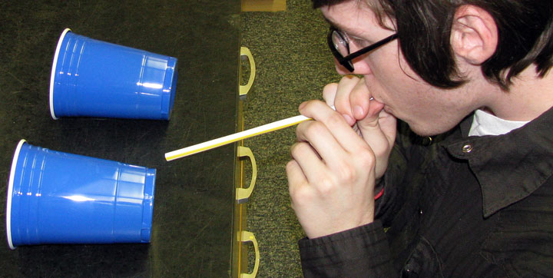
Then have the students blow through the straw directly in between the two cans.
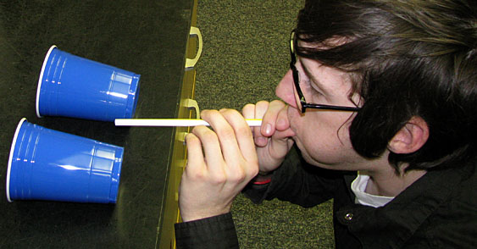
The two cups will roll together. Make sure the stream of air is not bouncing off the table. The straighter the stream is directly through the middle the better it will work.
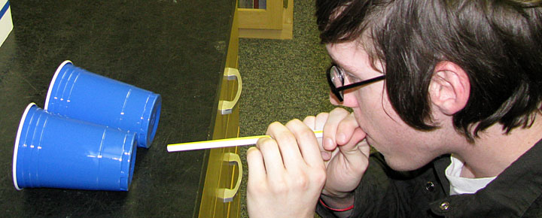
Have students document what happened and have them explain why they think it happened.

(What should happen): The two cups will roll together rather than apart. The velocity of the stream you produce is higher than the velocity of air around the two cans. That means the pressure around the two cans is higher than the pressure of the stream of air you produce, thus pushing the two cans together.

Station 2: A setup of a ping pong ball, tape and paper is needed. Ask the students to make a paper funnel and a paper tube as shown below. Have the students try to blow the ping pong ball out of the tube and then out of the funnel.

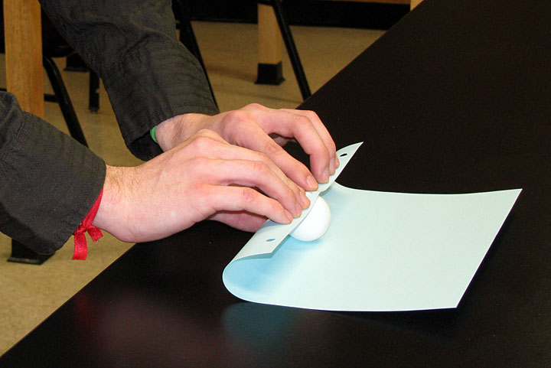
Roll the ping pong ball in a sheet of paper to create a tube the same size as the ball.
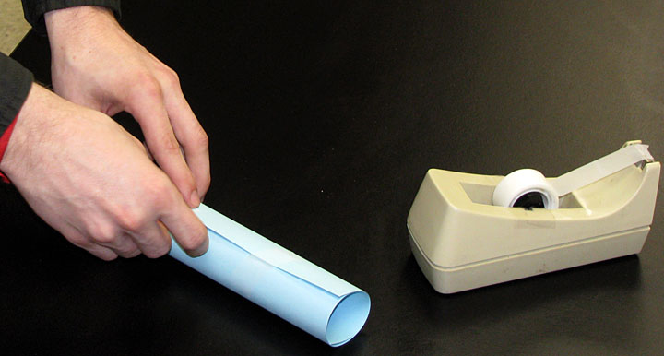
Tape the tube together.

Demonstrate that there is low pressure around the ball because the ball flies out when blown into the tube.
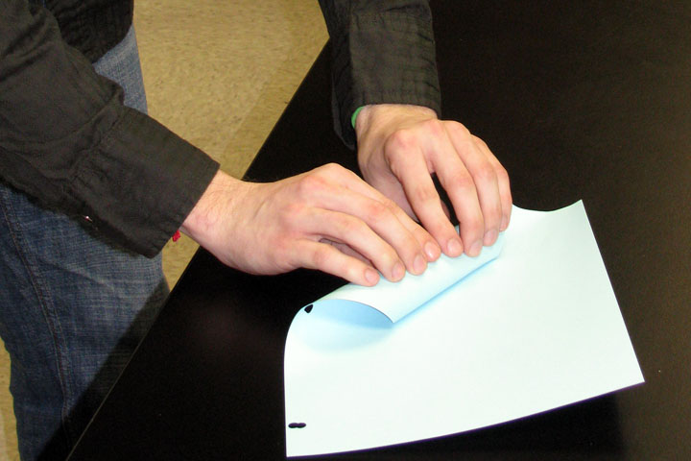
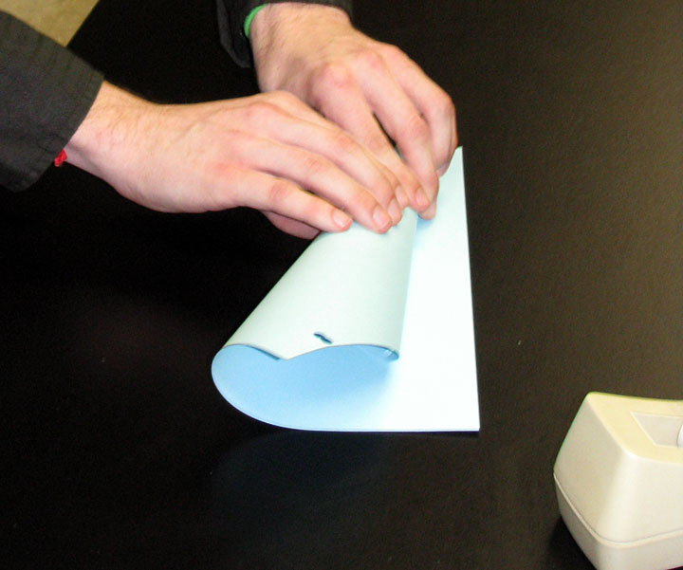
Ask the students to make a paper funnel. Make sure the top of the funnel has a rather large opening.
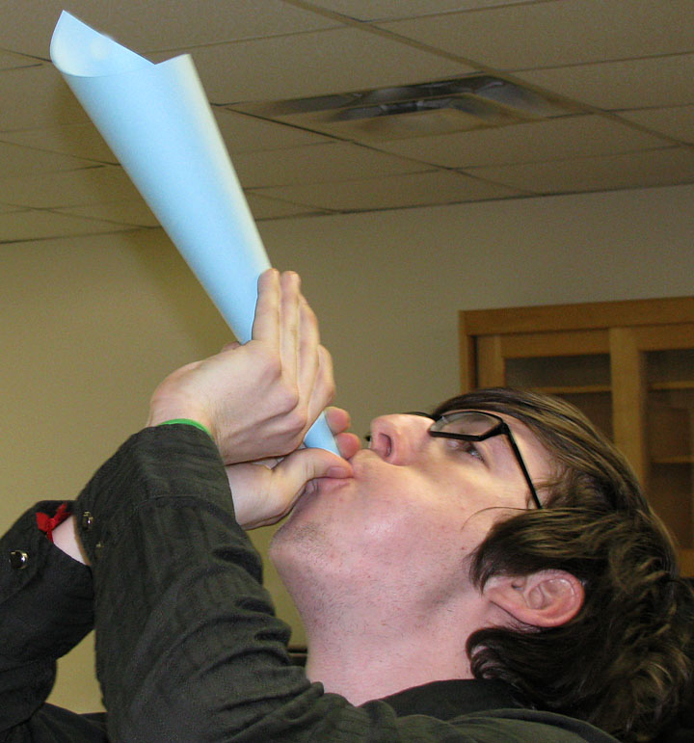
Demonstrate that it is impossible to blow the ball out because pressure is surrounding all sides of the ball. Notice you can feel the ball hovering inside the funnel.

(What should happen): The students should not be able to blow the ping pong ball out. The pressure around the outside of the ball should hold the ball within the funnel while it stays stationary in the air.

Station 3: A setup of a straw and a beaker filled partially full of water (adding food coloring to the water will in observing this activity.)
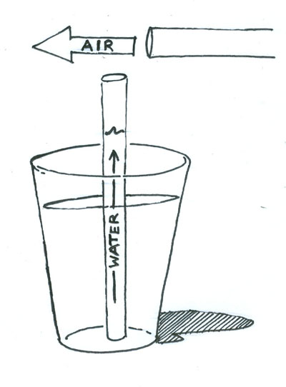
Have the student blow directly over the top of the straw and document what happened and explain why they think it happened.

(What should happen): The water from the beaker should shoot up through the straw. The velocity of the stream over the top of the straw creates low pressure around the top of the straw. The air and water moves up the straw to fill the void.

Station 4: A setup of 20 oz trash bags is needed.

Instructions: Ask the students to see how many breaths it takes to fill the bag with air. It should take more than one.

After a few tries, tell the students you can fill it up in one breath. Follow these instructions: Lay the bag flat on the table as shown.
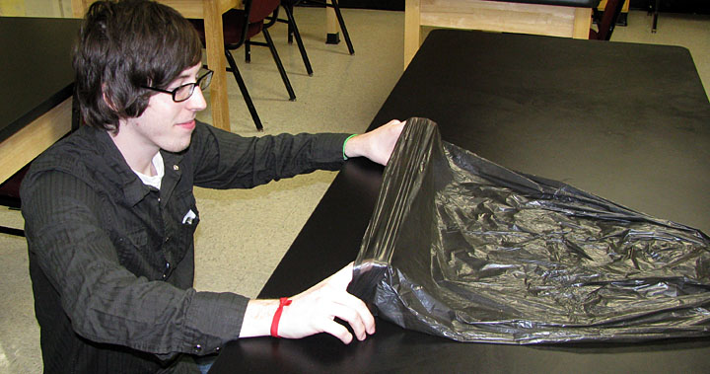
Hold the bag open with your hands about an inch apart and blow directly into the middle of the bag opening.
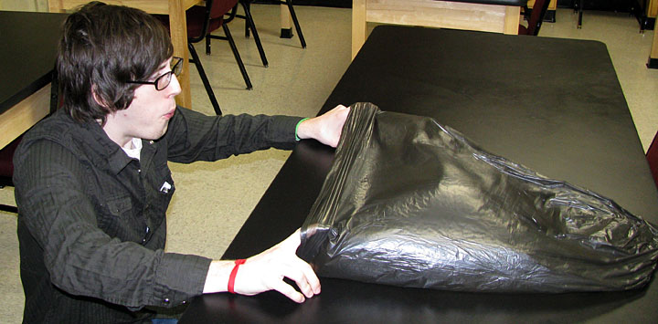
Finally close the opening and hold the air inside.
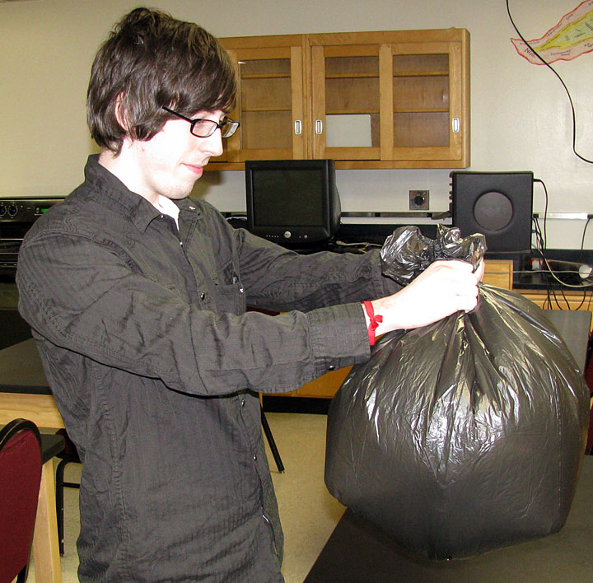

(What should happen): The students will not be able to fill the bag in one breath, if they try to blow it up the traditional way – mouth to bag. If the students do not figure out the correct way to fill the bag, the teacher must demonstrate the above instructions.

7. Post-Activity quiz.
• See quiz attachment.

Attachments for Learning Experiences:
Applications of Bernoulli’s Principle Power Point.
Bernoulli’s Principle Quiz.

Notes & Reflections: Each activity should only take a few of minutes. Make sure each student has done the activity at each station correctly.

Culminating Performance Task (Optional)
Culminating Unit Performance Task Title:

Culminating Unit Performance Task Description/Directions/Differentiated Instruction:

Attachments for Culminating Performance Task: Please list
Unit Resources
Web Resources: http://home.earthlink.net/~mmc1919/venturi.html
http://www.av8n.com/how/htm/airfoils.html
(VIDEO): http://www.youtube.com/watch?v=kXBXtaf2TTg

(These will help explain Bernoulli’s Principle, the first link is technical but the interactive program on the page is helpful.)

Attachment(s):

Materials & Equipment: empty drink cans or plastic cups, transparent straws, large trash bags, 3 or more ping pong balls, tape and paper, notebook or printer paper, beakers and water.

What 21st Century Technology was used in this unit:
Top of Form
x | Slide Show Software |  | Graphing Software |  | Audio File(s)
 | Interactive Whiteboard |  | Calculator |  | Graphic Organizer
 | Student Response System |  | Desktop Publishing |  | Image File(s)
 | Web Design Software |  | Blog | x | Video
 | Animation Software |  | Wiki |  | Electronic Game or Puzzle Maker
 | Email | x | Website
Bottom of Form

