Technology and Engineering Education
Introduction to Technology
General Safety Test
Name: ____________________________________ Date: ___________________

Section 1 directions: Please read each question carefully and circle the letter (a, b, c, or d) with the most accurate response. If you need assistance, please raise your hand, and your instructor can assist you.

1) Eye protection such as safety glasses must be worn:
a) Only when operating power equipment
b) At all times when in the shop
c) Only for those students who do not already wear prescription glasses
d) When you want to

2) If you find a power tool with a damaged power cord or with a switch that does not work, what
should you do?
a) Report the condition to the instructor immediately so the tool can be locked up until it is repaired
b) Try to fix the problem yourself
c) Put it back into the tool cabinet, as it does not work
d) Report the defect to the instructor after you have finished using the tool

3) When disconnecting portable power tools from a power receptacle, you should:
a) Remove your safety glasses to better see the cord end
b) Not remove it, but leave it plugged in
c) Pull on the plug end, and not the cord
d) Pull on the cord, and not the plug end

4) Long hair, loose clothing, jewelry, and long sleeves need what kind of attention?
a) All clothing should be tucked in or rolled back (such as long sleeves). Loose jewelry must be removed, and long hair should be tied up.
b) Long hair must be tied up, but long clothing does not need special attention
c) Long sleeves and loose clothing must be rolled up and tucked in, but long hair is not a problem
d) Long sleeves and loose hair and jewelry are not safety hazards, as all machines have the necessary safety guards to keep them from becoming tangled in a moving part

5) An ‘Operator Zone” refers to:
a) The area of the shop floor where all students except the machine operator must stand
b) The area next to the telephone in case there is a need to call for emergency help
c) The area of the shop floor where the machine operator only should stand
d) The floor space around the instructor’s desk

Section 2 directions: Please read each question carefully and write your answer in the blank provided using your best penmanship. If you need assistance writing or spelling, please raise your hand, and your instructor can assist you.

6) “Forcing” your work into a machine means that you are _______________it too hard.

7) It is dangerous to use a hammer with a loose handle because the hammer head
may________________________________.

8) Paint, enamel, lacquer or solvents must not be used near flames or sparks
because they are_________________________________.

9) Before using any power machine, for the first time, you must get the
permission of your________________________________.

10) The color ‘Orange’ on machine parts means the parts are _________________.

Section 3 directions: Please read each question carefully and circle either “T” if the statement is true, or “F” if any part or all of the statement is false If you need assistance, please raise your hand, and your instructor can assist you.

11) T or F: Hot metal thrown into water in order to cool it off can create steam hot
enough to burn skin.

12) T or F: When working in the lab you must always wear your safety glasses.

13) T or F: Smashing hammers together will not cause damage.

14) T or F: Since the blade is about to stop it is ok to place your hand near the blade.

15) T or F: Checking the machine before you start is good safety practice.

16) T or F: Wearing open toed shoes is safe in the lab area.

Section 4 directions: Please read each question carefully and provide a short answer. If you need assistance, please raise your hand, and your instructor can assist you.

17) Explain why oily rags or rags soaked in paint and other solvents must be stored in a metal, air-tight container when not in use.

18) Explain what you should do if you find a tool that is broken.

19) Explain what you should do in the event of an accident.

Section 5 directions: Please look at each of the following pictures and identify the safety violation taking place. If you need assistance, please raise your hand, and your instructor can assist you.

20)  __________________________________________  __________________________________________  __________________________________________  __________________________________________ | 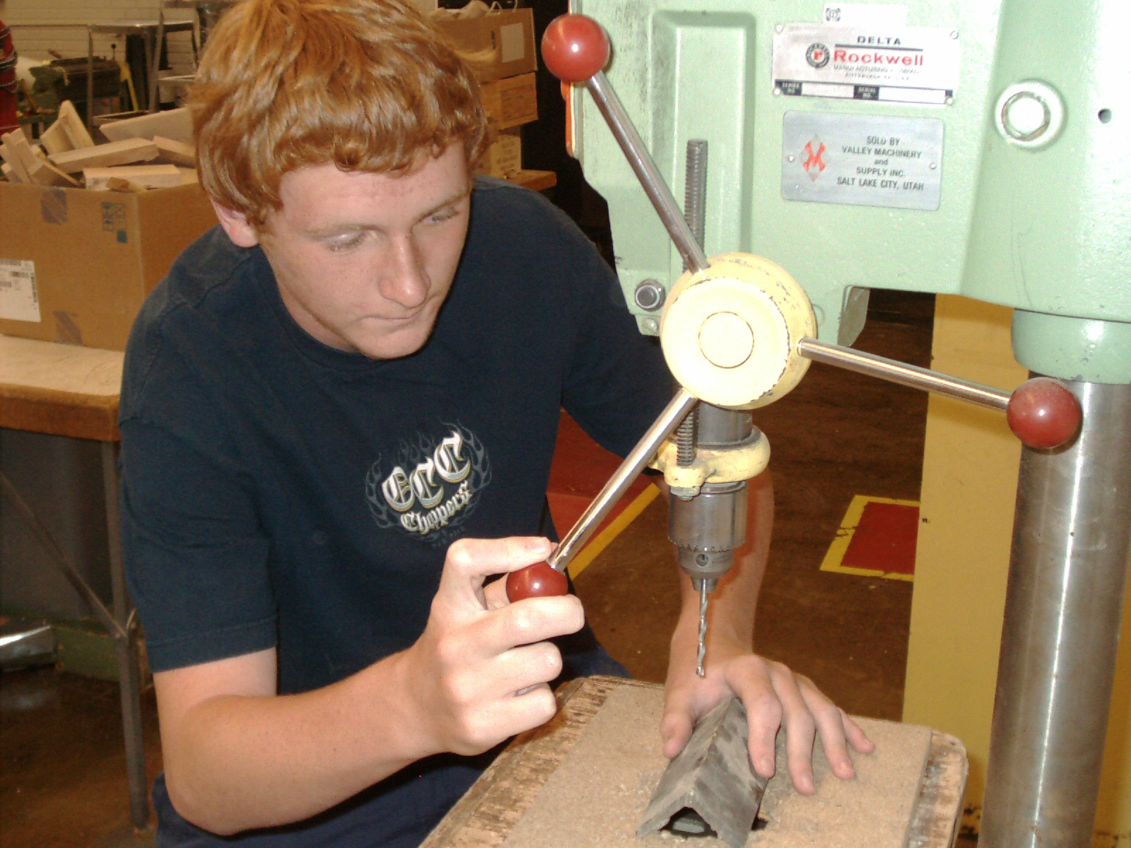
21)  __________________________________________  __________________________________________  __________________________________________  __________________________________________ | 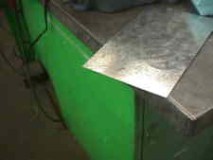
22)  __________________________________________  __________________________________________  __________________________________________  __________________________________________ | 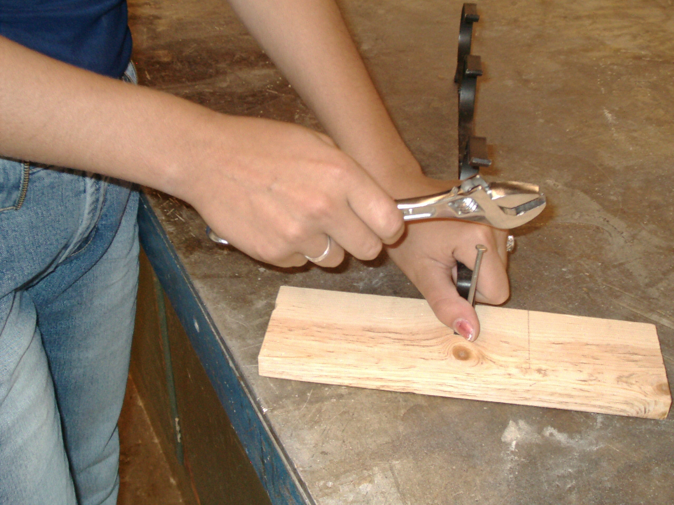
23)  __________________________________________  __________________________________________  __________________________________________  __________________________________________ | 

Section 6 directions: Match the color with the proper function

24. Red | a. Caution
25. Yellow | b. Moving parts
26. Blue | c. Radiation
27. Purple | d. Safety
28. Green | e. Information
29. Orange | f. Danger

