Student Resource 1.1.5

Automotive Ergonomics

Path of C. Motion | Control | Dimension  (mm) | Force F (N)  Moment M (Nm) |  | 2 positions | >2 positions | Continuous adjustment | Precise adjustment | Quick adjustment | Large force application | Tactile feedback | Setting visible | Accidental actuation
Turning Movement | Handwheel |  | D | M
Turning Movement | 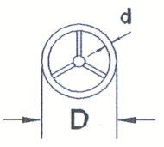 | D:160-800  d: 30-40 | 160-200 mm | 2-40 mm  4-60 mm | ◑ | ◑ | ● | ● | ◑ | ● | ○ | ○ | ◑
Turning Movement | Crank |  | R | M
Turning Movement | 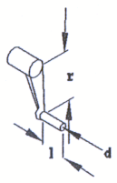 | Hand (Finger)  D: <250 (<100)  1: 100 (30)  d: 32 (16) | <100 mm  100-250 mm | 0, 6-3 Nm  5-14 Nm | ◑ | ◑ | ● | ◑ | ● | ◑ | ◑ | ◑ | ○
Turning Movement | Rotary knob |  | D | M
Turning Movement | 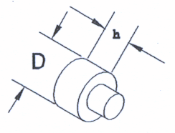 | Hand (Finger)  D: <25-100 (15-25)  H: >20 (>15) | 15-25 mm  25-100 mm | 0, 02-0, 05 Nm  0, 3-0, 7 Nm | ◕ | ◕ | ● | ● | ◑ | ○ | ○ | ○ | ◑
Turning Movement | Rotary selector switch  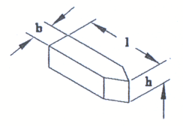 |  | D | M
Turning Movement |  | 1: 30-70  h: 20  b: 10-25 | 30 mm  30-70 mm | 0, 1-3, 3 Nm  0, 3-0, 6 Nm | ● | ● | ◔ | ◕ | ◔ | ◑ | ● | ● | ◑
Turning Movement | Thumbwheel
Turning Movement | 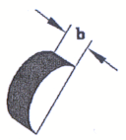 | b: >8 | 0, 4-5 N |  | ◑ | ◑ | ● | ● | ◑ | ○ | ○ | ○ | ◑
Turning Movement | Rollball
Turning Movement | 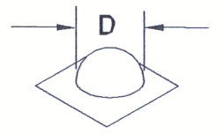 | D: 60-120 | 0, 4-5 N |  | ○ | ○ | ● | ● | ◕ | ○ | ○ | ○ | ◑
Hand- and foot-operated control devices and their operational characteristics and control functions; ● recommended; ○ not suitable.

