Human Factors Affecting Design

Engagement
- A K-W-L chart is used to obtain some understanding of student knowledge about ergonomics and ADA compliance issues regarding product design for intimate human use. (See KWL Chart.pdf and KWL Chart Assessment.doc)
- Responses from the K-W-L chart are compared to definitions from contemporary sources - ergonomics and ADA compliance.
- Several everyday products are presented and discussed with regards to ergonomic features and ADA compliance issues for persons with disabilities.
- The instructor leads a class discussion on ergonomics perspective. (see Ergonomic Perspective.doc)
- The instructor presents the following image for students to review and asks them to describe what they think it is and how are such calculations and measurements used to guide the design of many products. Students are challenged to discuss specific examples of how such studies can impact products such as cell phones, automobiles, aircraft, household appliances, etc. (see Range of Motion.doc)

Exploration
- Students work in small groups to analyze a few everyday devices and chart their observations and reactions using ergonomic features and ADA compliance requirements presented via a worksheet. Items are passed around to each group so that all students analyze the same devices.
- Groups edit their comments and analysis and prepare a final worksheet and then create a chart (chart paper) for sharing with the rest of the class.
- Students are challenged to conduct an independent investigation for federal ADA laws and regulations. The results of that investigation should be presented as a formal written report. This investigation should address at least the following items:
  - American Disabilities Act
  - Historical review of events and legislation
  - Biographical information about key people
  - Graph or chart depicting federal funding for ADA over the past 20 years
  - Examples of ADA compliance for public service environments - hospitals, schools, government, etc.
- Students research the ergonomic studies conducted by one of the major automobile manufacturers (General Motors, Ford, Chrysler, Honda, Toyota, Nissan) to obtain a description of their process for making such studies and results for several vehicle models from that organization. One organization that provides this type of research for many manufacturers is the University of Michigan Transportation Research Institute (UMTRI). (See BIC Categories and Examples.doc for an example of investigation criteria)

Enrichment Activities
- Automotive ergonomics is a challenging and critical component of automobile design. One of the most interesting devices used for determining seating area ergonomic data is an H-Point Machine. Students investigate this device and prepare a detailed report, including schematics on how this device operates and helps engineers optimize seating designs in vehicles. The report should include a discussion of test subject postures and anatomical landmarks and stereophotogrammetry. In addition, students develop and produce a chart similar to the one below for a family automobile, showing various controls within the automobile and describe how they measured the force required to move that control device. (See Automotive Ergonomics.doc to guide student work)
- Students perform the following measurements and prepare a spreadsheet and related graph for each based on their body measurements relative to the examples presented below:
  - Measure the shoulder-to-finger-tip arm span of your own body. Compare to the height of your desk and distance from its edge to your computer keyboard. Is there a correlation?
  - The standard desk height is 76 cm (30 in). Measure the height of your waist above the floor. Is there any correlation?
  - Measure your own floor-to-shoulder height and compare to the standard 106 cm (42 in) height of an electrical switch above the floor.
  - Measure your own head diameter and compare to the unseparated span of the earphones of a stereo headset. Is there any correlation?
  - Sit in car and measure the distance between the bottom of your foot and the accelerator pedal as the seat is moved from its extreme forward and backward positions. What range of driver leg length do you think the car can accommodate?
  - Examine the FILE pull-down menus of up to 10 computer programs and write down the order in which the various entries appear. Compare and contrast the differences in a simple table.
  - Examine the minimum and maximum height of buttons located in several elevators. Compare these numbers with the range of human arm span.
  - Measure the height-to-depth ratio of several staircases. Do you observe a pattern?
  - Measure the minimum and maximum base-to-cord lengths of several desktop telephones in the stretched and unstretched positions. Compare these figures to your own arm span.
- Most students enjoy bicycling at times. With that in mind, have students compare several different designs of contemporary bikes and create CADD drawings showing the location of key components, brakes, shifter, seat, pedals and available adjustments and range of adjustments for those controls. A spreadsheet should be generated comparing all models analyzed with the criteria for the comparison. The instructor can monitor this process to ensure appropriate rigor for this level of student. A final assessment is the ‘preference statement’ made by each student as to which bike would suit them ergonomically and compare that to the aesthetic appeal of the bike to see if they match. If not, have the students explain which bike they would prefer and why they made that choice based on ergonomics and aesthetic appeal.
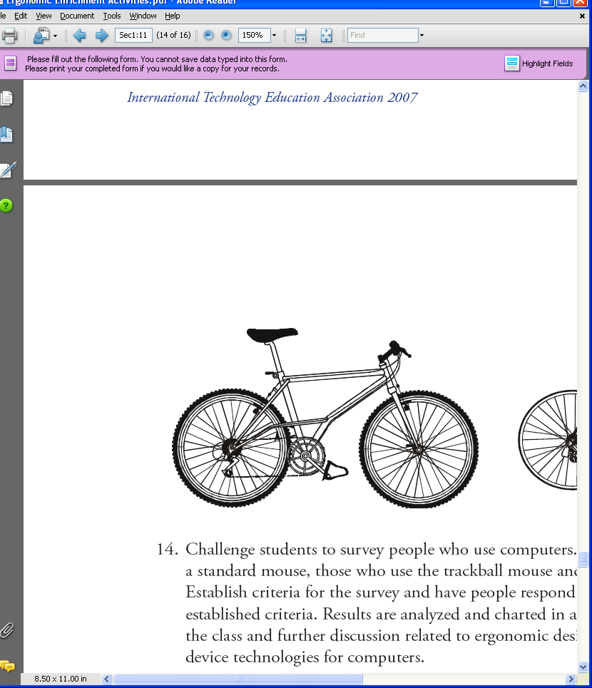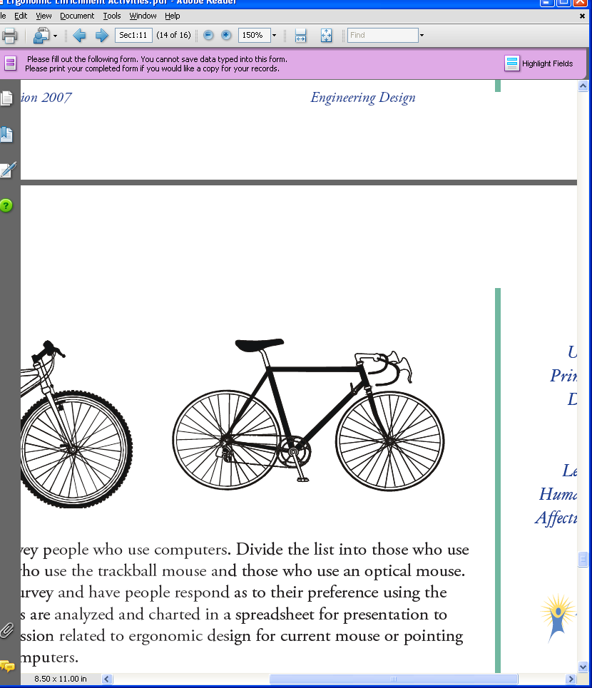
- Challenge students to survey people who use computers. Divide the list into those who use a standard mouse, those who use the trackball mouse and those who use an optical mouse. Establish criteria for the survey and have people respond as to their preference using the established criteria. Results are analyzed and charted in a spreadsheet for presentation to the class and further discussion related to ergonomic design for current mouse or pointing device technologies for computers.
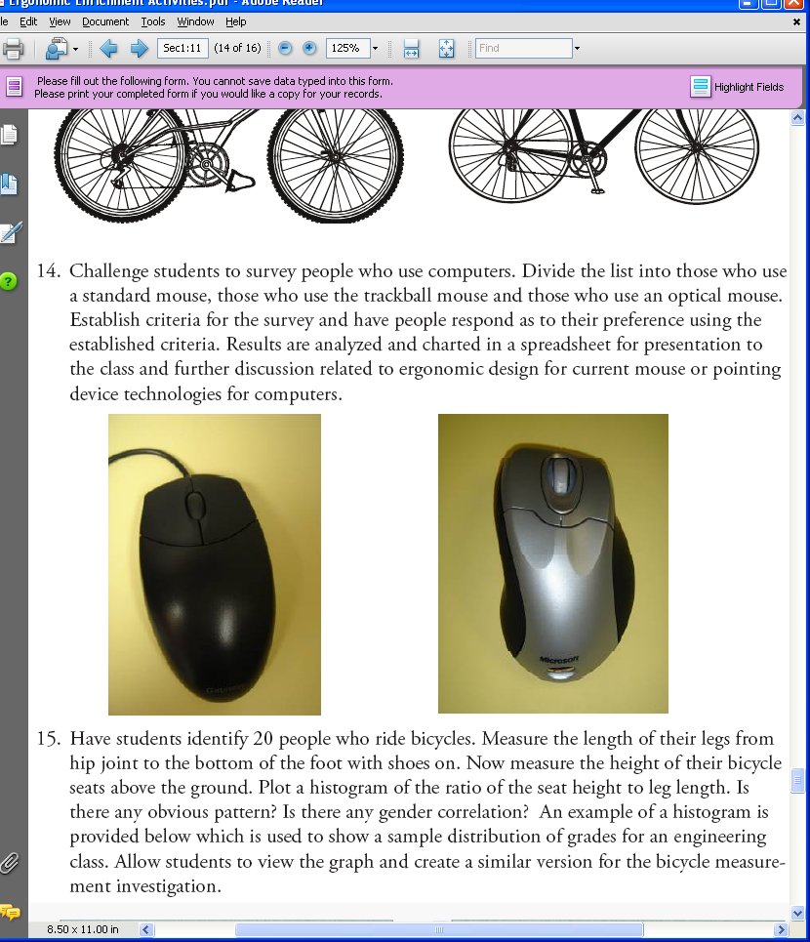
- Students are challenged to redesign a ‘Perfect’ ergonomically tailored office chair to accommodate a family member, friend, or themselves as directed by the instructor. (See Ergonomical Office Chair.doc for an example of a detailed schematic)

