For 2007, the challenge will be:
Take a whole orange, juice it, and pour the juice from a pitcher into a cup.

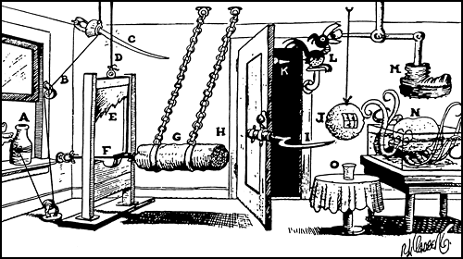
Milk man takes empty milk bottle (A), pulling string (B), which causes sword (C), to sever cord (D) and allow guillotine blade (E) to drop and cut rope (F) which releases battering ram (G). Ram bumps against open door (H) causing it to close. Grass sickle (I) cuts a slice off end of orange (J) at the same time spike (K) stabs "prune hawk" (L). He opens his mouth to yell in agony, thereby releasing prune and allowing divers boot (M) to drop and step on sleeping octopus (N). Octopus awakens in a rage and seeing orange attacks it and crushes it with tentacles, thereby causing all the juice in the orange to run into glass(O).

Analyze the above Rube Goldberg device and identify what simple machines are being used to transfer the energy to make orange juice.

