Greenhouse Activity
Objective: Create a basic greenhouse layout that optimizes the available space for bench placement.

Rules:
- The greenhouse dimensions are 30’x70’.
- The main aisle for carts must be 4’ wide and run the full length of the greenhouse.
- There must be an aisle 4’ wide across the front and back walls of the greenhouse.
- Walkways between benches must be a minimum of 18” wide.
- The benches must be stationary and one layered—no double-decker benches and no hanging plants.
- The benches can be any length.
- Each pot has to be within the reach of 3’.

Procedure:
- Sketch a greenhouse layout to the scale of 1”=1’ using the example provided.
- Considering the rules, plan where benches should be placed in the building in order to optimize usage of the space.
- Calculate the area of the usable bench space.
- Calculate the percent of the building that is usable table space.
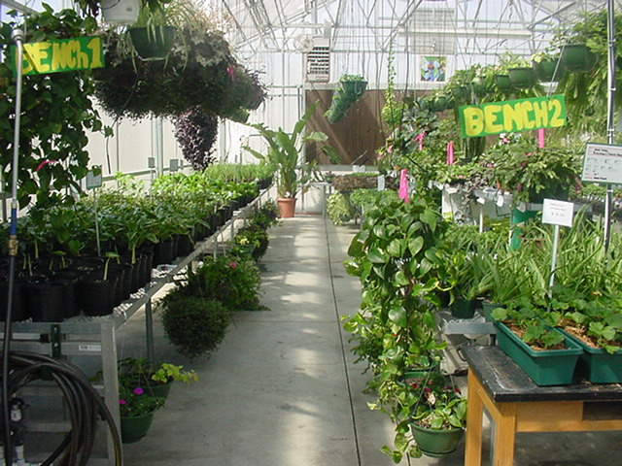
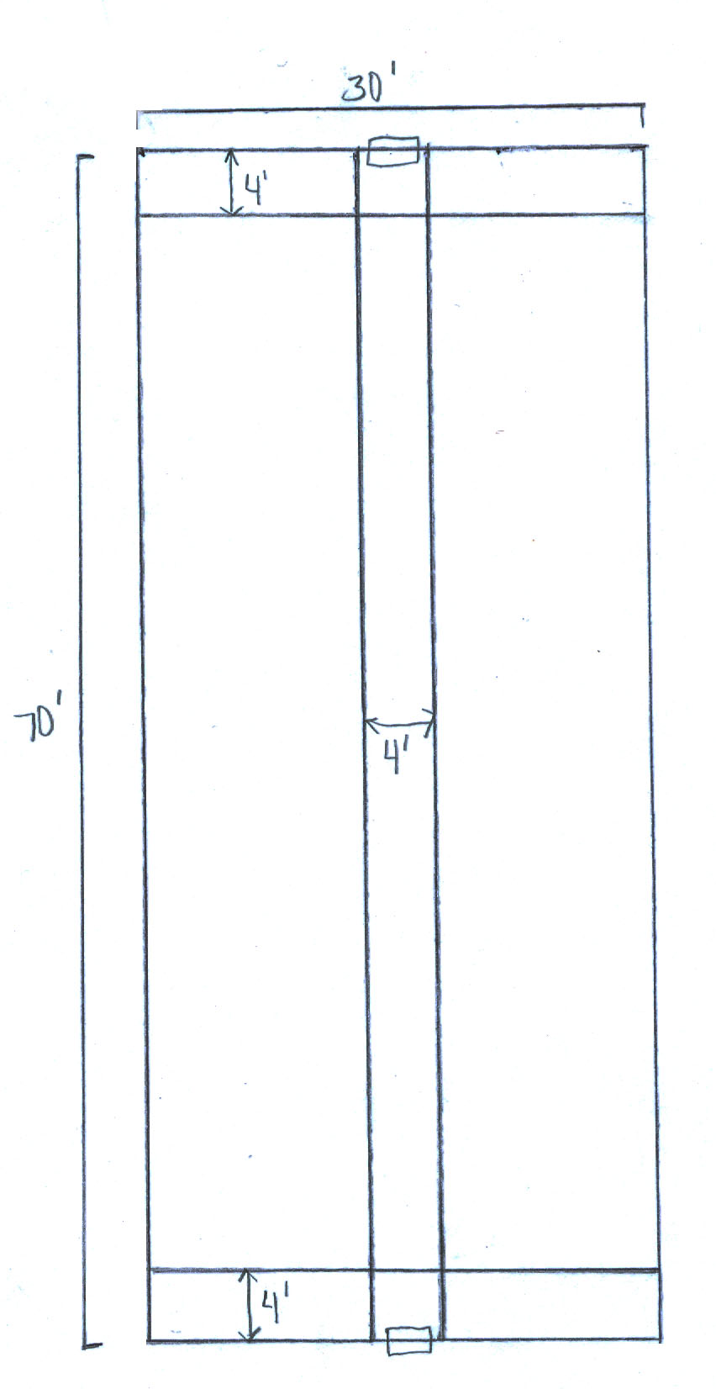

Note: This is just an example to show how to apply the rules, not drawn to scale. Students should re-draw the greenhouse using the 1”=1’ scale.

