What Does An Internal Audit Involve?
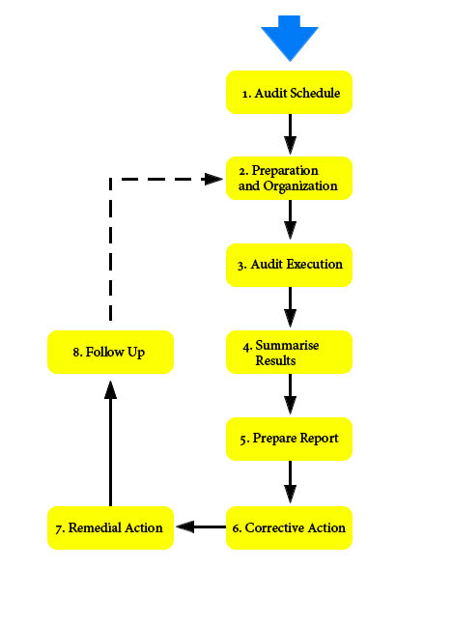

Adapted for CTAE Megan Maller from www.thecqi.org

