Negotiable Instruments Definitions-Teacher Guide:

- Certificate of deposit- a savings alternative in which money is left on deposit for a stated period of time to earn a specific rate of return.

- Negotiable instrument- a written order or promise to pay a sum of money, either to a specified party or to the person who holds it.

- Savings bond- A US savings bond is a bond sold by the United States Treasury to raise money for its operations. A US savings bond is non-transferable, meaning it cannot be sold on the market to other investors: the US savings bond can only be bought from, and sold to, the US Treasury.

- Rate of return- the percentage of increase in the value of your savings from earned interest

- Compounding- the process in which interest is earned on both the principal – the original amount you deposited – and on any previously earned interest.

- Annual percentage yield (AYP)- amount of interest that a $100 deposit would earn, after compounding, for one year.

- Endorsement- the signature of the payee, the party to whom the check has been written

- Money order- Financial instrument, issued by a bank or other institution, allowing the individual named on the order to receive a specified amount of cash on demand.
Bank draft- A check drawn by one bank against funds deposited into its account at another bank, authorizing the second bank to make payment to the individual named in the draft.
- Overdraft protection- an automatic loan made to an account I the balance will not cover checks written.

- Bank reconciliation- a report that accounts for the differences between the bank statement and your checkbook balance.

- Automated Teller Machine (ATM)- a computer terminal that allows a withdrawal of cash from an account.
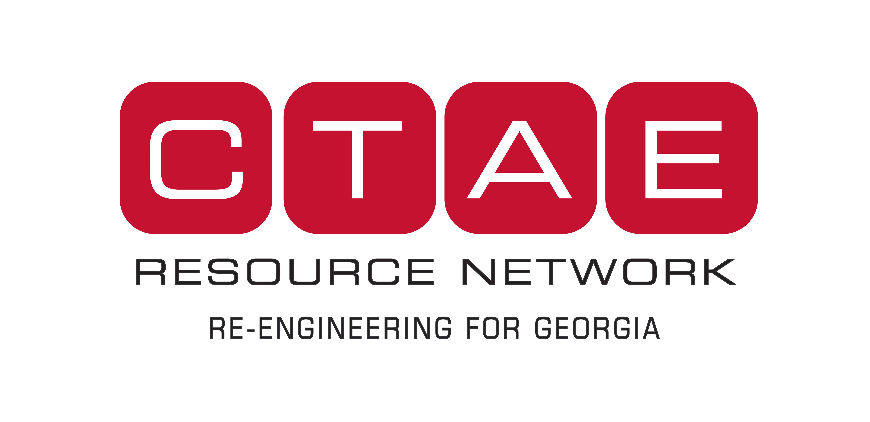
- Debit card- a cash card that allows you to withdraw money or pay for purchased from your checking or savings account

- Point-of-sale transaction- a purchase by a debit card of a good or service at a retail store, a restaurant, or elsewhere.

- Credit union- a nonprofit financial institution that is owned by its members and organized for their benefit.

- Stop-payment order- a request that a bank or other financial institution not cash a particular check.

- Float- the same funds being counted in two depository banks.

