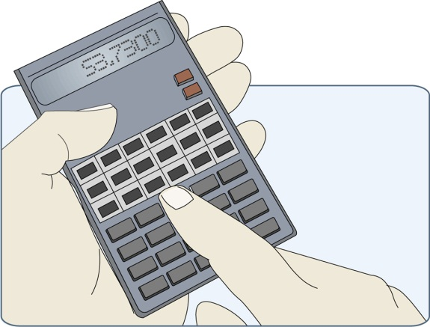
For My Retirement, I Will Need $_________
Now, calculate the dollar amount that you will need to save for retirement. Utilize your list that you developed on your worksheet, “When I Am Old, I Want To…” Remember that you have to plan for things such as where you want to live and the cost of living, the kind of home you want to have during retirement, the places you would like to travel, the activities that you want to experience, the types of vehicles you want to drive, how you want to be taken care of in “old age”, medical expenses you may incur, etc., etc. Utilize this web link: https://401k.fidelity.com/public/content/401k/Home/AmIsavingenough
My retirement resources will come from:
My Employer:
_____________________________ $____________ ____________________________ $_____________
_____________________________ $____________ ____________________________ $_____________
_____________________________ $____________ ____________________________ $_____________
The Government:
_____________________________ $____________ ____________________________ $_____________
_____________________________ $____________ ____________________________ $_____________
_____________________________ $____________ ____________________________ $_____________
My Financial Institutions:
_____________________________ $____________ ____________________________ $_____________
_____________________________ $____________ ____________________________ $_____________
_____________________________ $____________ ____________________________ $_____________

(Base your calculations on your projected lifestyle and a life expectancy of 85—20 years of retirement. How much will you need to save each year from the age of 21 to 85 to have and do all the things that you want for retirement?)

