B Employer identification number (EIN)

58-5X48648
22222

OMS No. 1545-0008
1 Wages, tips, other compensation
5150.00

2 Federal income tax withheld
500.00

c Employer's name, address, and ZIP code
Carr’s Cars
123 Fast Lane
Douglasville, GA 30135
d Employee Social Security Number
252-0X-6874

3 Social security wages
5150.00

5 Medicare wages and tips
5150.00

7 Social security tips

9 Advance EIC payment

4 Social security tax withheld
319.30

6 Medicare tax withheld
74.68

8 Allocated tips

10 Dependent care benefits

12a.

e Employee's Name
Alan Larson
987 Christmas Street
Douglasville, GA 30135

. 11 Nonqualified plans

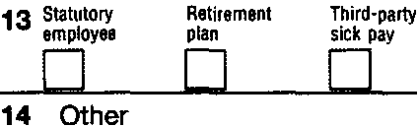

f Employee's address and ZIP code
15 State Employer's state 10 number
GA
54-X258698
Form W-2

16 State wages, tips, etc.
5150.00

17 State income tax
309.00

18 Local wages, tips, etc.

wage and Tax Statement
Copy 1-For State, City, or Local Tax Department

2011
Alan J. Larson is a 17-year-old student who worked after school as a janitor at a car dealership.
Alan wants to buy a used car from the dealership and has saved $2,000 for the purchase. He needs only another $150 to purchase the car. Will his income tax refund cover the remaining amount needed?
In order to get the fastest refund possible, Alan chooses to have his refund deposited directly into his checking account. His checking account routing number is 787878787, and his account number is 100237692.

Department of the Treasury-Internal Revenue Service

