B Employer identification number (EIN)

58-5648648
22222

OMS No. 1545-0008
1 Wages, tips, other compensation

2 Federal income tax withheld

c Employer's name, address, and ZIP code

d Employee Social Security Number

3 Social security wages

5 Medicare wages and tips

7 Social security tips

9 Advance EIC payment

4 Social security tax withheld

6 Medicare tax withheld

8 Allocated tips

10 Dependent care benefits

12a.

e Employee's Name

. 11 Nonqualified plans

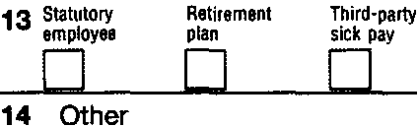

f Employee's address and ZIP code
15 State Employer's state 10 number
GA
5258974
Form W-2

16 State wages, tips, etc.

17 State income tax

18 Local wages, tips, etc.

wage and Tax Statement
Copy 1-For State, City, or Local Tax Department

2011

Department of the Treasury-Internal Revenue Service

