B Employer identification number (EIN)

58-5X48648
22222

OMS No. 1545-0008
1 Wages, tips, other compensation
32000.00

2 Federal income tax withheld
2600.00

c Employer's name, address, and ZIP code
Patient Advocacy Group
652 Loud Lane
Atlanta, GA 30254
d Employee Social Security Number
232-5X-5467

3 Social security wages
32000.00

5 Medicare wages and tips
32000.00

7 Social security tips

9 Advance EIC payment

4 Social security tax withheld
1984.00

6 Medicare tax withheld
464.00

8 Allocated tips

10 Dependent care benefits

12a.

e Employee's Name
Cealise VonPelser
658 Golden Blvd
Douglasville, GA 30350

. 11 Nonqualified plans

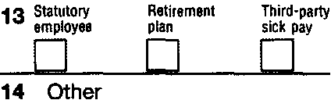

f Employee's address and ZIP code
15 State Employer's state 10 number
GA
5258974X12
Form W-2

16 State wages, tips, etc.
32000.00

17 State income tax
750.00

18 Local wages, tips, etc.

wage and Tax Statement
Copy 1-For State, City, or Local Tax Department

2011
Cealise VonPelser is single. She wants the $3 to go to the Presidential Elections Campaign. Her only income source is from her job as a patient advocate. She supports herself and is not claimed as a dependent on her parents’ tax return.

If she receives a refund, Cealise would like to have it deposited directly into her checking account. Her bank’s routing number is 938740387. Her checking account number is 1002999532.

Department of the Treasury-Internal Revenue Service

