B Employer identification number (EIN)

58-5648648
22222

OMS No. 1545-0008
1 Wages, tips, other compensation
8610.00

2 Federal income tax withheld
644.00

c Employer's name, address, and ZIP code
Beauty Barn
98 Curly Q Rd.
Atlanta, GA 30254
d Employee Social Security Number
232-5X-5467

3 Social security wages
8610.00

5 Medicare wages and tips
8610.00

7 Social security tips

9 Advance EIC payment

4 Social security tax withheld
533.82

6 Medicare tax withheld
124.85

8 Allocated tips

10 Dependent care benefits

12a.

e Employee's Name
Henrietta Alexander
111 Singlet St.
Douglasville, GA 30350

. 11 Nonqualified plans

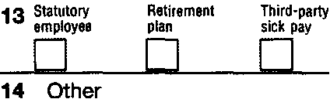

f Employee's address and ZIP code
15 State Employer's state 10 number
GA
5258974X12
Form W-2

16 State wages, tips, etc.
8610.00

17 State income tax
300.00

18 Local wages, tips, etc.

wage and Tax Statement
Copy 1-For State, City, or Local Tax Department

2011
Mark and Henrietta Alexander are a married couple. They both work and both have received W2’s from their employers. They file their tax return as Married Filing Jointly. They are not claimed as dependents on their parents’ tax returns.

If they receive a refund, they would like it to be deposited into their checking account. The bank’s routing number is 87X968549. Their account number is 100658632.

They do not want $3 to go to the Presidential Election Campaign.

Department of the Treasury-Internal Revenue Service

