INCOME TAX VOCABULARY PREVIEW

VOCABULARY WORD | DEFINITION | PICTURE/EXAMPLE OR SENTENCE
Income Tax | Tax levied directly on personal income | 
Progressive Tax | any tax in which the rate increases as the amount subject to taxation increases. | 
1040EZ Form | The simplest tax form used if:  • Your taxable income is below $100,000  • Your filing status is Single or Married Filing Jointly  • You and your spouse – if married -- are under age 65 and not blind  • You are not claiming any dependents  • Your interest income is $1,500 or less | 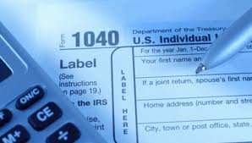
Income | Money earned by a taxpayer | 
Adjusted Gross Income | an amount used in the calculation of an individual's income tax liability
W2 Form |  | 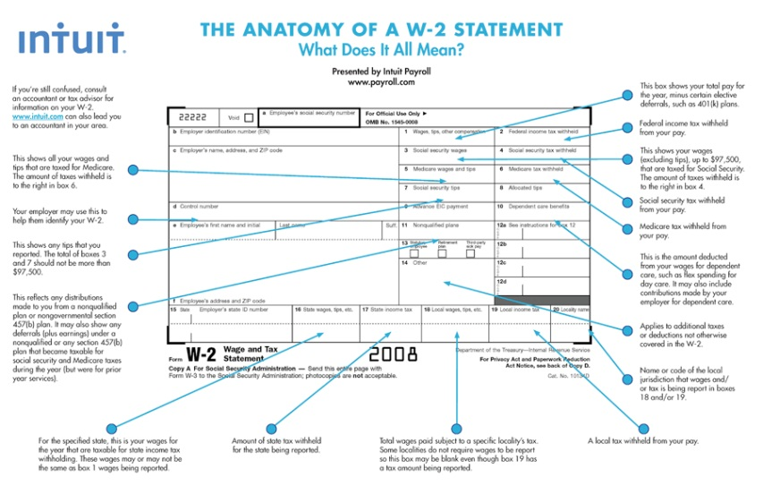
Deduction |  | 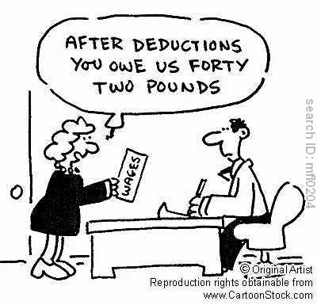
Standard Deduction | a dollar amount that non-itemizers may subtract from their income | 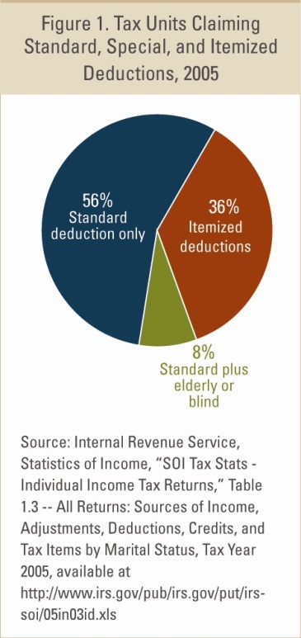
Direct Deposit | Your pay check is directly deposited into your checking account | 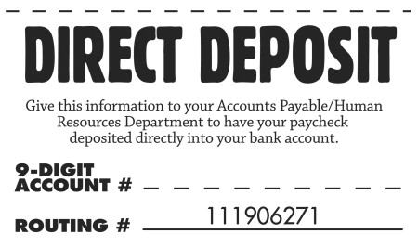
Filing Status | the type of tax return form an individual will use. | 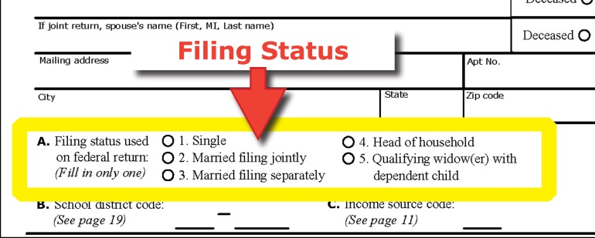
FICA | Federal Insurance Contributions Act | 
Withholdings | When an employer takes taxes out of your check | 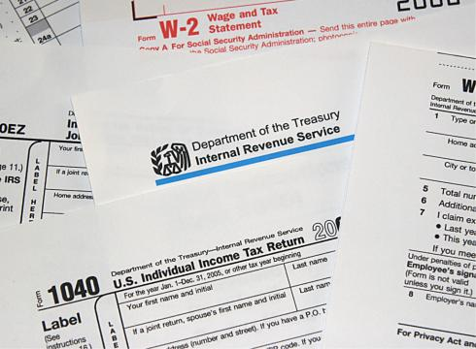
Internal Revenue Service | the bureau of the Treasury Department responsible for tax collections. | 
Taxable Income | Income that is taxable | 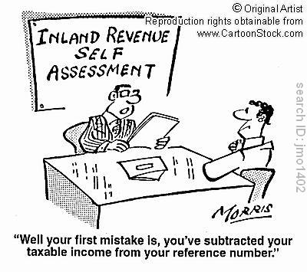
Personal Exemption | portion of income that is the subject of taxation according to the laws that determine what is income | 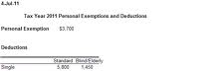
Tax Credit | An amount of money that can be offset against a tax liability | 

