B Employer identification number (EIN)

58-5648648
22222

OMS No. 1545-0008
1 Wages, tips, other compensation
6890.00

2 Federal income tax withheld
1378.00

c Employer's name, address, and ZIP code
Happy Healthcare
999 Healthy St.
Atlanta, GA 30254
d Employee Social Security Number
232-5X-5467

3 Social security wages
6890.00

5 Medicare wages and tips
6890.00

7 Social security tips

9 Advance EIC payment

4 Social security tax withheld
427.18

6 Medicare tax withheld
99.91

8 Allocated tips

10 Dependent care benefits

12a.

e Employee's Name
Jaye Britton
777 Success St.
Douglasville, GA 30350

. 11 Nonqualified plans

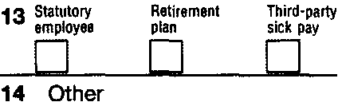

f Employee's address and ZIP code
15 State Employer's state 10 number
GA
5258974X12
Form W-2

16 State wages, tips, etc.
6890.00

17 State income tax
413.40

18 Local wages, tips, etc.

wage and Tax Statement
Copy 1-For State, City, or Local Tax Department

2011
Jaye Britton works part-time as a Certified Nursing Assistant while working on obtaining her nursing degree in college. She does not want $3 to be contributed to the Presidential Election Campaign.

She can be claimed as a dependent on her parent’s tax return. Jaye is in no hurry to get her refund, so she doesn’t complete that portion of the tax return that asks for her banking information.

Department of the Treasury-Internal Revenue Service

