B Employer identification number (EIN)

58-5648648
22222

OMS No. 1545-0008
1 Wages, tips, other compensation
849.00

2 Federal income tax withheld
169.80

c Employer's name, address, and ZIP code
Waffle Den
123 Greasy St.
Atlanta, GA 30254
d Employee Social Security Number
232-5X-5467

3 Social security wages
849.00

5 Medicare wages and tips
849.00

7 Social security tips

9 Advance EIC payment

4 Social security tax withheld
52.64

6 Medicare tax withheld
12.31

8 Allocated tips

10 Dependent care benefits

12a.

e Employee's Name
Jharis Kirby
678 Hardwork Rd
Douglasville, GA 30350

. 11 Nonqualified plans

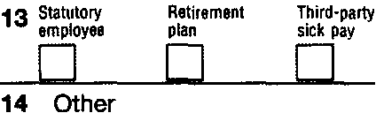

f Employee's address and ZIP code
15 State Employer's state 10 number
GA
5258974X12
Form W-2

16 State wages, tips, etc.
849.00

17 State income tax
50.94

18 Local wages, tips, etc.

wage and Tax Statement
Copy 1-For State, City, or Local Tax Department

2011
Jharis Kirby is an enterprising student who likes to make money. In 2011, he held two jobs while making
straight A’s in school. He does want $3 to go to the Presidential Election Campaign. He can be claimed as a dependent on his parents’ tax return.

If he receives a refund, he wants to have the checks mailed to him.

Complete Form 1040EZ and Form 500EZ for Jharis.

Department of the Treasury-Internal Revenue Service

