B Employer identification number (EIN)

58-5648648
22222

OMS No. 1545-0008
1 Wages, tips, other compensation
1525.00

2 Federal income tax withheld
150.00

c Employer's name, address, and ZIP code
Local Grocery Store
123 Road Rd.
Douglasville, GA 30135

d Social Security 333-65-8945

3 Social security wages
1525.00

5 Medicare wages and tips
1525.00

7 Social security tips

9 Advance EIC payment

4 Social security tax withheld
94.55

6 Medicare tax withheld
22.11

8 Allocated tips

10 Dependent care benefits

12a.

e Employee's Name
Jonathan Jackson
4675 Oak Town Dr.
Douglasville, GA 30135

. 11 Nonqualified plans

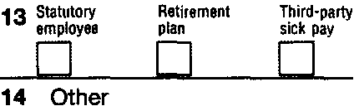

f Employee's address and ZIP code
15 State Employer's state 10 number
GA
Form W-2

16 State wages, tips,
1525.00

17 State income tax
40.00

18 Local wages, tips, etc.

wage and Tax Statement
Copy 1-For State, City, or Local Tax Department

2011
Jonathan Jackson is 17 years old, and he is a full-time high school student. His address is
4675 Oak Town Dr. Douglasville, GA 30135. He wishes to $3 to go to the Presidential Election Campaign fund.

He can be claimed as a dependent on his parent’s tax return.

He has a part-time job working at the local grocery store each day after school. Last year Jonathan earned $1,525. He is having his refund deposited directly in his bank account in order to receive it as quickly as possible.

His savings checking account number is 12121212 and the bank routing number is 2987563894.

Department of the Treasury-Internal Revenue Service

