B Employer identification number (EIN)

58-5X3724
22222

OMS No. 1545-0008
1 Wages, tips, other compensation
18,620.00

2 Federal income tax withheld
820.00

c Employer's name, address, and ZIP code
Wrestlers ‘R Us
546 Pin Dr.
Atlanta, GA 30254
d Employee Social Security Number
232-5X-5467

3 Social security wages
18,620.00

5 Medicare wages and tips
18,620.00

7 Social security tips

9 Advance EIC payment

4 Social security tax withheld
1154.44

6 Medicare tax withheld
269.99

8 Allocated tips

10 Dependent care benefits

12a.

e Employee's Name
Mark Alexander
111 Singlet St.
Douglasville, GA 30350

. 11 Nonqualified plans

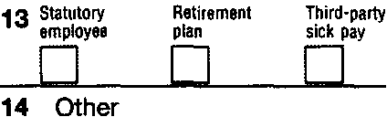

f Employee's address and ZIP code
15 State Employer's state 10 number
GA
5258974X12
Form W-2

16 State wages, tips, etc.
18,620.00

17 State income tax
500.00

18 Local wages, tips, etc.

wage and Tax Statement
Copy 1-For State, City, or Local Tax Department

2011
Mark and Henrietta Alexander are a married couple. They both work and both have received W2’s from their employers. They file their tax return as Married Filing Jointly. They are not claimed as dependents on their parents’ tax returns.

If they receive a refund, they would like it to be deposited into their checking account. The bank’s routing number is 87X968549. Their account number is 100658632.

They do not want $3 to go to the Presidential Election Campaign.

Department of the Treasury-Internal Revenue Service

